Name: ______________________________________ Date: ________________________

Student Exploration: Weather Maps

Vocabulary: air mass, air pressure, cold front, high-pressure system, knot, low-pressure system, precipitation, warm front

Prior Knowledge Questions (Do these BEFORE using the Gizmo.)

- How would you describe your weather today? ____________________________________

_________________________________________________________________________

- What information is important to include when you are describing the weather? __________

_________________________________________________________________________

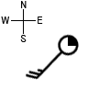
Gizmo Warm-up
Data on weather conditions is gathered from weather stations all over the world. This information is combined with satellite and radar images to create weather maps that show current conditions. With the Weather Maps Gizmo, you will use this information to interpret a variety of common weather patterns.

A weather station symbol, shown at right, summarizes the weather conditions at a location.

- The amount of cloud cover is shown by filling in the circle. A black circle indicates completely overcast conditions, while a white circle indicates a clear sky.

What percentage of cloud cover is indicated on the symbol above? ____________________

- Look at the “tail” that is sticking out from the circle. The tail points to where the wind is coming from. If the tail points north, a north wind is moving from north to south.

What direction is the wind coming from on the symbol above? ________________________

- The “feathers” that stick out from the tail indicate the wind speed in knots. (1 knot = 1.852 kilometers per hour.) A short feather represents 5 knots (9.26 km/h), a long feather represents 10 knots (18.52 km/h), and a triangular feather stands for 50 knots (92.60 km/h). Add the feathers to find the wind speed.

What is the wind speed shown on the symbol above? ______________________________

Activity A:  High-pressure systems | Get the Gizmo ready:  - Click New until you see a high-pressure system, represented by the symbol H.  - Turn on Show Mobile Station B data.  - Turn on Show land. | 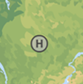

Question: What weather patterns are associated with high-pressure systems?

- Observe: Air pressure is equal to the weight of a column of air on a particular location. Air pressure is measured in hectopascals (hPa). Note how the air pressure changes as you move Station B towards the center of the high-pressure system.

    - What do you notice? __________________________________________________

___________________________________________________________________

    - Why do you think this is called a high-pressure system? ______________________

___________________________________________________________________

- Observe: Select Show satellite image to observe any clouds near the system. What do you notice about the cloud cover near the high-pressure system?

_________________________________________________________________________

High-pressure systems are regions where air moves downward. Usually few or no clouds form in these conditions.
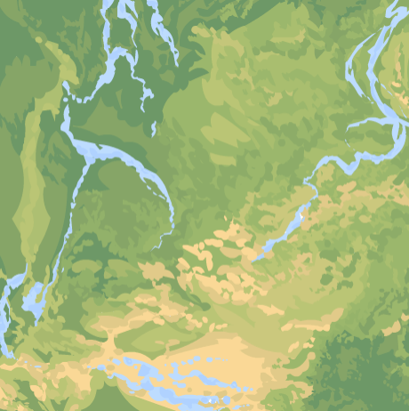

- Measure: Measure the wind speed and direction around the high-pressure system. Sketch the following on the map at right:
- The location of the high-pressure system.
- Arrows to show the wind directions around the high-pressure system.
- The approximate wind speed at each arrow (in kilometers per hour).

- Analyze: Use your map to answer the following questions:

  - Is the wind pattern clockwise or counterclockwise? __________________________

  - Where are the strongest winds found? ____________________________________

___________________________________________________________________

Activity B:  Low-pressure systems | Get the Gizmo ready:  - Click New until you see a low-pressure system, represented by the symbol L.  - Check that Show Mobile Station B data and Show land are on. | 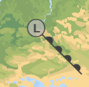

Question: What weather patterns are associated with low-pressure systems?

- Observe: Note how the air pressure changes as you move Station B towards the center of the low-pressure system.

- What do you notice? __________________________________________________

___________________________________________________________________

- Why do you think this is called a low-pressure system? _______________________

___________________________________________________________________

- Observe: Select Show satellite image. What do you notice about the cloud cover near the low-pressure system? _______________________________________________________
Low-pressure systems are regions where air moves upward. This can lead to condensation and cloud formation.

- Measure: Measure the wind speed and direction around the low-pressure system. Sketch the following on the map at right:
- The location of the low-pressure system.
- Arrows to show the wind directions around the low-pressure system.
- The approximate wind speed at each arrow (in kilometers per hour).
- Any clouds associated with the low-pressure system.

- Analyze: Use your map to answer the following questions:

  - Is the wind pattern clockwise or counterclockwise? __________________________

  - Where are the strongest winds found? ____________________________________

___________________________________________________________________

Activity C:  Fronts | Get the Gizmo ready:  - Click New until you see a cold front, represented by a row of triangles.  - Check that Show Mobile Station B data and Show land are on. | 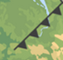

Question: What weather patterns are associated with cold fronts and warm fronts?

- Observe: An air mass is a large body of air with similar temperature, pressure, and humidity throughout. A cold front is a boundary between a warm air mass and an advancing cold air mass. On a weather map, the triangles point in the direction that the cold front is moving.
Sketch the cold front on the map at right. Draw and label the following features:
- The location of the low-pressure system.
- The cold front.
- Any clouds associated with the cold front.
- The temperature on each side of the cold front.
- The wind direction across the front.
- Any precipitation (rain, snow, etc.) that is occurring. (Select Show radar.)

- Compare: Click New so that you can observe several different cold fronts. Based on your observations, what do cold fronts seem to have in common?

_________________________________________________________________________

_________________________________________________________________________

- Analyze: Cold air is denser than warm air. When cold air hits warm air it pushes the warm air up. The rising warm air cools quickly, resulting in condensation, clouds, and stormy weather.
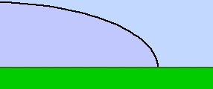
On the diagram, label the cold air mass, warm air mass, and cold front. Draw arrows to show the direction that the cold air and warm air is moving.

Why do clouds form behind the moving cold front?

________________________________________

________________________________________

(Activity C continued on next page)
Activity C (continued from previous page)

- Observe: Click New until you see a warm front, represented by a row of semicircles. A warm front is a boundary between a cold air mass and an advancing warm air mass. The semicircles point in the direction that the warm front is moving.
Sketch the warm front on the map at right. Draw and label the following features:
- The location of the low-pressure system.
- The warm front.
- Any clouds associated with the warm front. (Select Show satellite image.)
- The temperature on each side of the warm front.
- The wind direction across the front.
- Any precipitation that is occurring. (Select Show radar.)

- Compare: Click New so that you can observe several different warm fronts. Based on your observations, what do warm fronts seem to have in common? ________________________
_________________________________________________________________________

- Analyze: Warm air is less dense than cold air. When warm air hits cold air it rises up over the cold air. The rising warm air cools, resulting in condensation, clouds, and gentle rain.
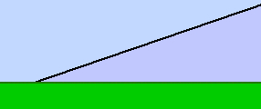
On the diagram, label the warm air mass, cold air mass, and warm front. Draw an arrow to show the direction that the warm air is moving.

Why do clouds form in front of a warm front?

________________________________________

________________________________________

- Summarize: Describe what the weather would be like as a warm front passes. Then, describe what would occur as a cold front passes. Use extra pages if necessary.

_________________________________________________________________________

_________________________________________________________________________

_________________________________________________________________________

