Name: Date:

Student Exploration: Weathering

Vocabulary: abrasion, chemical weathering, clay formation, climate, dissolving, frost wedging, granite, limestone, mechanical weathering, rusting, sandstone, shale, weathering
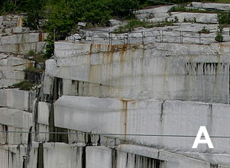

Prior Knowledge Questions (Do these BEFORE using the Gizmo.)
Compare the two pictures at right. Both pictures show the same kind of rock, granite.

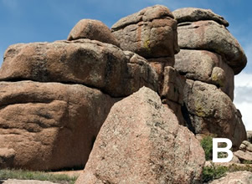
- Which rock do you think has been exposed on Earth’s surface longer?

- Why do you think so?

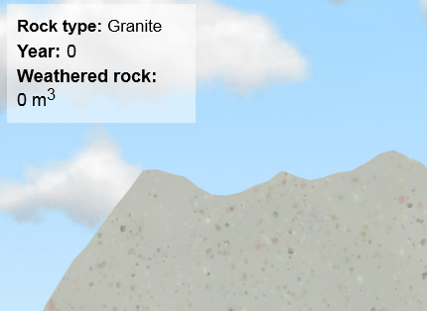
Gizmo Warm-up
When rocks are exposed on Earth’s surface, they are gradually broken down into soil by the actions of rain, ice, wind, and living organisms. This process is called weathering. In the Weathering Gizmo, you will explore how weathering takes place.

To begin, select the SIMULATION tab. Notice the selected Rock type is Granite, a hard, dense rock.

- Click Play (). Wait for about 5,000 simulated years, and click Pause (). What do you notice?

- Click Fastplay (). Wait for about 50,000 simulated years. What do you notice?

- Based on your observations, is weathering a fast or slow process?

Activity A:  Types of weathering | Get the Gizmo ready:  - Select the ANIMATION tab. Check that Frost wedging is selected. | 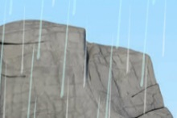

Introduction: Mechanical weathering occurs when rocks are physically broken or worn down. Chemical weathering occurs when the minerals in the rock are changed by chemical reactions.

Question: What are the most common ways in which weathering occurs?

- Observe: Read the text about frost wedging, then click Play.

- In the process of frost wedging, how does ice cause cracks in rocks to become larger?
- Is frost wedging more important in a warm or a cold climate?

- Observe: Read about and look at the animations for the other major types of weathering: Abrasion, Pressure release, Dissolving, Clay formation, and Rusting.

- What are three different ways that rocks can be worn down by abrasion?

- How can a large block of granite form layers like an onion?

- What type of rock is affected by dissolving, and what features result?

- How does clay formation affect a rock?

- Which part of a rock will undergo rusting?

- Fill in: Scientists use the terms “oxidation,” “carbonation,” “hydrolysis,” and “exfoliation” for different types of weathering. Fill in each blank with the appropriate term.

Pressure release: Dissolution:

Clay formation: Rusting:

(Activity A continued on next page)
Activity A (continued from previous page)

- Observe: Select Other. Read the descriptions of each type of weathering, then match each to its description below:

Salt weathering

Heat expansion

Root weathering

Lichen growth

- Weathering from chemicals produced by colonies of algae and fungi.
- Weathering that occurs when crystals grow.
- Weathering caused by the growth of trees.
- Weathering common in desert climates.

- Categorize: List all of the types of mechanical weathering you have learned about in the left column of the table, and all of the types of chemical weathering you have read about in the right column.

Mechanical weathering | Chemical weathering

- Interpret: Based on the descriptions and images, guess which type of weathering is shown by each of the images below. Explain each answer.

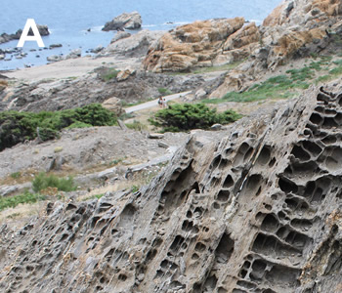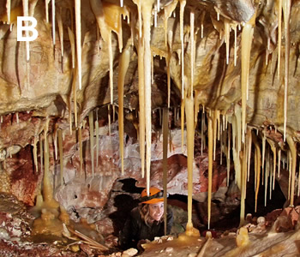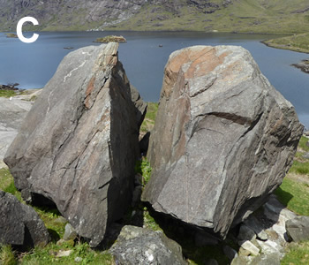

“Honeycomb” rocks in Spain Stalactites in South Dakota Split rock in Scotland

Activity B:  Weathering of different rocks | Get the Gizmo ready:  - On the Simulation tab, click Reset ().  - Set the Average temperature to 25 °C and Precipitation to 250 cm/yr. | 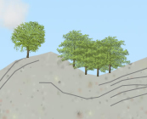

Introduction: The Weathering Gizmo lets you explore weathering of four common rocks. Granite is a very hard rock formed from the crystallization of magma deep underground. Sandstone forms when sand grains become cemented together. Limestone is formed from ancient corals, shells and skeletons. Shale is formed from compacted mud.

Question: How does weathering affect different rock types?

- Observe: Below Rock type, select Granite. Click Fastplay and run a simulation of about 100,000 years. Click the Tools palette and select Screen shot (). Right-click the image, click Copy, and then paste the image into a blank document. Label this image “Granite.” (When you are done, print out and turn in this document with this sheet.)

Describe what you see:

Look at Weathered rock above the outcrop. How much rock was weathered?

- Observe: Click Reset (). Repeat the same procedure for Sandstone, Limestone, and Shale. After 50,000 years, take an image of each, and describe your observations below. List the amount of weathered rock for each type of rock.

Sandstone:

Weathered rock:

Limestone:

Weathered rock:

Shale:

Weathered rock:

- Compare: Compare the results of weathering of different landscapes:

- Which rock types tend to weather into rounded shapes?

- Which rock weathers into caves and lumpy hills?

- Which rock weathers most quickly? Most slowly?

(Activity B continued on next page)
Activity B (continued from previous page)

- Observe: Click Reset. Select Granite and click Fastplay. Run the simulation until you can see large cracks forming in the rock. (This may take a while, be patient!) Take a snapshot of the resulting outcrop and add it to your document. Label this image “Granite cracks.”

What type of weathering forms these cracks?

(Hint: You may need to review the different types of weathering on the ANIMATION tab.)

- Infer: Some types of weathering only affect certain kinds of rocks. The Types of weathering that apply to each kind of rock are listed above the outcrop. If a type of weathering does not affect the selected rock, it is faded.

Select each rock and list the types of weathering that affect it.

Granite:

Sandstone*:

Limestone:

Shale:

*Note: Sandstones are only affected by clay formation when they contain minerals other than quartz. Sandstones that are pure quartz do not form any clay.

- Challenge: Based on the weathering patterns, guess the rock type shown in each photo.

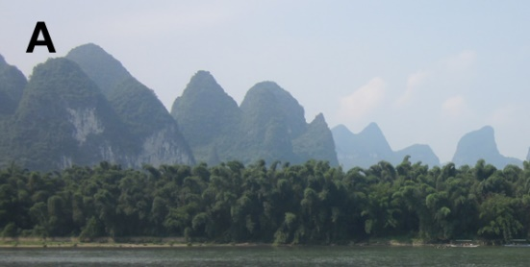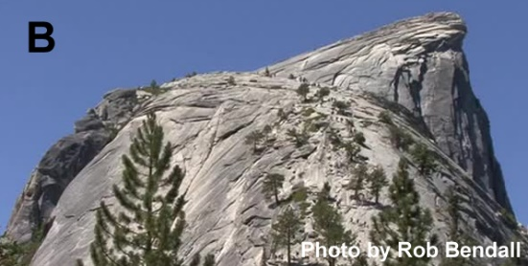

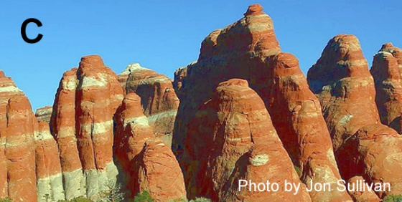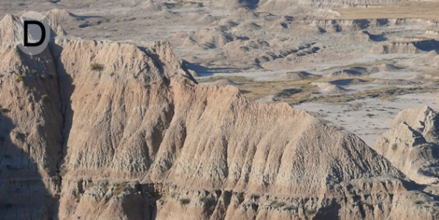

Activity C:  Weathering rates | Get the Gizmo ready:  - On the Simulation tab, select Sandstone.  - Check that Frost wedging, Clay formation, and Other are all selected. | 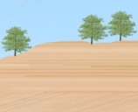

Introduction: The most important things that determines how quickly a particular rock type weathers is the climate, or typical weather conditions. Rocks in cool and dry climates weather much differently than rocks in hot and rainy climates.

Question: How does the climate and rock type affect how quickly a rock weathers?

- Predict: In each “Climate type” box, circle the condition you think will lead to the fastest weathering for the given weathering type.
Weathering type | Climate type
Frost wedging | Hot or Cold | Wet or Dry
Clay formation | Hot or Cold | Wet or Dry
Dissolving | Hot or Cold | Wet or Dry

- Experiment: Click Return to original settings. Using the Gizmo, test the effect of precipitation on the rate of weathering by measuring the amount of weathered sandstone in 20,000 years with low and high precipitation. Be sure to keep all the other variables the same. Describe your results below.

Weathered rock (low precip.) Weathered rock (high precip.)

How does the amount of precipitation affect the amount of weathering?

- Experiment: Click Reset and Return to original settings. Now test the effect of temperature on weathering rates. Describe your results below.

Weathered rock (low temp.) Weathered rock (high temp.)

How does the temperature affect the amount of weathering?

- Explain: Why do you think the rate of weathering tends to increase at hotter temperatures and higher amounts of rainfall?

(Activity C continued on next page)
Activity C (continued from previous page)

- Experiment: Click Return to original settings and select Limestone. Turn off Frost wedging and Other so that only Dissolving is selected. Using the Gizmo, test the effect of precipitation and temperature on the rate of dissolving.

Dissolved rock (low precip.) Dissolved rock (high precip.)

Dissolved rock (low temp.) Dissolved rock (high temp.)

Summarize your findings:

Dissolving occurs more quickly at low temperatures because cold water can dissolve more carbon dioxide than warm water. The greater the amount of dissolved carbon dioxide, the more acidic the water is and the faster the rate of dissolving.

- Experiment: Click Return to original settings and select Shale. Test the effects of temperature on frost wedging and clay formation. Summarize your findings below. (Hint: Be sure to test just one type of weathering at a time.)

Effect of temperature on frost wedging:

Effect of temperature on clay formation:

Temperature | Hot
 | Cool
 |  | Dry | Wet
 |  | Precipitation

- Summarize: The chart to the right summarizes different combinations of temperature and precipitation.

Based on what you have learned in this lesson, write the name of each weathering type listed below into the box on the chart where it would happen most quickly.

Frost wedging
Clay formation
Dissolving

