Vocabulary: Weight and Mass

Vocabulary

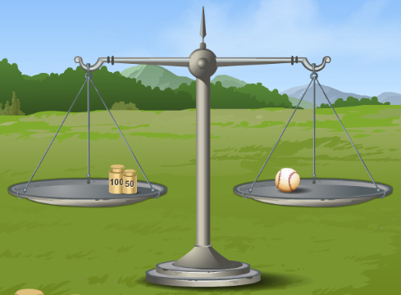
- Balance – an instrument used to compare two masses.
  - Usually an unknown mass on one pan is compared to a known mass on the other pan. The masses are equal when the pans are balanced.
  - A balance cannot measure mass directly. A balance is balanced when the weight on each pan is equal. In a given location, objects with equal weights have equal masses.

- Force – something that can cause a change in motion; a push or a pull.

- Gravity – the force of attraction between objects in the universe due to their mass.
  - Earth’s gravity causes objects to fall to Earth’s surface.
  - Gravity is only significant when one of the objects has a lot of mass, like the Earth. There is very, very little gravitational attraction between you and your couch—but there is some!

- Mass – the amount of matter in an object.
  - In the metric system, units for mass include the kilogram (kg) and the gram (g). There are 1000 grams in a kilogram.

- Newton – the metric unit of force and weight.
  - On Earth’s surface, an object with a mass of one kilogram has a weight of 9.82 newtons (N).

- Spring scale – an instrument used to measure force.
  - The more the spring is stretched, the greater the force.

- Weight – the downward force of gravity on an object.
  - The greater the strength of gravity, the more the object weighs.
  - The greater the mass of the object, the more it weighs.

