Vocabulary: Wheel and Axle

Vocabulary

- Effort – the force that is applied to a simple machine such as a wheel and axle.

- Force – something that can cause a change in motion; a push or a pull.

- Load – the weight that will be moved, lifted, or supported by a simple machine.

- Mechanical advantage – the amount by which a simple machine reduces the effort needed to accomplish a task.
  - For example, a simple machine with a mechanical advantage of 2 will require 50 newtons of effort to lift a 100-newton load.

- Radius – the distance from the edge of a circular object to the center.

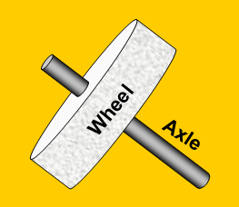
- Wheel and axle – a simple machine composed of a large wheel attached to a narrower shaft called an axle.
  - Turning the wheel turns the axle, and turning the axle turns the wheel.
  - In many machines (windmills, water wheels, steering wheels, winches) a force turns a wheel. The rotating wheel turns an axle.
  - In a car, a motor turns an axle. The rotating axle causes the wheels to turn and move the car forward.

