Vocabulary: Whole Numbers with Base-10 Blocks

Vocabulary

- Addend – a number that is added to another.
  - In the equation 5 + 3 = 8, the numbers 5 and 3 are addends.

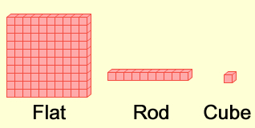
- Base-10 blocks – a set of blocks used to model numbers in the base-10 system.
    - A cube is a single block.
    - A rod is a row of 10 cubes.
    - A flat is a square array of 100 cubes. (A flat is also a stack of 10 rods.)

- Base-10 system – a system of numbers based on powers of 10.

- Difference – the result of subtracting numbers.
  - The difference of 8 and 3 is 5 because 8 – 3 = 5.

- Place value – the value of a digit based on its position in a number.
- For example, the number 647 means 6 hundreds, 4 tens, and 7 ones.

- Regroup – to change how a number is grouped into ones, tens, hundreds, etc.
  - Regrouping can be helpful when subtracting numbers like 42 – 17.
    - Subtracting (4 tens + 2 ones) – (1 ten + 7 ones) is a problem, because you can’t take 7 ones away from 2 ones.
    - Regroup (change 1 ten to 10 ones), so 42 = 3 tens + 12 ones.
    - So, 42 – 17 becomes (3 tens + 12 ones) – (1 ten + 7 ones).
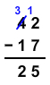
      - 3 tens – 1 ten = 2 tens = 20
      - 12 ones – 7 ones = 5 ones = 5
      - This shows that 42 – 17 = 25.

- Sum – the result of adding numbers.
  - The sum of 5 and 3 is 8 because 5 + 3 = 8.

- Whole number – a number that is positive or zero, and has no fractional part.
  - For example, the numbers 0, 3, 798, 2,419, and 580,373 are whole numbers.
  - The set of whole numbers goes on forever.

