Name: Date:

Student Exploration: Absolute Value Equations
and Inequalities

Vocabulary: absolute value, compound inequality, equation, inequality, solution

Prior Knowledge Questions (Do these BEFORE using the Gizmo.)
The solution of an equation like x + 2 = 5 is the value(s) of x that make the equation true.

- What is the solution of x + 2 = 5?
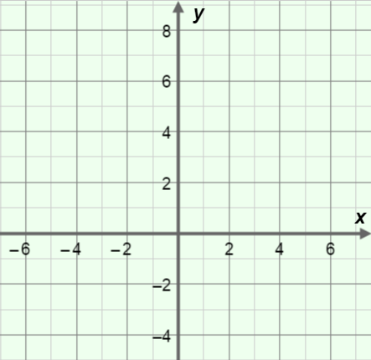

- An equation like x + 2 = 5 can be solved graphically too. Graph each side of the equation (y = x + 2 and y = 5) on the grid to the right.

  - What is the intersection point?

  - Which coordinate is the solution, x or y?

Gizmo Warm-up
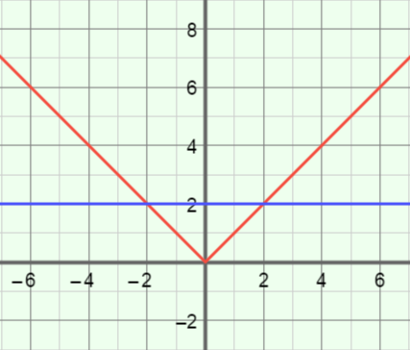
You can solve equations by graphing each side, as you did above. In the Absolute Value Equations and Inequalities Gizmo, you will use graphs to find the solutions of equations and inequalities that involve absolute value, the distance a quantity is from 0 on a number line.

On the CONTROLS tab in the Gizmo, set a to 1, b to 0, c to 2, and select . (To quickly set the value of a slider, type the number into the text box to the right of the slider and press Enter.) Notice that each side of |x| = 2 is graphed
(y = |x| and y = 2).

- Look at the graph of y = |x|. What is the shape of this graph?

- Because absolute value is a distance, it is never negative. How does this relate to the shape of the graph of y = |x|?

- Look at the graphs of y = |x| and y = 2. What values of x make |x| equal to 2?

Activity A:  Absolute value equations | Get the Gizmo ready:  - On the CONTROLS tab, set a to 1, b to 2, c to 3, and select . | 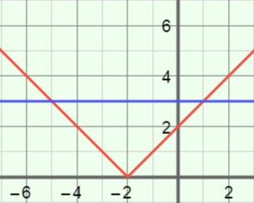

- The equation in the Gizmo should be |x + 2| = 3. To solve this equation, look for values of x that make
|x + 2| equal to 3. In the Gizmo, you will find the solution by graphing each side, y = |x + 2| and y = 3.

  - Sketch the graphs of y = |x + 2| and y = 3 on the grid to the right.

  - How many times do the graphs intersect?

  - Select Highlight solution on graph. Mouseover the green points of intersection. What are the x-values of each point of intersection?
Select Show solution on number line to check your answer.

  - In the space below, substitute each of these x-values into |x + 2| = 3 and simplify. These x-values are solutions of |x + 2| = 3 because they make the equation true.

- Another way to solve an absolute value equation is to use algebra. Check that the equation in the Gizmo is still |x + 2| = 3.

- If |x + 2| = 3, what are the two possible values of x + 2? (Fill in the blanks below.)

x + 2 = or x + 2 =

- Use algebra to solve each of these equations. Show your work below. Select the SOLUTION tab in the Gizmo to check your answers.

(Activity A continued on next page)
Activity A (continued from previous page)

- On the CONTROLS tab, turn off Show solution on number line. Set the Gizmo to show the absolute value equation |2x – 3| = 7.

- If |2x – 3| = 7, what are the two possible values of 2x – 3? (Fill in the blanks below.)

2x – 3 = or 2x – 3 =

- Use algebra to solve each of these equations. Show your work below. Select the SOLUTION tab in the Gizmo to check your answers.

- Select the CONTROLS tab. What equations can you graph to solve |2x – 3| = 7?

- With Highlight solution on graph selected, mouseover the green points of intersection. What are the x-values of each point of intersection?
Select Show solution on number line to check your answer.

- In the space below, substitute each of these x-values into |2x – 3| = 7 and simplify. These x-values are solutions of |2x – 3| = 7 because they make |2x – 3| equal to 7.

- On the CONTROLS tab, be sure Highlight solution on graph and Show solution on number line are selected. Vary the values of a, b, and c.

- When does an equation of the form |ax + b| = c have two solutions?

- When does an equation of the form |ax + b| = c have one solution?

- When does an equation of the form |ax + b| = c have no solution?

Activity B:  Absolute value inequalities | Get the Gizmo ready:  - On the CONTROLS tab, turn off Highlight solution on graph and Show solution on number line.  - Set a to 1, b to 1, c to 5, and select . | 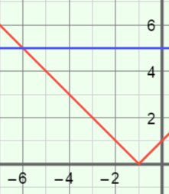

- The inequality shown in the Gizmo should be |x + 1| < 5. You will find the solution of this inequality by graphing each side, y = |x + 1| and y = 5.
- Sketch the graphs of y = |x + 1| and y = 5 on the grid to the right. Shade the part of the graph of y = |x + 1| where |x + 1| is less than 5.

- Select Highlight solution on graph. The green shaded part is where |x + 1| is less than 5.

What are the x-values of the points in this shaded area?

- Check that the inequality in the Gizmo is still |x + 1| < 5. If this were the equation |x + 1| = 5, you would look for all x-values for which x + 1 = 5 or x + 1 = –5. You can do something similar to solve |x + 1| < 5.

- For |x + 1| < 5 to be true, should x + 1 be greater than or less than 5?

- For |x + 1| < 5 to be true, should x + 1 be greater than or less than –5?

- Write two inequalities that give the possible values of x + 1. (Fill in the blanks below.)

x + 1 and x + 1

- The combination of the two inequalities above is a compound inequality. Use algebra to solve this compound inequality. Show your work below. Select the SOLUTION tab in the Gizmo to check your answers.

- Why is the solution of |x + 1| < 5 written using and instead of or?

(Activity B continued on next page)
Activity B (continued from previous page)

- On the CONTROLS tab, turn off Highlight solution on graph and Show solution on number line. Set the Gizmo to show the absolute value inequality |2x – 1| ≥ 3.

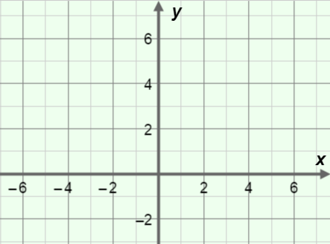
- Sketch the graphs of y = |2x – 1| and y = 3 on the grid to the right. Shade the part of the graph of y = |2x – 1| where |2x – 1| is greater than or equal to 3.

- Select Highlight solution on graph. What are the x-values of the points in the shaded area?

- Write two inequalities that give the possible values of 2x – 1. (Fill in the blanks.)

2x – 1 or 2x – 1

- Use algebra to solve this compound inequality. Show your work below. Select the SOLUTION tab in the Gizmo to check your answers.

- Why is the solution of |2x – 1| ≥ 3 written using or instead of and?

- Select the CONTROLS tab. With Highlight solution on graph and Show solution on number line selected, vary a, b, and c. Also vary the inequality signs. Answer the questions below for absolute value inequalities with |ax + b| on one side and c on the other.

- When is the solution of an absolute value inequality all real numbers?
Why?
- When does an absolute value inequality have no solution?

Why?

Activity C:  Solving absolute value equations and inequalities | 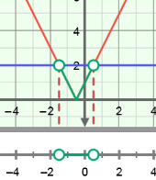  Get the Gizmo ready:  - Select the CONTROLS tab.

- Use algebra to solve each absolute value equation or inequality. Show your work in the space below each problem. Then graph the equation or inequality in the Gizmo to check your solution.

- |2x + 1| = 5

- |x – 4| > 6

- |4x + 3| ≤ 5

- State the absolute value inequality shown in each graph. Check your answer in the Gizmo.

