Name: Date:

Student Exploration: Addition and Subtraction of Functions

Vocabulary: function, parabola, quadratic function

Prior Knowledge Questions (Do these BEFORE using the Gizmo.)

- Mark and his sister Ellen are saving money to buy a fish tank. Mark has $4 and saves $2 each day. Ellen has $3 and saves $1 each day.

- Write an expression to describe the amount Mark will have after x days.

- Write an expression to describe the amount Ellen will have after x days.

- Use the expressions you wrote above to write a function that describes the total amount y Mark and Ellen will have after x days. y =

- How much money will Mark and Ellen have after 3 days?

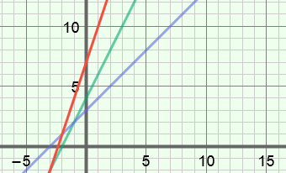
Gizmo Warm-up
To find the function you wrote above, you can add the like terms of 2x + 4 and x + 3. In the Addition and Subtraction of Functions Gizmo, you will add or subtract like terms to find the sums or differences of functions. You will also examine how the graph of the sum or difference relates to the graphs of the two functions.

On the ADDING tab, click on the top (green) function, and graph f(x) = 2x + 4 by setting a to 0.0, b to 2.0, and c to 4.0. (Change the values by dragging the sliders, or by clicking in the text field, typing in a value, and hitting Enter.) Then graph g(x) = x + 3 on the bottom (blue) function.

- Select Show sum. What is the sum of f(x) = 2x + 4 and g(x) = x + 3? (f + g)(x) =

- Describe the graphs of the functions f(x) and g(x) and their sum.

- Select Show probe. Drag the probe to 3. Next to the graph, click the button once to zoom out. Look at the table and graph. What is f + g when x = 3?

Activity A:  Adding two functions | Get the Gizmo ready:  - On the ADDING tab, turn off Show sum and Show probe.  - Click the button to reset the graph. | 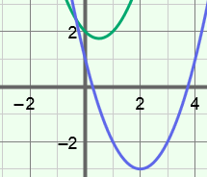

- In the Gizmo, graph f(x) = x² – x + 2 and g(x) = x² – 4x + 1. Both of these are quadratic functions (degree 2) whose graphs are parabolas.

  - Add the like terms in the polynomials x² – x + 2 and x² – 4x + 1 to find the sum of the functions. Fill in the blank below to write the function that represents the sum.

(f + g)(x) =

Select Show sum to check your answer. Notice that the sum is the equation of the red parabola shown in the Gizmo.

  - Evaluate f(x), g(x), and (f + g)(x) when x = –1. Show your work below. Then select Show probe and drag the probe to x = –1 to check your answers. (You can click on the graph and drag down to see the point where the probe intersects (f + g)(x).)

  - When x = –1, how is f(x) + g(x) related to (f + g)(x)?

- Turn off Show sum and Show probe. Graph f(x) = 2x² + 4x + 3 and g(x) = –2x² – 3x + 2.

- What is the sum of the functions? (f + g)(x) =

Select Show sum to check your answer.

- Select Show probe. Drag the probe and study the y-values of the functions at different x-values. At any given x-value, how is f(x) + g(x) related to (f + g)(x)?

- Experiment with more functions. At any given x-value, how is f(x) + g(x) related to
(f + g)(x)?

- If (2, 1) lies on the graph of function f and (2, 5) lies on the graph of function g, what point must lie on the graph of f + g? ( , )

Activity B:  Subtracting two functions | Get the Gizmo ready:  - Select the SUBTRACTING tab.  - Click the button to reset the graph. | 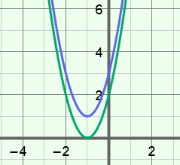

- In the Gizmo, graph f(x) = 2x² + 4x + 2 and g(x) = 2x² + 4x + 3.

  - Subtract the terms in 2x² + 4x + 3 from the like terms in 2x² + 4x + 2 to find the difference. Fill in the blank below to write the function that represents the difference.

(f – g)(x) =

Select Show difference to check your answer. Notice that the difference is the equation of the red line shown in the Gizmo.

  - Evaluate f(x), g(x), and (f – g)(x) when x = –1. Show your work in the space below. Then select Show probe and drag the probe to x = –1 to check your answers.

  - When x = –1, how is f(x) – g(x) related to (f – g)(x)?

  - Drag the probe and study the y-values of the functions at different x-values. At any given x-value, how is f(x) – g(x) related to (f – g)(x)?

  - Experiment with more functions. At any given x-value, how is f(x) – g(x) related to
(f – g)(x)?

- Turn off Show difference and Show probe. Graph f(x) = x² + x – 2 and g(x) = 2x² + x + 1.

- What is the difference of the functions? (f – g)(x) =

- Turn on Show difference. Where is the vertex of f – g located?

- With b still set to 1.0 for both f and g, vary a and c for both functions. Is the vertex of f – g always located on the y-axis?
- Now vary b for both f and g. What must be true about b in f and g in order for the vertex of f – g to be on the y-axis?

