Vocabulary: Addition and Subtraction of Functions

Vocabulary

- Function – a set of ordered pairs such that for each input (x) value, there is one and only one output (y) value.

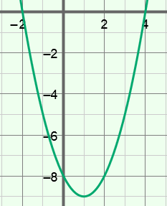
- Parabola – the graph of a quadratic function.
- For example, the graph of y = x² – 2x – 8 (shown to the right) is a parabola.

- Quadratic function – a function of the form y = ax² + bx + c, where a ≠ 0.
- The “a” cannot be 0 because, if a = 0, the function becomes linear: y = bx + c.

