Name: Date:

Student Exploration: Adding and Subtracting Integers

Vocabulary: addend, commutative property of addition, difference, integer, sum

Prior Knowledge Questions (Do these BEFORE using the Gizmo.)
Chad likes to play Bingo at the nearby American Legion Hall. One day he goes into the hall with $14 in his pocket. When he comes out, he has no money left and owes his friend Greg $3.

- How much money did Chad lose that night?

- At home, Chad finds $5 in the kitchen drawer. If you include the $3 he owes Greg, how much does Chad have, total?

- If Greg forgives Chad’s $3 debt to him, how does that affect how much money Chad has?

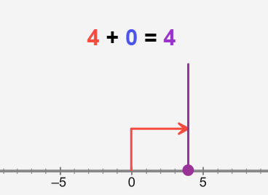
Gizmo Warm-up
One way to understand negative numbers is to think about money. If you are in debt, you have less than zero dollars, which is a negative amount of money.

Working with negative numbers can be tricky, but using a number line may help. You can explore how to add and subtract positive and negative integers, or numbers with no fractional part, in the Adding and Subtracting Integers Gizmo.

- To begin, check that Add integers is selected. Set the Value of first integer to 4 by dragging the slider or by typing “4” into the box to the right of the slider and hitting Enter.

- Where on the number line is the purple dot representing this number?

- In what direction does the red arrow point?

- Now set the Value of the first integer to –4. How does the graph change?

Activity A:  Adding integers | Get the Gizmo ready:  - Be sure Add integers is selected.  - Set the Value of first integer to 4 and the Value of second integer to 3. | 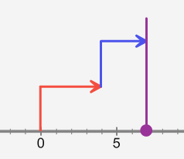

- After entering the values above, look at how the sum 4 + 3 is shown on the number line.

  - What is the length and direction of the red arrow?

  - What is the length and direction of the blue arrow?

  - What is 4 + 3?

- Set the Value of the first integer to –4 to model (–4) + 3.

- How does the red arrow change?

- Does the blue arrow change?
- What is (–4) + 3?

- Set the first integer to 3 and the second integer to –4 to model the sum 3 + (–4).

- What is the length and direction of the red arrow?

- What is the length and direction of the blue arrow?
- What is 3 + (–4)?
- Compare 3 + (–4) to (–4) + 3. What happens to the sum when the addends are reversed?
The commutative property of addition states that the order in which numbers are added does not change the sum.

- Consider the sum (–8) + (–7). Do not input these values into the Gizmo yet.

- What will be the direction of the red arrow? The blue arrow?

- What do you think (–8) + (–7) equals?

- Check your answer using the Gizmo. Were you correct?

- Find the following sums. For the first two, check your answers with the Gizmo.

(–4) + (–9) = 8 + (–10) = (–8) + 16 = (–11) + (–14) =

Activity B:  Subtracting integers | Get the Gizmo ready:  - Select Subtract integers.  - Set the Value of first integer to 5 and the Value of second integer to 3. | 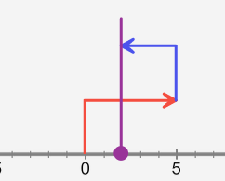

- Look at how the difference 5 – 3 is shown on the number line.

  - What is the length and direction of the red arrow?

  - What is the length and direction of the blue arrow?

  - What is 5 – 3?
  - What addition expression is equivalent to 5 – 3?
  - Try other positive values for the second integer. When subtracting a positive integer, in what direction does the blue arrow point?

- Set the second integer to 8 to model 5 – 8.

- What does 5 – 8 equal?

- In general, what can you say about the difference when you subtract a larger integer from a smaller integer?
- What addition expression is equivalent to 5 – 8?

- Set the first integer to –5 to model (–5) – 8.

- How does the red arrow change?

- Does the blue arrow change?
- What is (–5) – 8?

- What addition expression is equivalent to (–5) – 8?

- Set the first integer to 2 and the second integer to –7 to model the difference 2 – (–7).

- What is the length and direction of the blue arrow?
- What is 2 – (–7)?
- What addition expression is equivalent to 2 – (–7)?

(Activity B continued on next page)
Activity B (continued from previous page)

- Try subtracting other negative numbers from 2.

- In general, what is the direction of the second (blue) arrow when you subtract a negative?
- Fill in the blank: Subtracting a negative is equivalent to a positive.

- Consider the difference (–4) – (–9). Do not input these values into the Gizmo yet.

- What will be the direction of the red arrow? The blue arrow?

- What do you think (–4) – (–9) equals?
- Check your answer using the Gizmo. Were you correct?

- What addition expression is equivalent to (–4) – (–9)?

- Find the following differences. For the first two, check your answers with the Gizmo.

7 – (–9) = 3 – 10 = (–2) – 12 = (–13) – (–4) =

- Use the Gizmo to compare 5 – (–4) to (–4) – 5.

- What is 5 – (–4)? What is (–4) – 5?

- Does the commutative property apply to subtraction? Explain.

- Use the Gizmo to investigate other pairs of differences. In general, if you know the difference of a – b, what is b – a?

- Challenge: In this activity, you have compared subtraction expressions (differences) to their equivalent addition expressions (sums). Fill in the table below with the sum that is equivalent to each difference.

 | Difference |  | Equivalent sum
 | a – b
 | (–a) – b
Difference |  | Equivalent sum
a – (–b)
(–a) – (–b)

