Vocabulary: Adding and Subtracting Integers

dictionary2

**Vocabulary**

* Addend – a number that is added.
  + For example, in the sum 5 + 3 = 8, “5” and “3” are addends.
* Commutative property of addition – a rule that states that changing the order of numbers that are added does not change the sum.
  + For example, 5 + 3 and 3 + 5 are both equal to the same value, 8.
* Difference – the result of subtracting numbers.
  + For example, the difference between 8 and 3 is 5 because 8 – 3 = 5.
* Integer – a number with no fractional part.
  + Integers can be positive, negative, or zero. All the numbers labeled on the number line below are integers.

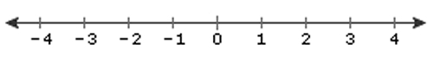

* + 1.25, 2, and –6.99, are not integers because all have fractional parts.
* Sum – the result of adding numbers.
  + For example, the sum of 5 and 3 is 8 because 5 + 3 = 8.