Name: Date:

**Student Exploration: Adding Vectors**

**Vocabulary:** component, initial point, magnitude, resultant, scalar, terminal point, vector

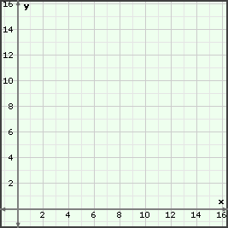

***A***

***B***

***C***

**5 miles**

**12 miles**

**Prior Knowledge Questions** (Do these BEFORE using the Gizmo.)

Starting at her house (point *A*), Ava drives 5 miles east to visit her friend Bernice (point *B*). She then drives 12 miles north to visit Christine (point *C*). Finally, she drives directly back home.

1. Sketch the straight path from point *C* to point *A* on the diagram to the right. How can you use the figure formed to find the length of the straight path from point *C* to point *A*?

1. Calculate the distance from point *C* to point *A*. Show your work in the space to the right. Distance =

**Gizmo Warm-up**

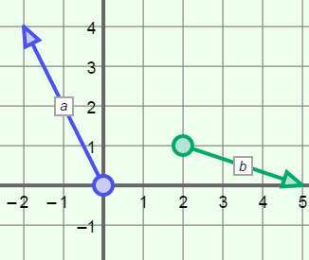A **vector** is a representation of something with both size, or **magnitude**, and direction. For example, a moving car can be represented by a vector because the car has both speed (magnitude) and direction.

On a graph, vectors are represented by arrows. The base of the arrow is the **initial point** and the tip of the arrow is the **terminal point**.

Drag the initial point (the circle) of vector ***a*** to the origin. This vector is now said to be in *standard position*. Notice the **components** of ***a*** shown in brackets like this: <_ , _>.

What are the components of ***a***?

1. Drag the initial point of vector ***a*** around.
2. Does this change the components of ***a***?
3. Compare the coordinates of the initial and terminal points of ***a*** to its components.

How can you find the components of vector ***a***?

|  |  |  |
| --- | --- | --- |
| **Activity A:**  **Describing vectors** | Get the Gizmo ready:   * Drag the initial points of both vectors to the origin. * Drag the terminal point of ***a*** to (4, 0) and the terminal point of ***b*** to (0, –3). | 171SE2 |

1. Recall that all vectors have magnitude (length) and direction. Magnitude is a **scalar**, or a number that does not indicate direction.
2. Use north, south, east, or west to give the direction of ***a*** = <4, 0> and ***b*** = <0, –3>.

***a*** ***b***

1. The expressions ||***a***|| and ||***b***|| represent the magnitudes of ***a*** and ***b***, respectively.

Find ||***a***|| and ||***b***||. ||***a***|| = ||***b***|| =

Select **Show ruler** to open the Gizmo rulers. Attach the “donuts” to the initial and terminal points of the vectors to check your answers.

1. The magnitude of a vector is always positive. Why do you think this is true?

1. With the initial point of ***a*** at the origin, drag the terminal point so ***a*** = <3, 4>. (Drag vector ***b*** out of the way for now.)
2. How does the direction of ***a*** change?
3. 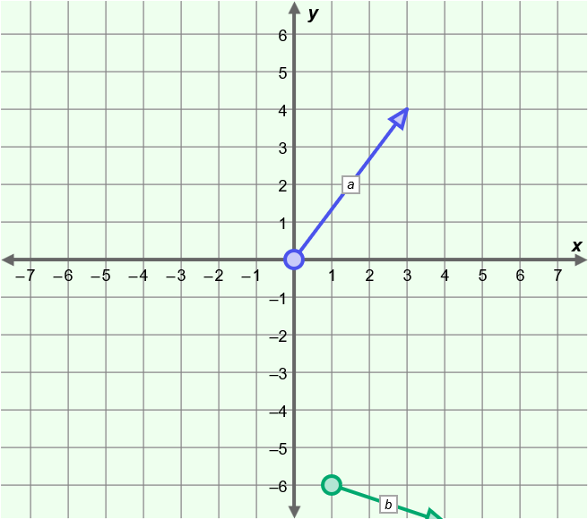Create a right triangle on the grid to the right that has vector ***a*** as the hypotenuse. The legs of the right triangle are the components of vector ***a***. Label the legs of the triangle *a* and *b*, and the hypotenuse *c*.
4. Use the Pythagorean Theorem (*a*2 + *b*2 = *c*2) to find the length of the hypotenuse, *c*. This is the magnitude of ***a***.
5. 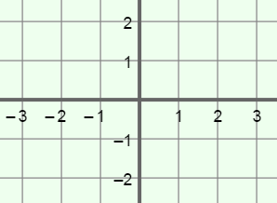The initial point of a vector is (–3, 1) and the terminal point is (2, –1). Sketch the vector on the grid to the right. Then find its magnitude to the nearest hundredth. Show your work.

|  |  |  |
| --- | --- | --- |
| **Activity B:**  **Vector sums** | Get the Gizmo ready:   * Drag the initial point of both vectors to the origin. * Drag the terminal point of ***a*** to (0, 5) and the terminal point of ***b*** to (2, 0). | 171SE5 |

1. Vector ***a*** represents the velocity (speed) and direction of a boat crossing a river. Vector ***b*** represents the velocity and direction of a strong west-to-east current the boat encounters.

**2 mph**

**5 mph**

**a**

**b**

1. How do you think the current will affect the boat?

Sketch ***c*** to the right to show where you think the boat will go.

1. Turn on **Show resultant**. Vector ***c*** is the **resultant**, or sum, of vectors ***a*** and ***b***. In this case, ***c*** shows the resulting velocity and direction of the boat.

What are the components of ***c***? < , >

1. 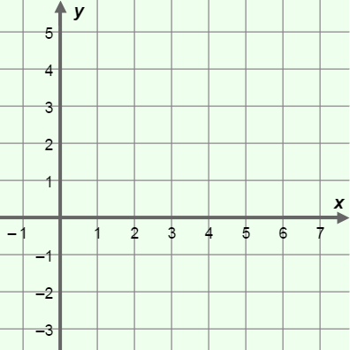Turn off **Show resultant**. With the initial points at the origin, change ***a*** to <1, 3> and ***b*** to <4, 2>. Sketch these vectors on the grid to the right.
2. What do you expect the components of the resultant to be? < , >
3. Turn on **Show resultant**, and sketch the resultant in your diagram. What are the components of the resultant?

< , >

1. In general, how can you use the components of ***a*** and ***b*** to find the components of ***c***?

Select **Show sum computation** to check your answer. Vary the components of ***a*** and ***b*** to check that a vector sum can always be found by adding the corresponding components of the vectors.

1. Drag the initial point of ***b*** to the terminal point of ***a***. What do you notice?

**(Activity B continued on next page)**

**Activity B (continued from previous page)**

1. Suppose ***a*** and ***b*** have initial points at the origin, and ***a*** = <–5, –1> and ***b*** = <1, 4>.
2. 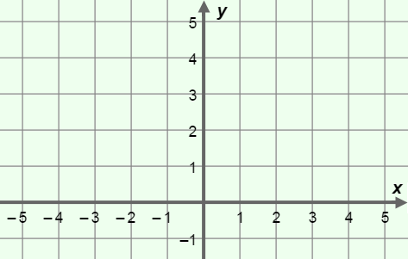Add the components of ***a*** and ***b*** to find the components of the resultant, ***c***. Show your work in the space below.
3. Sketch ***a***, ***b***, and ***c*** on the grid to the right. Check your answer in the Gizmo.
4. Drag the initial point of ***b*** onto the terminal point of ***a***. Sketch the result on the grid above. Notice that the vectors in your sketch form three sides of a parallelogram.
5. Sketch the fourth side of the parallelogram above. Which vector forms the fourth side? Turn on **Show resultant** and **Show parallelogram** to check.
6. What part of the parallelogram is ***c***, the resultant?
7. Compare the coordinates of the terminal point of ***c*** to the sum of ***a*** and ***b*** (the components of ***c***). What do you notice?
8. Drag ***a*** and ***b*** to make new vectors. Be sure to keep the initial point of ***a*** at the origin and the initial point of ***b*** on the terminal point of ***a***.

Is ***a*** + ***b*** always the same as the coordinates of the terminal point of ***c***?

1. What is ***c*** if ***c***= ***a*** + ***b***, ***a*** = <3, 4>, and ***b*** = <–3, –4>?

This is called a state of equilibrium. Equilibrium occurs when equal forces pull in opposite directions.

1. Use vector sums to answer each of the following questions. Show your work. Check your answers in the Gizmo.
2. What is the resultant of ***a*** = <1, 3> and ***b*** = <–3, –4>?
3. What is the vector sum of <–5, 2> and <6, –1>?