Vocabulary: Adding Vectors

dictionary2

**Vocabulary**

* 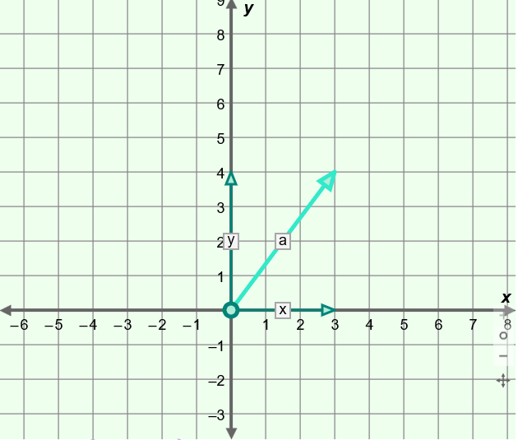Component – the projection of a vector in a given direction.
  + On a coordinate grid, a vector can be described by an *x*-component and a *y*-component.
  + For example, vector ***a***shown to the right has an   
    *x*-component of 3 and a *y*-component of 4.
* Initial point – the starting point of a vector.
* The initial point is found at the base of the arrow.

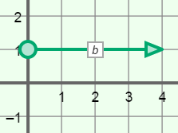

* Magnitude – the length of a vector.
* Magnitude is the distance from the initial point of a vector to its terminal point and is always positive.
* For example, the magnitude of the vector shown to the right is 4 units.
* The magnitude of a vector that is not perfectly vertical or horizontal can be found using the Pythagorean Theorem.
  + The expression ||***b***|| represents the magnitude of vector ***b***.
* Resultant – a vector representing the sum of two or more vectors.
* Scalar – a quantity that has magnitude, but no direction.
  + Examples of scalars include speed, temperature, and volume.
* Terminal point – the ending point of a vector.
* The terminal point is at the tip of the arrow.

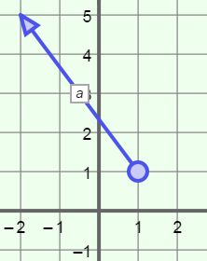

* Vector – a representation that specifies the direction and magnitude of a quantity.
* Vector ***a*** shown to the right has a length of 5 units and a direction that is northwest.
* Vector ***a*** <–3, 4> has initial point (1, 1) and terminal point (–2, 5).
* A vector with an initial point at the origin is in *standard position*.