Name: Date:

**Student Exploration:** **Adding Fractions**

**Vocabulary:** denominator, equivalent, fraction, least common denominator, numerator, sum

**Prior Knowledge Questions** (Do these BEFORE using the Gizmo.)

1. If I have 2 cats and you have 3 cats, how many cats do we have total? ________
2. If I have 2 floobs and you have 3 floobs, how many floobs do we have total? ________
3. If I have 2 ninths and you have 3 ninths, how many ninths do we have total? ________

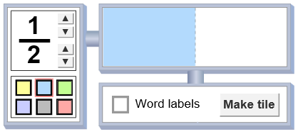

**Gizmo Warm-up**

A **fraction** shows the relationship between a part and a whole. In the *Adding Fractions* Gizmo, you can use the Fractionator (shown to the right) to make fraction tiles. In the image to the right, a “one half” fraction tile is about to be made.

1. The **denominator** is the bottom number of a fraction. In the Gizmo, adjust the denominator with the up and down arrows ( and ).

What does the denominator do to the rectangle (the whole) in the Fractionator? __________

_________________________________________________________________________

1. The **numerator** is the top number in a fraction. Click the arrows to change the numerator.

What does the numerator affect? ______________________________________________

_________________________________________________________________________

1. Show what the fraction tiles for  and  would look like. First sketch them below. Then check your answers in the Gizmo. Click **Make tile** to make these two tiles.



 

|  |  |  |
| --- | --- | --- |
| **Activity A:**  **Adding fractions (like denominators)** | Get the Gizmo ready:   * Click **Clear** to clear the number line and the bin. * Turn on **Word labels**. | 1027SE2 |

1. Begin by creating a  fraction tile in the Fractionator. Place it on the bottom number line.
   1. How do you say  in words? ___________________________
   2. What does  equal? ______________ Turn on **Show sums** to check your answer.
2. 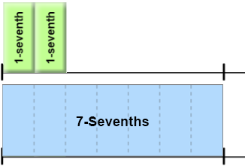On the top number line, model  + , as shown to the right.
   1. How many sevenths do you have on top? __________
   2. How do you write that as a fraction? ___________
3. Look at the sum you modeled ( + ). Compare it to the whole () below it.
   1. How many more sevenths do you need to make a whole on the top? __________
   2. Create the tile you need to make a whole. Add it to the top number line. What sum do you have on the top now?

+ + =

1. Find each sum, in words and as a fraction. First predict. Then model them in the Gizmo.
   1. 3-fifths plus 1-fifth Sum in words: _______________ Sum as fraction: ________
   2.  +  Sum in words: _______________ Sum as fraction: ________
   3.  +  +  Sum in words: _______________ Sum as fraction: ________
2. What is missing from this sum? Predict, and then check in the Gizmo.  + = 
3. In general, how do you add fractions with the same denominators? ____________________

_________________________________________________________________________

|  |  |  |
| --- | --- | --- |
| **Activity B:**  **Adding fractions (unlike denominators)** | Get the Gizmo ready:   * Click **Clear**, and turn off **Show sums**. * Turn off **Word labels**. | 1027SE4 |

Hungry Harry and Lean Larry are sharing a candy bar. Larry eats  of the bar. Harry eats  of the bar. How much of the candy bar did they eat all together?

1. Harry and Larry ate  +  of the candy bar. Model this sum on the top line in the Gizmo.
   1. If the candy bar had 8 pieces, each piece is 1-eighth () of the bar. How many eighths is half of the bar? In words: 1-half = ____-eighths As fraction:  = 

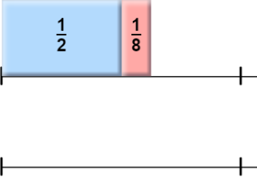

* 1. In the Gizmo, on the bottom number line, build a sum that is **equivalent** (equal) to  + , using *only* 1-eighth tiles. Sketch it carefully to the right.
  2. How many 1-eighth tiles equal the sum  + ? ________
  3. What one single tile is equal to this sum? ________ Use the Gizmo to check.
  4. What fraction of the candy bar did Harry and Larry eat, total? ________

1. To add fractions, the fractions need matching, or common, denominators. For example, the fact that 1-half () = 4-eighths () helped get a common denominator in the sum above.

What other fractions are equivalent to ? _______________________________________

1. For the problems below, find a common denominator and then find the sum. Check your answers with the Gizmo. (Either find an equivalent sum with tiles, or turn on **Show sums**.)
   1.  +  = +  =
   2.  +  = +  =
   3.  +  = +  =
   4.  +  = +  =

|  |  |  |
| --- | --- | --- |
| **Activity C:**  **Using the LCD** | Get the Gizmo ready:   * Click **Clear**, and turn off **Show sums**. * Be sure **Word labels** is turned off. | 1027SE6 |

Theo is making a cake and Amy is baking cookies. Theo’s recipe for cake calls for him to add  cup of sugar, and Amy’s cookies need  cup of sugar. How much sugar do they need, total?

1. To find the sum of  and , first model that sum on the top number line in the Gizmo.
   1. Sketch your fraction tiles here:



* 1. To add fractions with different denominators, you first need to convert them to equivalent fractions with the same denominators (called “common denominators”). List some other fractions that are equivalent to these two fractions below.

 = __________________________  = _________________________

* 1. Use a pair of equivalent fractions with common denominators to find the total amount of sugar Theo and Amy need. Then check your answer in the Gizmo.

 +  = + = cup

1. Look at your lists of fractions equivalent to one half and one third above. In general, what do you have to do to the numerator and denominator of a fraction to find equivalent fractions?

_________________________________________________________________________

A common denominator has to be a multiple of the given denominators. For example, the denominator you used above to find  +  should be a multiple of both 2 and 3. The **least common denominator** (LCD) is the lowest number that is a multiple of the given denominators.

1. Find the sums below. Check your answers in the Gizmo. (Either build an equivalent sum with tiles, or turn on **Show sums**. Note: The answer to D cannot be modeled in the Gizmo.)
   1.  +  =
   2.  +  =
   3.  +  =
   4.  +  =