Name: ______________________________________ Date: ________________________

Student Exploration: Advanced Circuits

[Note to teachers and students: This Gizmo was designed as a follow-up to the Circuits Gizmo. We recommend doing that activity before trying this one.]

Vocabulary: circuit breaker, equivalent resistance, fuse, Ohm’s law, parallel circuit, series circuit

Prior Knowledge Questions (Do these BEFORE using the Gizmo.)

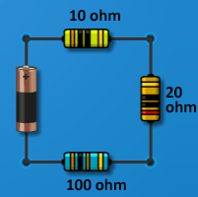
- What is the mathematical relationship between current, resistance, and voltage?

___________________________________________________

- What is the equivalent resistance (total resistance) of the series circuit shown at left? ____________________________
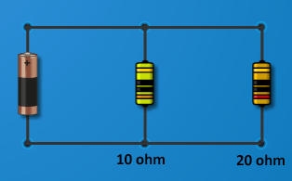
Gizmo Warm-up
In the Circuits Gizmo, you learned how to use Ohm’s law:
I = V/R, to determine the current in parallel and series circuits. But how do you find the resistance and current in a complex circuit that has both series and parallel elements?

First, review how to find the equivalent resistance of a parallel circuit. Use the Advanced Circuits Gizmo to construct the parallel circuit shown at right, using a 10-ohm and a 20-ohm resistor. Set the Selected battery voltage to 20 volts.

- Move the Ammeter next to the battery. What is the current? _________________________

- Based on Ohm’s law, what is the equivalent resistance in the circuit? __________________

- You can calculate the equivalent resistance of a parallel circuit using the following equation:
Based on this equation, what is the equivalent resistance of the circuit? ________________

Activity A:  Solving complex circuits | Get the Gizmo ready:  - Click Clear to remove all components from the CIRCUIT BOARD. | 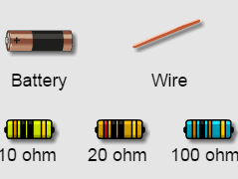

Introduction: Solving a complex circuit may look difficult, but all you have to do is be patient and solve one part of the circuit at a time. Use these two rules to find the resistance of a part of a circuit:
- For components connected in series, the equivalent resistance is the sum of the resistance of each component: R_{t} = R₁ + R₂ + … + R_{n}.
- For resistors connected in parallel, use the equivalent resistance equation:

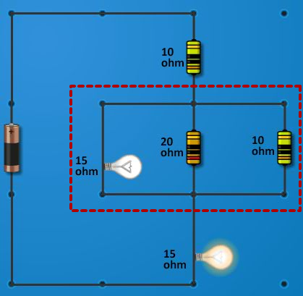
Goal: Determine the resistance and current in a circuit with parallel and series elements.

- Calculate: Use the Gizmo to create the circuit shown at right. Next, find the equivalent resistance of the outlined parallel component of the circuit. Show your work. (Hint: The lowest common denominator of the three fractions is 60.)

Equivalent resistance of parallel component: ________________

- Interpret: Now that you found the resistance of the parallel part of the circuit, what do you think you will do next? _______________________________________________________

- Calculate: Add up the resistance of each part of the circuit to find the equivalent resistance of the whole circuit. What do you get? ___________________________________________

- Check: Remove the battery from the circuit. Connect the two parts of the Ohmmeter to the ends of the circuit, where the battery was attached. What is the resistance? _____________
(Activity A continued on next page)
Activity A (continued from previous page)

- Apply: Remove the ohmmeter and reattach the battery. Set the Selected battery voltage to 10 volts. What do you expect the total current to be through this circuit? ________________
Check your answer by placing the Ammeter on the circuit near the battery.

- Analyze: You can use Ohm’s law (I=V/R) to calculate the current and voltage through each component of the circuit. Recall that the current is the same through each series component but gets split up in the parallel section of the circuit.

- What is the voltage across the first 10-ohm resistor? _________________________

- What is the voltage across the middle, parallel section of the circuit? _____________

- What is the current in each branch of the parallel section?

Light bulb: _____ 20-ohm resistor: _____ 10-ohm resistor: _____

- What is the voltage across the last 15-ohm light bulb? ________________________

Use the Voltmeter and the Ammeter to check your answers.

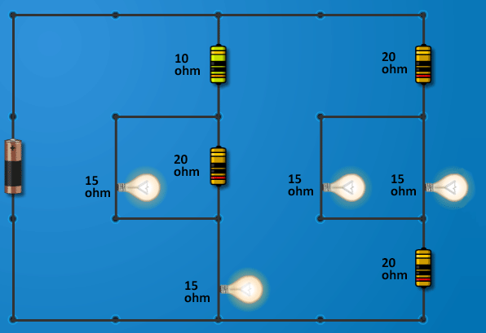
- Practice: Click Clear. Use what you have learned to find the equivalent resistance of the circuit shown at right. Show your work in the space below. Use the Gizmo to check your answers.

Equivalent resistance: ______________

Activity B:  Fuses | Get the Gizmo ready:  - Click Clear. | 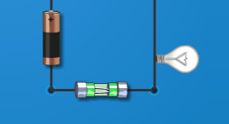

Introduction: Have you ever touched an incandescent light bulb that has been on for a while? Ouch! What you feel is frictional heat produced by the current moving through the light’s resistor. The high heat produced in electric circuits leads to the danger of electrical fires.

A fuse is a safety device that prevents a circuit from overloading and starting a fire. A fuse is usually a thin piece of metal with low resistance. If too much current flows through the fuse, the metal melts and the circuit is broken. The blown fuse will have to be replaced before the circuit can be used again.
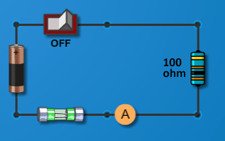
Question: How do fuses help to prevent electrical fires?

- Predict: Build the circuit shown at right, using a 0.30 A fuse. Make sure the switch is turned off as you build the circuit. Set the Selected battery voltage to 10 volts.

- Based on the number on the fuse, what do you think is the maximum current allowed in this circuit? ______________
- What is the maximum battery voltage you could use in this circuit? ______________

(Hint: Use Ohm’s law.) Show your work:

- Check: Click the switch to turn it on, and then gradually increase the Selected battery voltage to the amount you calculated.

What is the current reading on the Ammeter? ______________

- Test: Increase the voltage so the current exceeds 0.30 amps. What happens? ___________

_________________________________________________________________________

- Calculate: Turn the switch off, replace the blown fuse with a new 0.30 A-fuse, and replace the 100-ohm resistor in the circuit with a 20-ohm resistor. Change the battery voltage to 1 V.

What is the maximum allowed voltage now? ______________

Use the Gizmo to test your answer. At what voltage did the fuse blow? ______________

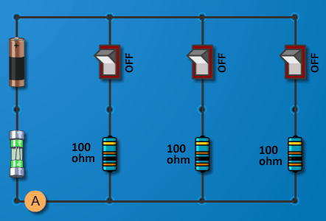
(Activity B continued on next page)
Activity B (continued from previous page)

- Apply: Click Clear. Build a parallel circuit as shown at right, using a 0.30 A fuse and a 12-volt battery. Be sure all the switches are off before adding the fuse. This circuit is similar to what you might find in a house, with three appliances connected in parallel to a single circuit.

- Click the first switch to turn on the first appliance.

What is the total current now? ________

- Turn on the second switch. What is the total current now? ________

- What do you think will happen when you turn on the third switch? _______________

___________________________________________________________________

- Turn on the third switch. What happens? __________________________________

- Why might it be a problem if too many large appliances are connected to the same parallel circuit? _______________________________________________________
___________________________________________________________________

- Summarize: In your house, a device called a circuit breaker serves the same purpose as a fuse. When the current exceeds the limit, the circuit breaker trips, stopping the current. Unlike a fuse, the circuit breaker does not need to be replaced each time it trips. Instead, it can simply be reset.

Why are fuses and circuit breakers important safety features for any circuit? ____________

_________________________________________________________________________

_________________________________________________________________________

_________________________________________________________________________

