Name: Date:

Student Exploration: Using Algebraic Equations

Vocabulary: equation, variable

Prior Knowledge Questions (Do these BEFORE using the Gizmo.)

- The words “like,” “dogs,” and “walks” can be used to form a sentence.

- Write a sentence in which “dogs” is used first.

- Write a sentence in which “walks” is used first.

- Do you think both sentences make sense? Why or why not?

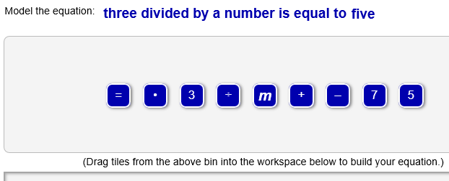
Gizmo Warm-up
In the Using Algebraic Equations Gizmo, you translate algebraic equations into English sentences and vice versa.

An equation is a mathematical sentence that states that two expressions are equal. An algebraic
equation contains at least one variable – a letter used to represent unknown numbers.

In general, the Gizmo will give you either an algebraic equation or a sentence at the top of the Gizmo. Below the equation or sentence is a set of tiles. Your goal is to use the tiles to form a sentence to match the equation, or an equation to match the sentence.

- Drag a tile with a word representing a number from the top bin into the bottom bin. Look to the left under the bottom bin. What do you see?

- Drag a tile with a word that represents an operation into the bottom bin. Use the little gray arrow to help you place it after the first tile. Then drag the first tile after the second tile.

What happens at the bottom when you change the order of the tiles?

Activity A:  Equations and sentences | Get the Gizmo ready:  - Click Refresh in your browser. | 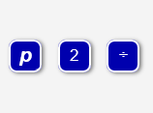
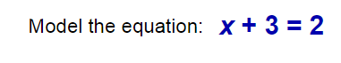
- You should see the equation to the right at the top of the Gizmo.

- To make a sentence that means “x + 3 = 2,” you will need one tile for each number, variable, and sign. How many tiles will you use for this equation?
- You can read x + 3 = 2 from left to right in the same way you read a sentence. What does “x” stand for, in words? Drag that tile into the bottom bin.
- Which two tiles should come next, to mean “+ 3”?
Drag them into the bottom bin.

- Drag two more tiles down, to finish off the “= 2” part of the equation. If a check mark appears, then you are correct. Write the sentence for this equation.

- Switch the first tile and the third tile. The check mark should still indicate that the sentence is correct. Why do you think you can switch these tiles in this equation?

- Drag the “two” tile from last to first. Move another tile until you get another correct sentence. What sentence did you make?

- Click New. You should see the sentence to the right in the Gizmo.

  - The first part of this phrase is “a number.” Which tile represents an unknown number? Drag that tile into the bottom bin.
  - What symbol means “increased by?” Drag that tile into the bottom bin.

  - Keep going until you have an algebraic equation that matches the given phrase. What equation did you make?

- Click New. Work through more problems in the Gizmo. If you need help, click HINT.

(Activity A continued on next page)
Activity A (continued from previous page)

- Write a sentence for each algebraic equation.

  - 22 + r = 10

  - 15 = 14 – b

  - n • 10 = 20

  - 26 ÷ y = 2

  - 18 = 9 • x

  - 2 • 5 + a = 7

  - 9 = 12 + c – 5

- Write an algebraic equation for each sentence.

- a number plus twelve is equal to three

- two is equal to twenty times a number

- sixteen minus a number is equal to ten

- five is equal to thirty divided by a number

- ten increased by a number is equal to twelve

- a number divided by sixteen is equal to eight

- twenty added to a number minus four is equal to seven

Activity B:  Equivalent equations | Get the Gizmo ready:  - Click NEW until the Gizmo gives you an algebraic equation that involves multiplication. | 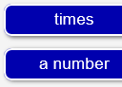

- In the Gizmo, be sure you now have an algebraic equation that involves multiplication.

  - What is the equation?
  - Drag tiles to the bottom bin to make a sentence that is equivalent to this equation. What is your sentence?
  - There is more than one sentence that is equivalent to your equation. For example, the equation n + 5 = 6 is equivalent to all of these sentences:

- a number plus five is equal to six
- five plus a number is equal to six
- six is equal to a number plus five
- six is equal to five plus a number

You’ve already written one sentence above. Adjust the tiles in the Gizmo to make three more sentences equivalent to your equation. What are they?

- Click NEW until the Gizmo gives you an equation that involves subtraction.

- What is the equation?
- Use the Gizmo to make all the equivalent sentences. How many are there?

- What sentences did you make?

- You can write more sentences for equations with addition or multiplication than for equations with subtraction or division. Explain why.

- Write as many sentences as possible for the equation 70 ÷ h = 10.

