Name: Date:

Student Exploration: Using Algebraic Expressions

Vocabulary: expression, variable

Prior Knowledge Questions (Do these BEFORE using the Gizmo.)

- Certain phrases are often shortened in e-mails and text messages by using just the first letter of each word. Write the short form of each of the following phrases.

- For your information
- By the way

- Why do you think people use the shortened form of these phrases?

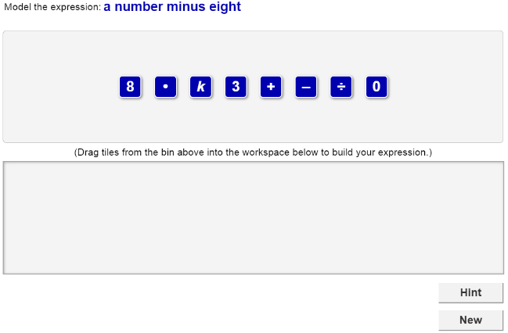
Gizmo Warm-up
In the Using Algebraic Expressions Gizmo, you translate algebraic expressions into English phrases, and vice versa.

An expression is a combination of numbers, variables, and/or operations. An algebraic expression always contains at least one variable – a letter used to represent unknown numbers.

In general, the Gizmo will give you either an algebraic expression or a phrase at the top. Below the expression or phrase is a set of tiles. Your goal is to use the tiles to form a word phrase to match the algebraic expression, or an algebraic expression to match the word phrase.

- Drag a tile with a word representing a number from the top bin and place it in the bottom bin. Look to the left under the bottom bin. What do you see?

- Drag a tile with a word that represents an operation into the bottom bin. Use the little gray arrow to help you place it after the first tile. Then drag the first tile after the second tile.

What happens at the bottom when you change the order of the tiles?

Activity A:  Expressions and phrases | Get the Gizmo ready:  - Click Refresh in your browser.

- You should see the expression to the right at the top of the Gizmo.

- To make a phrase that means “3 + x,” you will need one tile for each number, variable, and sign. How many tiles will you use for this expression?
- You can read “3 + x” from left to right in the same way you read a sentence. Which tile should be first in the word phrase? Drag that tile into the bottom bin.
- Which tile should be next in the word phrase? Drag it into the bottom bin.

- Drag down the tile for what “x” stands for in words. If a check mark appears at the bottom of the screen, the tiles are correct. Write the phrase for this expression.

- Switch the first tile and the third tile. The check mark should still indicate that the phrase is correct. Why do you think you can switch the tiles in this expression?

- Click New. You should see the phrase shown at the right in the Gizmo.

  - The first part of this phrase is “a number.” Which tile represents an unknown number? Drag that tile into the bottom bin.
  - What symbol means “divided by?” Drag that tile into the bottom bin.

  - Keep going until you have an algebraic expression that matches the given phrase. What expression did you make?

- Click New. Work through more problems in the Gizmo. If you need help, click HINT.

(Activity A continued on next page)
Activity A (continued from previous page)

- Write a word phrase for each algebraic expression.

  - t + 15

  - k – 24

  - 18 • m

  - j ÷ 10

  - 9 – x

  - 8 ÷ a – 3

  - 7 + c – 5

- Write an algebraic expression for each word phrase.

- a number minus sixteen

- twelve times a number

- thirteen divided by a number

- a number plus thirty

- five subtracted from a number

- one more than a number

- a number times fifteen divided by five

Activity B:  Equivalent expressions | Get the Gizmo ready:  - Click NEW until the Gizmo gives you an algebraic expression that involves multiplication. | 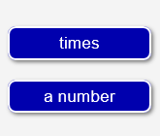

- In the Gizmo, be sure you now have an algebraic expression that involves multiplication.

  - What is the expression?

  - Drag tiles to the bottom bin to make a phrase that is equivalent to this expression. What is your phrase?
  - Adjust the tiles to make a different phrase equivalent to your expression. What phrase did you make?

- Click NEW until the Gizmo gives you a word phrase that involves addition.

- What is the phrase?

- Drag tiles to the bottom bin to make an equivalent expression for this phrase. What is your expression?
- Adjust the tiles to make a different expression equivalent to your phrase. What expression did you make?

- There is only one phrase for an algebraic expression that involves subtraction or division. For example, “4 – p” can be written as “four minus a number” but not “a number minus four.”

Explain why.

- Write two different phrases equivalent to each expression. Use the same words for each pair of phrases, but in a different order.

- 15 • x

- m + 20

- h • 11

- 12 + k

