Name: Date:

**Student Exploration:** **Area of Triangles**

**Vocabulary:** area, height (of a triangle or quadrilateral), parallelogram, triangle

**Prior Knowledge Questions** (Do these BEFORE using the Gizmo.)

1. Jason is laying squares of sod in his backyard, as shown to the right. How many squares has he laid so far? The number of squares is the **area** (number of square units inside) of the rectangle.
2. Jason wants to be able to find the area of the yard without counting all the squares of sod.
3. How many squares are laid along the bottom? Along the left side?
4. How can he use these numbers to find the area?

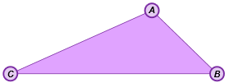

**Gizmo Warm-up**

In the *Area of Triangles* Gizmo, you can manipulate **triangles** like the one shown to the right, and explore how they are related to **parallelograms** (quadrilaterals with two pairs of parallel sides).

1. In the Gizmo, be sure **Triangle** is selected. Then, drag the vertices of the triangle and click **Animate**. In the space to the right, sketch the figures from the Gizmo, before and after the animation.
2. How is the triangle used to make a parallelogram?

1. Turn on **Show base and height**. The length of the vertical segment shown is the **height** of the triangle. Reshape the triangle and click **Animate** again. What seems to always be true about the height of the triangle? (Fill in the blanks below.)

The height comes from one and is to the base.

|  |  |  |
| --- | --- | --- |
| **Activity A:**  **Area of triangles** | Get the Gizmo ready:   * Select **Parallelogram**. * Select **Show base and height**. | 172SE2 |

1. In the Gizmo, drag the vertices to create a parallelogram of your choice. Click **Animate.** Explain why the parallelogram and the rectangle in the animation must have equal areas.

1. In the Gizmo, select **Triangle**. Be sure **Show base and height** is selected. In the Gizmo, create a triangle of your choice. Then click **Animate**.
2. Sketch your “pre-animation” triangle and your “post-animation” parallelogram to the right. Label each figure’s dimensions.
3. How is the area of the triangle related to the area of the parallelogram?

1. If the formula for the area of a parallelogram is *A* = *bh*, what is the formula for the area of a triangle?
2. Find the area of the parallelogram and the area of the triangle you sketched above.

Parallelogram: Triangle:

Turn on **Show area** to check the area of the triangle. Experiment with other triangles to confirm that this is always true.

1. Find the areas of the triangles to the right. Show your work in the space below each triangle. Then check your answers in the Gizmo.
2. 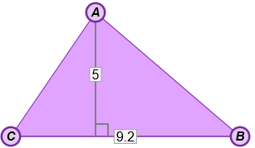
3. 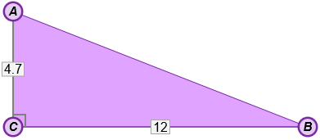

|  |  |  |
| --- | --- | --- |
| **Activity B:**  **Using area of triangles** | Get the Gizmo ready:   * Be sure **Show base and height** is selected. | 172SE5 |

Solve each problem. Show all of your work in the space below each. Then, if possible, check your answers in the Gizmo.

1. 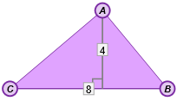Find the area of this triangle.
2. 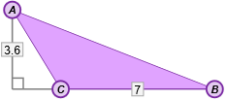What’s the area of this triangle?
3. What is the height of a triangle with an area of 30 m2 and a base of 10 m?
4. Find the total area of this composite shape, made up of a parallelogram joined to a triangle.

**5 ft**

**4 ft**

**6 ft**

**12.5**

**2*x* – 2**

1. Find the value of *x* which makes the area of this triangle 87.5 square units.