Name: Date:

Student Exploration: Arithmetic and
Geometric Sequences

Vocabulary: arithmetic sequence, common difference, common ratio, explicit formula, geometric sequence, sequence

Prior Knowledge Questions (Do these BEFORE using the Gizmo.)
Ms. Lin wrote this list of numbers on the board: 3, 7, 11, 15, 19. She asked her students to come up with two different ways to tell someone how to write this exact list in order (without just listing the numbers). Fill in the blanks with two different sets of instructions that could work.

Gizmo Warm-up
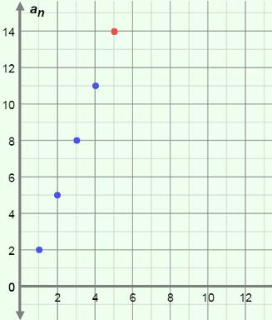
Ms. Lin’s list is an ordered list of numbers, so it is a sequence. In fact, it is an arithmetic sequence because the difference between any two consecutive numbers (terms) is the same. In the Arithmetic and Geometric Sequences Gizmo, you will explore arithmetic and geometric sequences as graphs and lists.

On the ARITHMETIC tab, graph Ms. Lin’s sequence by setting First term (a₁) to 3, Common difference (d) to 4, and n (the number of terms) to 5. (To set a value, either drag the slider, or click the text field, type the new value, and hit Enter.) To see all the points, either click and drag the graph, or click zoom out (–).

- Vary d. How does the graph change?

- Select the TABLE tab above the graph.

- Vary d. How do the values change?

- Vary n. What changes?

Activity A:  Arithmetic sequences | Get the Gizmo ready:  - On the ARITHMETIC tab, set a₁ to 1, d to 2, and n to 5. | 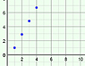

- On the TABLE tab, using the values above, look at the a_{n} (read “a sub n”) column.

  - What are the five terms of this arithmetic sequence?

  - Select the GRAPH tab. Adjust the graph to see all five points. Mouseover the points. What are the coordinates?
  - What does each x- and y-coordinate represent?

x-coordinate: y-coordinate:

The points on the graph of a sequence are called (n, a_{n}) instead of (x, y).

  - Find the following differences. (Note: a₁ means “1st term,” a₂ “2nd term,” and so on.)

a₂ – a₁ = a₃ – a₂ = a₄ – a₃ = a₅ – a₄ =

You should have found that the differences between consecutive terms are all equal. This value (in this case, 2) is the common difference (d) of the arithmetic sequence.

  - Fill in the blanks below to show how many 2’s (d) you can add to a₁ to get each term.

a₂ = a₁ + • 2 a₃ = a₁ + • 2 a₄ = a₁ + • 2 a₅ = a₁ + • 2

  - Use the pattern above to write a general formula for the n^{th} term of an arithmetic sequence (a_{n}), using the first term (a₁) and the common difference (d).

a_{n} = This is called an explicit formula.

- An arithmetic sequence has a first term of 2 and a common difference of 0.5. (Do not graph this sequence in the Gizmo yet.)

- What are the first six terms of this sequence?

- If you were to graph these terms, what would the coordinates of the six points be?

Check this in the Gizmo.

- The points of this graph lie on a line. What is the slope of the line?

Explain why that makes sense.

(Activity A continued on next page)
Activity A (continued from previous page)

- On the previous page, you looked at an arithmetic sequence with a first term of 2, and a common difference of 0.5.

- What is the explicit formula for this arithmetic sequence?

- In the space to the right, simplify the formula you wrote above.

- How does the simplified formula above relate to the graph of this sequence?

- An arithmetic sequence begins with the terms 5, 2, –1, –4, … .

- What is a₁ of the sequence? What is d?

- What are the next three terms of this sequence (a₅, a₆, and a₇)?

- What is the explicit formula for this sequence?

- What is a₁₀? a₁₀ = Check your answer in the Gizmo.

- Write the explicit formula for the arithmetic sequence shown in each graph. Then check your answers in the Gizmo.
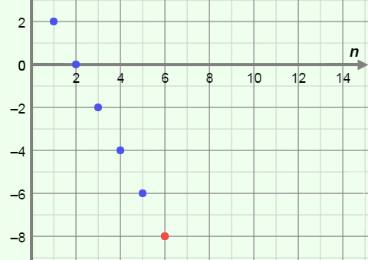
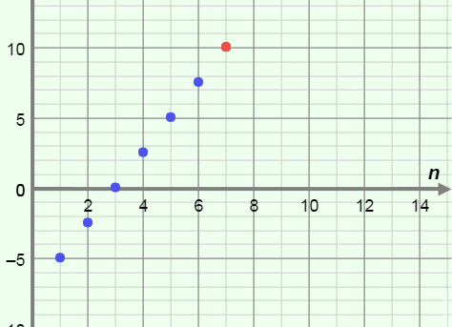

Activity B:  Geometric sequences | Get the Gizmo ready:  - Select the GEOMETRIC and TABLE tabs.  - Set a₁ to 2, r to 3, and n to 5. | 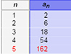

- The values in the a_{n} column of the table are terms of a geometric sequence. In general, the ratio of any two consecutive terms of a geometric sequence is the same.

  - Using the values above, what are the 5 terms of this sequence?

  - How can you tell that this sequence is not an arithmetic sequence?

  - Select the GRAPH tab. Adjust the graph to see all five points. Mouseover the points. What are the coordinates?
  - Find the following ratios. (Note: a₁ means “1st term,” a₂ “2nd term,” and so on.)

a₂ ÷ a₁ = a₃ ÷ a₂ = a₄ ÷ a₃ = a₅ ÷ a₄ =

You should have found that the ratios of consecutive terms are all equal. This value (in this case, 3) is called the common ratio (r) of this geometric sequence.

  - Fill in the blanks with the number you can multiply by the first term, a₁, to get each of the other terms (a₂, a₃, a₄, a₅) in the sequence.

a₂ = a₁ • a₃ = a₁ • a₄ = a₁ • a₅ = a₁ •

  - Rewrite the equations above using 3 (the value of r) raised to an exponent.

a₂ = a₁ • a₃ = a₁ • a₄ = a₁ • a₅ = a₁ •

  - Use the pattern above to write a general formula for the n^{th} term of a geometric sequence (a_{n}), using the first term (a₁) and the common ratio (r).

a_{n} = This is the explicit formula for a geometric sequence.

- A geometric sequence has a first term of 8 and a common ratio of 0.5. (Do not graph this sequence in the Gizmo yet.)

- What are the first six terms of this sequence?

- If you were to graph these terms, what would the coordinates of the six points be?

Check this in the Gizmo.

(Activity B continued on next page)
Activity B (continued from previous page)

- On the previous page, you looked at a geometric sequence with a₁ = 8 and r = 0.5.

- What is the explicit formula for this geometric sequence?

- The points of the graph of this sequence lie on the graph of an exponential function.

Explain why this makes sense.

- Why will the terms in this sequence never reach zero?

- Set a₁ to 3, r to 1, and n to 10. Vary the r slider for values greater than 1.

- Describe the graph from left to right.

- Vary the r slider for values between 0 and 1. How does the graph change?

Why?

- Describe the graph when r is negative.

Why is this?

- Explain why a sequence like 12, 12, 12, 12, … is both arithmetic and geometric.

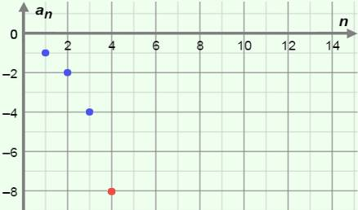
- Write the explicit formula for the geometric sequence shown in the graph to the right.

Then check your answer in the Gizmo.

Activity C:  Practice with sequences | Get the Gizmo ready:  - Select the GRAPH tab. | 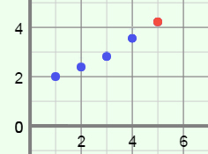

- The graph of a sequence is shown to the right.

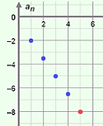
- Is the sequence arithmetic, geometric, or neither?

Why?

Graph the sequence in the Gizmo to check your answer.

- What is the explicit formula for this sequence?

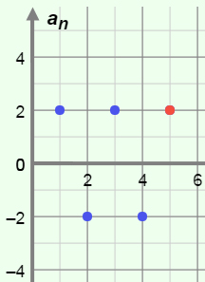
- The graph of a sequence is shown to the right.

- Is the sequence arithmetic, geometric, or neither?
Why?

Check your answer in the Gizmo.

- What is the explicit formula for this sequence?

- A sequence starts –5, 1, … . Answer the questions below, and check answers in the Gizmo.

- What are the next four terms and explicit formula if this sequence is arithmetic?

Next 4 terms: Explicit formula:

- What are the next four terms and explicit formula if this sequence is geometric?

Next 4 terms: Explicit formula:

- Write an explicit formula for each sequence described below. Then check your answers in the Gizmo. (Recall that “d” means “common difference” and “r” means “common ratio.”)

- An arithmetic sequence with d < 0 and a₈ = 0. a_{n} =

- A geometric sequence with r < 0 and a₆ > 0. a_{n} =

- A sequence with all positive terms, approaching zero. a_{n} =

