Name: Date:

Student Exploration: Arithmetic Sequences

Vocabulary: arithmetic sequence, common difference, explicit formula, recursive formula, sequence, term

Prior Knowledge Questions (Do these BEFORE using the Gizmo.)
In 2007, millions of locust cicadas emerged from the ground in parts of the midwestern U.S.

- If the cicadas have a life cycle of 17 years, what are the next three years that the cicadas will appear after 2007?

2007, , ,

- If you consider 2007 to be the first year in the sequence, how many times did you have to add 17 to find the other years?

- To find the second year, you have to take 2007 and add 17 time(s).

- To find the third year, take 2007 and add 17 time(s).

- To find the 50th year, how many times would you have to add 17?

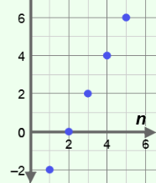
Gizmo Warm-up
A sequence is an ordered list of numbers, called terms. In an arithmetic sequence, like the list of years you made in question 1 above, the difference between consecutive terms is constant. The common difference is the difference between any two consecutive terms in the sequence. In the Arithmetic Sequence Gizmo, you can explore the effects of varying the first term (abbreviated a₁) and the common difference (d) of a sequence on a graph.

To vary the values of a₁ and d, drag the sliders. To enter a specific value, click on the number in the text field, type the value, and hit Enter.

- In the Gizmo, a sequence is graphed. Vary the first term with the a₁ slider. How does this affect the graph?

- Next vary the d slider. As d increases, what happens to the graph?
Activity A:  Explicit formula | Get the Gizmo ready:  - Select the CONTROLS tab.  - Unselect all checkboxes. | 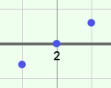

- Before using the Gizmo, consider an arithmetic sequence with a first term (a₁) of 4 and a common difference (d) of 3.

- What are the first five terms of the sequence?

- In the Gizmo, set a₁ = 4 and d = 3. The graph in the Gizmo represents the sequence. Click and drag the graph downward to see more points. What are the first five points on this graph? (Place your cursor over any point to see its coordinates.)

First five points on the graph:

Select the TABLE tab. Each row of this table gives the coordinates of a point on the graph. Check your answers, and then return to the CONTROLS tab.

- The points in the graph of a sequence are called (n, a_{n}) instead of (x, y).

For each point, what does n mean?

What does a_{n} mean?

- What do you think are the coordinates of the 8th point?

Check your answer in the Gizmo, using either the graph or the table.

- Consider the arithmetic sequence with a₁ = –7 and d = 5. (Do not enter it in the Gizmo yet.)

- What are the first five terms of the sequence?

Enter these values in the Gizmo, and check your answers.

- What would you add to the first term to find the 10th term?

Explain.

- What can be added to the first term to find the nth term?

An explicit formula is a rule allowing direct calculation of any term in the sequence. The explicit formula for the nth term of an arithmetic sequence is a_{n} = a₁ + (n – 1)d.

- Turn on Show explicit formula. In the space to the right, use the explicit formula to find a₂₀.
Check your answer in the Gizmo. (Set n = 20.)

(Activity A continued on next page)
Activity A (continued from previous page)

- In the Gizmo, graph the arithmetic sequence with a₁ = 6 and d = –2.

- What are the first five terms?

- How did the negative value of d affect terms of the sequence?

- How did the negative value of d change the graph?

- How would the graph look if d = 0?

Explain.

Use the Gizmo to check your answer.

- Before using the Gizmo, consider the arithmetic sequence with a₁ = 4 and d = 0.5.

- Write the explicit formula for the n^{th} term of the sequence.

- In the space to the right, use the explicit formula to find the value of a₁₅.

Check your answer in the Gizmo.

- An arithmetic sequence has the terms a₆ = 53 and a₈ = 61.

- What is the value of d? What is the value of a₁?

Explain.

- Write the explicit formula for the sequence.

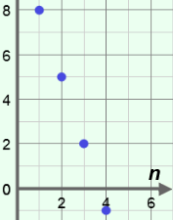
- A sequence is graphed to the right.

- What is a₁? What is d?

- Write the explicit formula for a_{n}.

- In the space to the right, find the value of a₁₅.
Then check your answer in the Gizmo.

Activity B:  Recursive formula | Get the Gizmo ready:  - Be sure the CONTROLS tab is selected.  - Select Show explicit formula. | 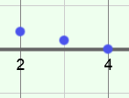

- Consider the arithmetic sequence 3, 7, 11, 15, … (Do not enter it in the Gizmo yet.)

- What is the value of a₁? What is the value of d?

- What are the next three terms of the sequence?

Explain.

- What is the explicit formula for the nth term?

Enter a₁ and d in the Gizmo. Check your answers and make necessary corrections.

- Use the explicit formula to find a_{10.} Show your work in the space to the right.

- In this sequence, the 150th term is 599. What is the 151st term?

Explain.

- If the 150th term is 599, what is the 149th term?

Explain.

- For this sequence, how can you find the nth term, a_{n}, if you know the previous term?

A recursive formula is a rule for finding a term in a sequence based on the previous term. In general, for an arithmetic sequence, the recursive formula is a_{n} = a_{n – 1} + d. That rule plus the value of the first term (a₁) defines the sequence.

- Before using the Gizmo, consider the sequence defined by a₁ = –2 and d = 0.5.

- What are the first four terms of the sequence?

- Write the explicit formula for the sequence.

- Fill in the recursive part of the rule for this sequence: a₁ = –2, a_{n} =

Check your answer in the Gizmo.

(Activity B continued on next page)
Activity B (continued from previous page)

- Suppose you are given this recursive rule for an arithmetic sequence: a_{n} = a_{n – 1} – 7.

- List three different sequences below (first 4 terms only) that satisfy the recursive rule.

- Explain why a recursive rule alone does not define one sequence.

- Before using the Gizmo, consider the recursive formula, a₁ = 7 and a_{n} = a_{n – 1} + 5.

- What are the first four terms of the sequence?

- What is the value of d?

- Write the explicit formula for the sequence.

- In the space to the right, find a₂₅. Then check your answer in the Gizmo. (Set n = 25.)

- Arithmetic sequences can be expressed using an explicit formula or recursive formula.

- Express the arithmetic sequence 5, 2, –1, –4, … using both types of formulas.

Explicit: Recursive:

- What is a₁₀? Check your answer in the Gizmo.

- Which formula did you use? Why?

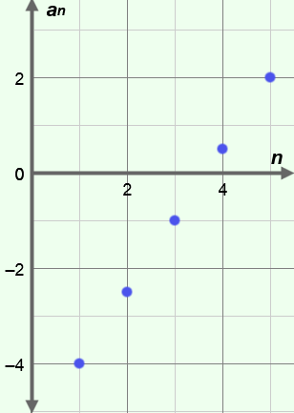
- An arithmetic sequence is graphed to the right.

- What is a₁? What is d?

- Write the recursive formula that defines this sequence.

- Write the explicit formula for a_{n}.

- What is a₁₅?

Check your answers in the Gizmo.

