Name: Date:

Student Exploration: Average Atomic Mass

Vocabulary: average atomic mass, isotope, mass defect, mass number, mass spectrometer, nuclear binding energy, unified atomic mass unit, weighted average

Prior Knowledge Questions (Do these BEFORE using the Gizmo.)

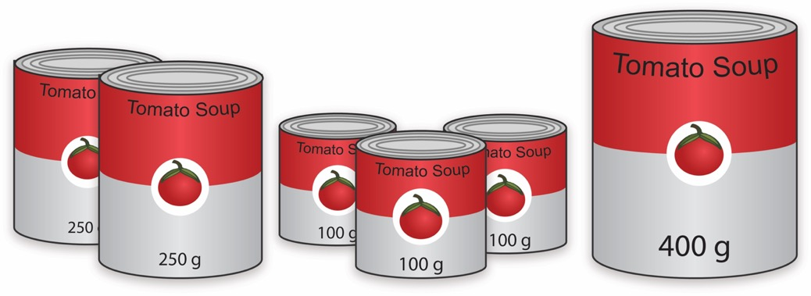
- In the image to the right, the cans of soup have different masses. Without doing the math, estimate the average mass of a can of soup.

Estimate:

- Now calculate the average mass by adding up the masses of all the cans and dividing by the total number of cans.

- What is the average mass of a can of soup?

- How close was your prediction?

Gizmo Warm-up
Just like cans of soup, atoms of the same element often have different masses. These different varieties are called isotopes. In the Average Atomic Mass Gizmo, you will learn how to find the average mass of an element using an instrument called a mass spectrometer.

To begin, check that Carbon is selected and the Isotope mix is Custom. Use the sliders to add about 20 atoms each of Carbon-12 and Carbon-13 to the chamber.

- In the mass spectrometer, atoms are vaporized (turned into a gas) and ionized (stripped of electrons). The charged particles are then shot through a tube surrounded by electromagnets. Click Release atoms and observe the particles as they hit the detector.

- Do the ions travel in a straight path or a curved path?

- Which atoms are deflected the most by the magnetic field?

- What is the relationship between the amount of deflection and the mass of the isotope?

Activity A:  Weighted averages | Get the Gizmo ready:  - Check that Carbon is selected from the drop-down menu and Custom Isotope mix is chosen. | 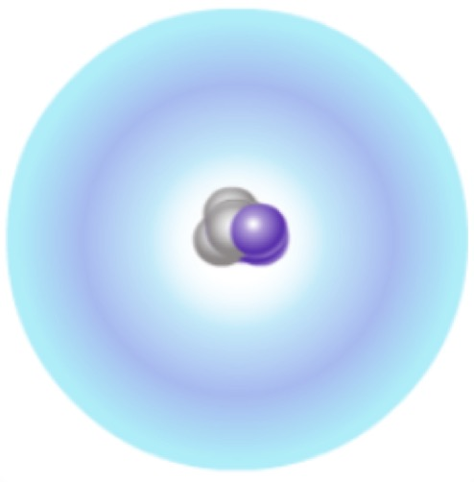

Introduction: Atomic masses are expressed in unified atomic mass units (u), where 1 u is equal to $\frac{1}{12}$ the mass of a C-12 atom.

Question: How do the amounts of each isotope affect the average mass of a mixture of atoms of the same element?

- Compare: The mass number of C-12 is 12, a value representing the total number of protons and neutrons in the nucleus. Since both protons and neutrons have masses that are just over 1 u, the mass number will typically be very close to the atom’s mass. Add a few atoms each of C-12 and C-13 to the chamber, press Release atoms, and then click on the bars of the graph to reveal a close-up image of each isotope.

- How does the proton number in each isotope compare?

- How does the neutron number in each compare?

- What can you conclude about the role of neutrons in forming new isotopes?

- Investigate: Click Start over. Using the sliders, add a single C-12 atom and a single C-13 atom to the chamber. Select Percent for the y-axis and turn on Weighted average. A weighted average still represents the mean, but is calculated by a different method than the “traditional” average you might be familiar with.

- Click Release atoms. What is the average mass of the two atoms?

- What do you think might happen to the average mass if you were to add another
C-12 atom?
- Set the C-12 slider to 1 and release the atoms. What is the average mass?

- Was your prediction correct?

- Experiment by adding differing amounts of each carbon isotope to the chamber. Predict the average mass of each isotope mixture before revealing the weighted average. Based on what you see, fill in the blanks:

When more C-12 atoms are added, the average goes .

When more C-13 atoms are added, the average goes .

(Activity A continued on next page)
Activity A (continued from previous page)

- Calculate: In attempting to find the average mass of an element, it would not be feasible to add up the masses of untold billions of atoms and then divide by the total number of atoms. It is much more practical to consider the percentage of each isotope within a sample, and then calculate a weighted average based on these percentages.

- Turn off Show values and Weighted average. Select Chlorine. Using the sliders, add 17 atoms of Cl-35 and 30 atoms of Cl-37 to the chamber. Calculate the percentage of each by dividing the number of atoms of each isotope by the total number of atoms. Show these values below. (Round to one decimal place.)

Cl-35 percentage: Cl-37 percentage:

- Click Release atoms. Turn on Show values. Were your calculations correct?

- Calculate: To find the weighted average, multiply the percentage of each isotope by its exact atomic mass. (To find the exact masses of the isotopes, click on each bar of the graph to see the pop-up view.) The sum of these products will give you the weighted average, as summarized by the following formula:
Weighted Average = (% Isotope A)·(Mass A) + (% Isotope B)·(Mass B) + . . .

- Using the percentages of each isotope, use the above formula to calculate the weighted average of the chlorine atoms that were added to the chamber. Express percentages as decimals. (For example, 5% = 0.05, 50% = 0.50, etc.) Show work.

Weighted average:

- Turn on Weighted average. Was your answer correct?

- Repeat the above steps with a different atom. Show work below, and use the Gizmo to check your final answer when finished.

Weighted average:

- Compare: To see how weighted averages compare to traditional averages, you can try each method and then compare the results. Find the average mass of 3 atoms of C-12 and 1 atom of C-13 by adding up their masses and dividing by four. Then use the Gizmo to find the weighted average. What do you find?

Activity B:  Average atomic mass | Get the Gizmo ready:  - Select Carbon.  - Choose Natural Isotope mix. | 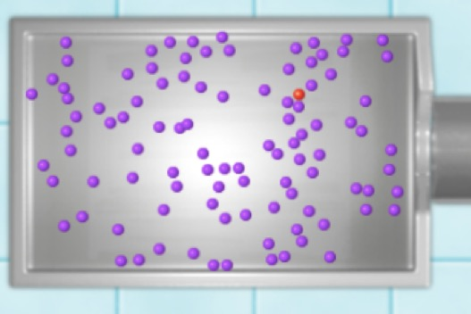

Introduction: The atomic masses you see on the periodic table are average atomic masses. These are weighted averages of an element’s naturally occurring isotopes.

Question: How is the average atomic mass of an element determined?

- Investigate: In this activity, the atoms that appear in the chamber have the same isotope ratio as that found in nature. Turn off Weighted average.

- Click the 100 button. What do you notice about the atoms in the chamber?

- Predict the percentages of C-12 and C-13 atoms in the mixture.

- Estimate the average mass of a carbon atom in the mixture.

- Compare: Click Release atoms. Turn on the Weighted average checkbox.

- How does your prediction compare to the weighted average?

Turn on Show average atomic mass. How does the average atomic mass compare to the weighted average?

- Experiment: Click Start over. Add different numbers of atoms to the chamber, ending with 1 million atoms. Each time, compare the weighted average to the average atomic mass. How does sample size affect how close these values are to one another?

- Calculate: Turn off Show average atomic mass and Weighted average. Turn on Show values. Select Magnesium and release 1 million atoms.

- Observe the percentages on the graph. Calculate the average atomic mass. Make sure you use the exact mass for each isotope as revealed in the pop-up view.

- Turn on Show average atomic mass. How close is your calculated weighted average to the actual average atomic mass of Mg?
(Activity B continued on next page)
Activity B (continued from previous page)

- Estimate: Not only can you estimate an element’s average atomic mass by looking at its isotope ratios, you can also reasonably predict the percentage of an atom’s isotopes given its average mass. Make sure Show average atomic mass is turned on.

- Select Copper, and click 1 million atoms. Based on the average atomic mass, as well as the atoms you see, estimate the percentage of each isotope.

- Press Release atoms. On the graph, observe the percentages of the isotopes. How close were your estimates?
- Repeat with Bromine. Write down your estimates for the percentage of each isotope before revealing them.
- How close were your estimates?

- Apply: Select Lead. Observe the average atomic mass. Note that lead has four isotopes.

- Based on the average atomic mass of lead, which isotope do you think is the most common? Explain your reasoning:

- Release 1 million lead atoms. Was your prediction correct?

- Why is it difficult to accurately predict lead’s most common isotope?

- Infer: Since the periodic table shows the average atomic mass for each element, examining these values can help you to predict the most common isotope of that element.

- For the following elements, the average atomic mass (in u) is given in parentheses. Predict the mass of the most common isotope for each. (Use whole numbers.)

H (1.008) ______ O (15.999) ______ N (14.007) ______

- What can you infer about the likely occurrence of the other isotopes in each of the above elements? Explain your reasoning.

Extension:  Mass defect | Get the Gizmo ready:  - Choose Natural Isotope mix, and select Lead. | 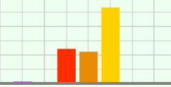

Introduction: Atomic masses in the periodic table are averages, leading to a wide variation of possible values. Although the masses of individual atoms are not averages, their values still appear strange at times—a single atom of Mg-24, for example, has a mass of 23.985 u.

Question: Why is the mass of an atom not equal to the sum of its parts?

- Investigate: A Pb-208 atom contains 82 protons, 82 electrons, and 126 neutrons. The mass of a proton is 1.0073 u, an electron is 0.00055 u, and a neutron is 1.0087 u.

- Based on these numbers, what should the mass of a Pb-208 atom be?

Show your work:

- Add 100 atoms and press Release atoms. Click the bar for Pb-208 to show the pop-up view. What is the exact atomic mass of the Pb-208 isotope?
- How does the actual mass of a Pb-208 atom compare to the total mass of all of the particles that make it up?
- Where do you think the “missing” mass goes?

The difference between the sum of the masses of an atom’s individual particles and its actual mass is known as the mass defect. The “missing mass” is a result of mass changing into energy when the nucleus forms. This conversion of mass into energy is one way to confirm Einstein’s famous equation—E = mc². As a result, an atom is actually lighter than the parts from which it is made!

- Infer: The energy released when the nucleus forms is known as the nuclear binding energy. The nuclear binding energy also represents the amount of energy that must be absorbed to break apart an existing nucleus. A more stable nucleus requires more energy to pry it apart. If it takes more energy to break apart a nucleus, then when that nucleus forms more energy is released. A greater release of energy leads to a greater mass defect. When considering the same element, the greater the mass defect, the more stable the isotope.

The mass defect of each lead isotope is as follows: Pb-204:1.732 u; Pb-206:1.749 u; Pb-207:1.755 u; Pb-208:1.763 u.

Based on this information, which isotope of lead is the most stable?

Explain your reasoning:

