Vocabulary: Average Atomic Mass

Vocabulary

- Average atomic mass – a weighted average of the atomic masses of all the naturally occurring isotopes of an element.
  - All atomic masses listed in the periodic table are average atomic masses.

- Isotope – one of several forms of the same element.
  - All isotopes of a given element have the same number of protons, but a different number of neutrons.
  - An isotope will have the same atomic number but different atomic mass than that of another isotope of the same element.
  - Most elements have more than one naturally occurring isotope.
  - An isotope is written with the symbol followed by the mass. For example, the three isotopes of hydrogen are H-1, H-2 and H-3.

- Mass defect – the difference between the sum of the masses of the particles that make up an atom and an atom’s actual mass.
  - Due to mass defect, an atom is always lighter than the parts from which it is made.

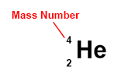
- Mass number – the number of protons plus neutrons in the nucleus of an atom.
  - For example, the mass number of helium is 4 (2 protons and 2 neutrons).
  - In isotope notation (or nuclear notation), the mass number is shown at upper left.

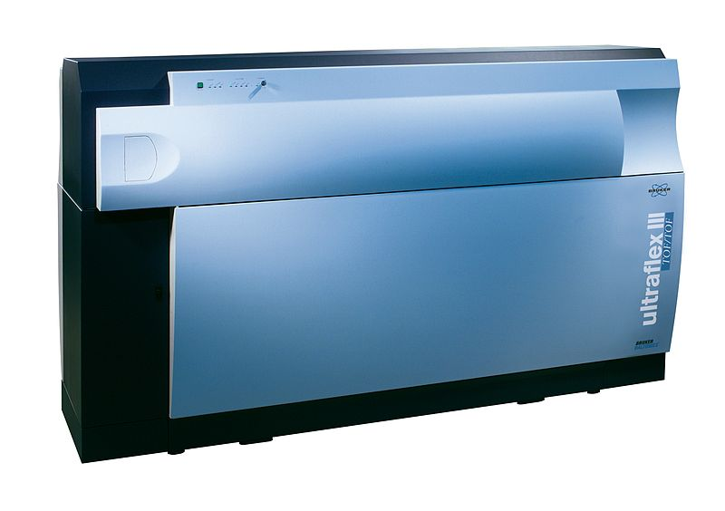
- Mass spectrometer – an analytical instrument that can be used to determine the mass of individual species within a sample.
  - The sample to be analyzed is first ionized. The resulting ions are accelerated through a magnetic field. The amount of deflection a particle undergoes is used to determine its mass.
  - A mass spectrometer can be used to analyze the components of a mixture, compound, or element.

- Nuclear binding energy – the amount of energy required to break apart the nucleus into individual protons and neutrons.
  - The nuclear binding energy also refers to the amount of energy released when the protons and neutrons join to form the nucleus.
  - The nuclear binding energy is produced when mass is converted into energy, as described by the equation E = mc², creating the mass defect.

- Unified atomic mass unit – the unit of atomic and molecular mass.
  - An atomic mass unit is equal to $\frac{1}{12}$ the mass of a C-12 atom.
  - The abbreviation for unified atomic mass unit is u.
  - 1 u = 1.66 x 10^{–24} g.

- Weighted average – an average that is calculated by considering the relative abundance of each component.
  - The average atomic mass of an element is a weighted average.
  - The formula for calculating a weighted average is:
Weighted average = (% of A)·(magnitude of A) + (% of B)·(magnitude of B) + . . .
  - If 90 atoms out of a hundred have a mass of 12.0 u, and the remaining 10 atoms have a mass of 13.0 u, the weighted average would be calculated as follows: (0.9)·(12.0) + (0.1)·(13.0) = 10.8 + 1.3 = 12.1 u.

