Name: Date:

Student Exploration: Balancing Blocks

Vocabulary: area, balance, dimension, prism, product, rectangular prism, volume

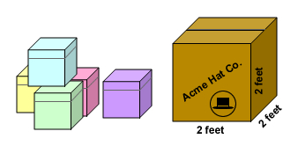
Prior Knowledge Questions (Do these BEFORE using the Gizmo.)

Lucille works at the Acme Hat Factory. Each hat fits in a box that measures 1 foot on each side. Lucille’s job is to put the hat boxes into a larger box that measures 2 feet long, 2 feet wide, and 2 feet tall.

- How many hat boxes will cover the bottom of the larger box? _____________

- How many hat boxes will fit into the larger box, total? _____________

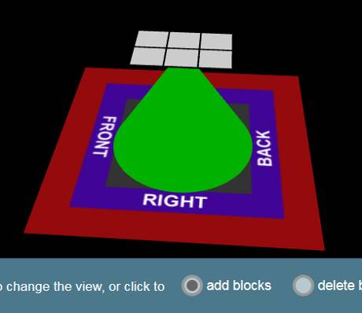
Gizmo Warm-up
The Balancing Blocks Gizmo gives you the challenge of balancing a collection of blocks on the point of a cone. To get started, practice using the Gizmo.
- Change your viewpoint by clicking and dragging the blue mat that the cone sits on.
- Select add blocks at the bottom of the Gizmo and click the model to add blocks. Notice that the model tilts when you add blocks. When the blocks are in balance, the cone turns green.
- Select delete blocks and click the model to remove blocks.

- Next to GOAL, click Show. Can you balance 12 blocks on the 3 × 2 platform? ________ Click Count blocks to check. Then sketch your blocks to the right.

- Under BASE, use the or arrows to set the base dimensions (measurements) to 3 × 3.

Can you balance 12 blocks now? __________ How? ______________________________

_________________________________________________________________________

Activity A:  Volume of small prisms | Get the Gizmo ready:  - Under BLOCKS, click Clear.  - Set the BASE dimensions to 3 × 2.  - Next to GOAL, turn off Show. | 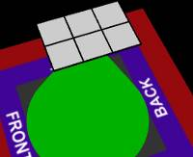

- Look at the 3 × 2 base.

  - How many total squares do you see? _______ This number is the area of the base.

  - What does 3 × 2 equal? ________

  - What do you think is the area of a 5 × 4 base? ________ Check this in the Gizmo.

  - If you know the length and width of a rectangle, how do you find its area? _________

___________________________________________________________________

- Set the BASE dimensions back to 3 × 2. Under BLOCKS, click Stack to stack one layer of blocks. You have created a shape called a rectangular prism, like a box or a brick. A rectangular prism can be described by three dimensions: length (l), width (w), and height (h).

  - What are the dimensions of this rectangular prism? l: _____ w: _____ h: _____

  - The volume (V) of an object is equal to the number of unit blocks that can fit inside. Count the blocks. What is the volume of this rectangular prism? ___________ blocks

- Set Stack to 2 layers. In the spaces below, list the dimensions and volume of the prism.

Length (l): _____ Width (w): _____ Height (h): _____ Volume (V): _____________

- What will the volume be if you stack 5 layers of blocks on the 3 × 2 base? ______________

Use the Gizmo to check your answer.

- Next to GOAL, turn on Show and check that Difficulty 1 is selected. Solve three challenges by building and balancing rectangular prisms with the given volumes. Feel free to change the dimensions of the base. Click New for a new challenge.

Write the volumes and dimensions of each prism below.

Volume (V): ___________ Length (l): _____ Width (w): _____ Height (h): _____

Volume (V): ___________ Length (l): _____ Width (w): _____ Height (h): _____

Volume (V): ___________ Length (l): _____ Width (w): _____ Height (h): _____

Activity B:  Volume of large prisms | Get the Gizmo ready:  - Under BLOCKS, click Clear.  - Set the BASE dimensions to 4 × 5.  - Next to GOAL, turn off the Show checkbox. | 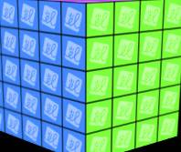

- Look at the 4 × 5 base. What is its area? __________ squares

- Set BLOCKS to 2 Layers to make a rectangular prism of blocks.

      - How many blocks do you have? __________ Click Count to check.

      - What is the product of the dimensions of the prism, 4 × 5 × 2? __________

- Try different combinations of base dimensions and stacked layers. Record the volume of each rectangular prism. For the last two, choose your own dimensions.

Base | Height | Volume (blocks)
4 × 5 | 3
4 × 5 | 4
4 × 5 | 5
2 × 4 | 1
2 × 4 | 2

Base | Height | Volume (blocks)
2 × 4 | 3
2 × 4 | 4
2 × 4 | 5

- Look at your table. In general, how do you calculate the volume of a rectangular prism if you know its length, width, and height? _____________________________________________

- Calculate the volumes of the following rectangular prisms. Use the Gizmo to check answers.

Length (l): 2 Width (w): 3 Height (h): 5 Volume (V): _____________

Length (l): 5 Width (w): 5 Height (h): 3 Volume (V): _____________

- Next to GOAL, turn on Show and check that Difficulty 2 is selected. Solve three challenges by building and balancing rectangular prisms with the given volumes. Write down 3 goal volumes and your solutions.

Volume (V): ___________ Length (l): _____ Width (w): _____ Height (h): _____

Volume (V): ___________ Length (l): _____ Width (w): _____ Height (h): _____

Volume (V): ___________ Length (l): _____ Width (w): _____ Height (h): _____
Activity C:  Odd shapes | Get the Gizmo ready:  - Under BLOCKS, click Clear.  - Set the BASE dimensions to 3 × 2.  - Next to GOAL, turn off the Show checkbox. | 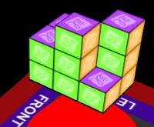
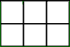

Level 1 Level 2
- On the 3 × 2 base, try to create a balanced stack of 10 blocks that is no more than 2 layers high. On the diagrams at right, color in the blocks you placed on level 1 and level 2.

- On your computer, open a new document in a word-processing program. Add your name and a title, such as “Balanced Blocks.”

- Next to GOAL, turn on Show. Select Difficulty 3. Try at least three challenges. (Feel free to change the dimensions of the base.) When you build and balance each one, click the camera in the upper left corner. Copy the image and then choose Paste in your document.

- Turn off Show. Find at least three different ways to balance 28 blocks. Take a snapshot of each, and paste each one in your document.

- Try to make a balanced stack of 11 blocks on a 2 × 2 base. Can you do it? _____________

Explain. __________________________________________________________________

- For each challenge below, circle “Possible” if it is possible to create a balanced stack, and “Impossible” if it isn’t. If it is possible, paste a snapshot of your solution into your document.

  - 23 blocks on a 5 × 2 base Possible Impossible

  - 16 blocks on a 3 × 3 base Possible Impossible

  - 19 blocks on a 1 × 5 base Possible Impossible

  - 20 blocks on a 2 × 3 base Possible Impossible

- Now make some general rules by stating which are possible and which are impossible.

  - An even number of blocks on a base with an even area: ______________________

  - An even number of blocks on a base with an odd area: _______________________

  - An odd number of blocks on a base with an even area: _______________________

  - An odd number of blocks on a base with an odd area: ________________________

