Name: ______________________________________ Date: ________________________

Student Exploration: Balancing Chemical Equations

Vocabulary: coefficient, combustion, compound, decomposition, double replacement, element, molecule, product, reactant, single replacement, subscript, synthesis

Prior Knowledge Questions (Do these BEFORE using the Gizmo.)
The scouts are making s’mores out of toasted marshmallows, chocolate, and graham crackers.

- What is wrong with the image below? ___________________________________________

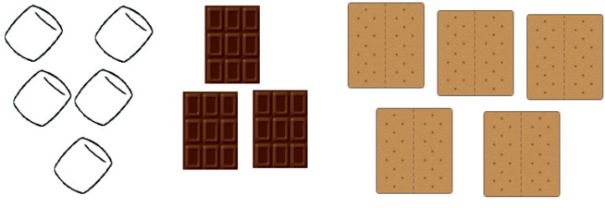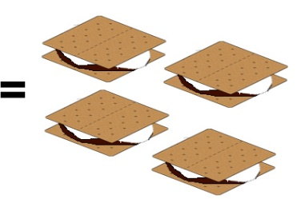

- Assuming a s’more requires two graham crackers, one marshmallow, and one piece of chocolate, how many s’mores could you make with the ingredients shown? _____________

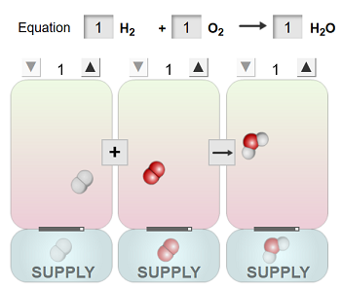
Gizmo Warm-up
In a chemical reaction, reactants interact to form products. This process is summarized by a chemical equation. In the Balancing Chemical Equations Gizmo, look at the floating molecules below the initial reaction: H₂ + O₂ H₂O.

- How many atoms are in a hydrogen molecule (H₂)? ___

- How many atoms are in an oxygen molecule (O₂)? ____

- How many hydrogen and oxygen atoms are in a water molecule (H₂O)? ________________

- In general, what does a subscript (such as the “2” in H₂) tell you about the molecule?

_________________________________________________________________________

- A chemical equation is balanced if the number of each type of atom on the left side is equal to the number of each type on the right side. Is this reaction balanced? ________________
Activity A:  Balancing equations | Get the Gizmo ready:  - Check that the Synthesis reaction is selected and that all coefficients are set to one. (The coefficients are the numbers in the boxes.)

Introduction: The equation H₂ + O₂ H₂O is unbalanced because there are two oxygen atoms on the reactants side of the equation, and only one on the products side of the equation. To balance the equation, you cannot change the structure of any of the molecules, but you can change the number of molecules that are used.

Question: How are chemical equations balanced?

- Balance: Turn on Show histograms. The equation is balanced when there are equal numbers of each type of atom represented on each side of the equation.

In the Gizmo, use the up and down arrows to adjust the numbers of hydrogen, oxygen, and water molecules until the equation is balanced. When you are done, turn on Show summary to check your answer.

Write the balanced equation here: _____ H₂ + _____ O₂ _____ H₂O

- Solve: Turn off Show summary. Use the Choose reaction drop down menu to see other equations, and balance them. Check your answers and then write the balanced equations.

_____ Al + _____ HCl _____ AlCl₃ + _____ H₂

_____ NaCl _____ Na + _____ Cl₂

_____ Na₂S + _____ HCl _____ NaCl + _____ H₂S

_____ CH₄ + _____ O₂ _____ CO₂ + _____ H₂O

- Practice: Balance the following chemical equations. (These equations are not in the Gizmo.)

    - _____ Na + _____ Cl₂ _____ NaCl

    - _____ Na + _____ H₂O _____ NaOH + _____ H₂

    - _____ Mg + _____ O₂ _____ MgO

    - _____ KClO₃ _____ KCl + _____ O₂

    - _____ Al + _____ CuO _____ Al₂O₃ + _____ Cu

    - _____ I₂ + _____ Na₂S₂O₃ _____ NaI + _____ Na₂S₄O₆

    - _____ Mg + _____ P₄ _____ Mg₃P₂

Activity B:  Classifying reactions | Get the Gizmo ready:  - Turn off Show summary and Show histograms.

Introduction: Chemical equations show how compounds and elements react with one another. An element is a substance consisting of one kind of atom, such as aluminum (Al) or oxygen gas (O₂). A compound is a substance made of more than one kind of atom, such as water (H₂O) or table salt (NaCl).

Question: How are chemical reactions classified?

- Match: Most chemical reactions can be classified as one of four types. Using the chemical equations in the Gizmo as a guide, match the following definitions to the type of reaction.

____ One reactant is broken down into two or more products.

____ A fuel combines with oxygen to produce carbon dioxide (CO₂) and water (H₂O).

____ Two or more reactants combine to form one product.

____ Two compounds react to form two different compounds.

____ A compound reacts with an element to form a new compound and a different element.
- Synthesis

- Decomposition

- Single replacement

- Double replacement

- Combustion

- Practice: Balance each of the chemical equations below. (Some equations may already be in balance.) In the space to the right, classify the reaction as a synthesis, decomposition, single replacement, double replacement, or combustion.

- ___ AgNO₃ + ___ KCl ___ AgCl + ___ KNO₃ _______________________

- ___ H₂O + ___ SO₃ ___ H₂SO₄ _______________________

- ___ KI + ___ Cl₂ ___ KCl + ___ I₂ _______________________

- ___ NaHCO₃ ___ Na₂CO₃ + ___ H₂O + ___ CO₂ _______________________

- ___ Zn + ___ HCl ___ ZnCl₂ + ___ H₂ _______________________

- ___ BaCl₂ + ___ Na₂SO₄ ___ BaSO₄ + ___ NaCl _______________________

- ___ C₃H₈ + ___ O₂ ___ CO₂ + ___ H₂O _______________________

- ___ Al + ___ CuCl₂ ___ AlCl₃ + ___ Cu _______________________

