Name: ______________________________________ Date: ________________________

Student Exploration: Basic Prism
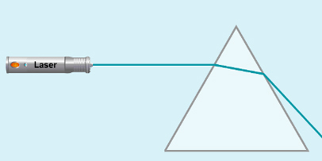

Vocabulary: angle of incidence, angle of refraction, critical angle, dispersion, index of refraction, medium, prism, refract, Snell’s law, total internal reflection, visible spectrum, wavelength

Prior Knowledge Questions (Do these BEFORE using the Gizmo.)
A prism is a transparent object that can be used to bend, or refract, light. The photo below shows what happens when sunlight passes through a prism.

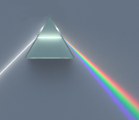
- What do you see? ________________________________

_______________________________________________

- What does this indicate about the composition of sunlight?

_______________________________________________

_______________________________________________

Gizmo Warm-up
The Basic Prism Gizmo allows you to investigate how a prism refracts light. The Gizmo shows a laser emitting a beam of light through a triangular prism.

To begin, check that Single color beam is selected, λ is 500 nm, n is 1.50, w is 2.0, and the angle (θ) is 0°.

- What do you notice about the path of light when it passes through the prism? ___________

_________________________________________________________________________

- Move the λ slider to increase and then to decrease the wavelength of the beam of light.

- How does this affect the color of the light ray? ______________________________

___________________________________________________________________

- How does this affect the direction of the light ray? ___________________________

___________________________________________________________________

Activity A:  Refraction and dispersion | Get the Gizmo ready:  - Set λ to 500 nm and n to 1.00.  - Check that w is 2.0 and θ is 0°. | 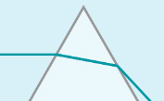

Introduction: When light passes from a vacuum into a medium such as glass, it slows down. The index of refraction (n) is equal to the ratio of the speed of light in a vacuum to the speed of light in a medium. The index of refraction of air is very close to 1.00.

Question: What factors affect the refraction of light through a prism?

- Observe: What do you notice about the beam of light when the n is 1.00? ______________

_________________________________________________________________________

- Predict: How do you think increasing the index of refraction will change the path of the light?

_________________________________________________________________________

- Observe: Slowly increase n to 1.50, close to the value for glass. What happens? ________

_________________________________________________________________________

- Observe: Increase n to 1.53. What happens now? _________________________________

_________________________________________________________________________

In this situation, the light cannot move from the prism into the air. Instead, it reflects off the surface, a phenomenon called total internal reflection.

- Gather data: Set n to 1.50. The Gizmo also allows you to change the width of the prism (w), the angle of the prism (θ), and the wavelength of the light (λ). Describe the effect of each action listed below. Return the Gizmo to its starting conditions after each trial.

Action | Effect on path of light ray exiting the prism
Decrease w to 1.0.
Increase w to 3.0.
Decrease θ to -30°.
Increase θ to 30°.
Decrease λ to 400 nm.
Increase λ to 700 nm.

(Activity A continued on next page)
Activity A (continued from previous page)

- Summarize: Which actions caused the amount of refraction to increase? _______________

_________________________________________________________________________

Which actions caused the amount of refraction to decrease? _________________________

_________________________________________________________________________

- Think and discuss: Why does widening the prism cause the beam to bend more? If possible, discuss your answer with your classmates and teacher.

_________________________________________________________________________

_________________________________________________________________________

_________________________________________________________________________

- Observe: Return the Gizmo to its initial settings (n = 1.50, w = 2.0, θ = 0°). Select White light from the menu at upper left. What happens when white light goes through a prism?

_________________________________________________________________________

_________________________________________________________________________

The band of colors you see is called a visible spectrum. The ability of a prism to separate white light into a spectrum is called dispersion. (Note: The Gizmo shows the spectrum as a collection of individual colored beams rather than a continuous band of color that would be produced by a real prism.)

- Explain: Why is a spectrum of colors produced when white light passes through a prism? (Hint: Think about the effect of the wavelength of light on how much it refracts.)

_________________________________________________________________________

_________________________________________________________________________

_________________________________________________________________________

_________________________________________________________________________

Activity B:  Snell’s law | Get the Gizmo ready:  - Select the Single color beam.  - Check that λ is 500 nm, n is 1.50, w is 2.0,  and θ is 0°.  - Turn on Show protractor. | 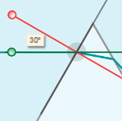

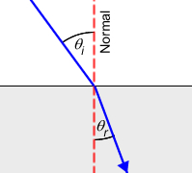
Introduction: When light crosses a boundary from one medium into another, there are several important angles to keep in mind. One is the angle of incidence (θ_{i}), which is the angle between the beam of light and the normal to the boundary. (A normal is an imaginary line that is perpendicular to the boundary.) The other is the angle of refraction (θ_{r}), which is the angle between the refracted beam of light and the normal.

Question: How can the angle of refraction be determined?

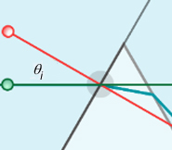
- Measure: To measure the angle of incidence, do the following:
- Drag the center of the protractor (the gray circle) to the junction of the light ray and the prism, as shown.
- The red line is the normal. Rotate the red line so that it is perpendicular to the edge of the prism. (The gray line should be aligned to the edge of the prism.)
- Rotate the green line so that it aligns to the light beam.

What is the angle of incidence for this ray of light? __________

- Measure: To measure the angle of refraction, rotate the green line so that it lines up with the light beam inside the prism.

What is the angle of refraction for this ray of light? __________

- Gather data: The index of refraction of air (n₁) is 1.00, and the index of refraction of the prism (n₂) can vary. For each value of n₂ in the table below, find θ_{i} and θ_{r}.

n₁ | n₂ | θ_{i} | θ_{r} | sine(θ_{i}) | sine(θ_{r}) | n₁ · sine(θ_{i}) | n₂ · sine(θ_{r})
1.00 | 1.50
1.00 | 1.75
1.00 | 2.00

- Calculate: Use a scientific calculator to find the sine of each angle. Then find the product of the sine of each angle and its associated index of refraction to complete the table.

(Activity B continued on next page)
Activity B (continued from previous page)

- Analyze: What do you notice about n₁ · sine(θ_{i}) and n₂ · sine(θ_{r})? _____________________

_________________________________________________________________________

- Manipulate: This relationship is called Snell’s law:

n₁ · sine(θ_{i}) = n₂ · sine(θ_{r})

Rearrange this equation to solve for the angle of refraction (θ_{r}):

θ_{r} =

- Practice: What will the angle of refraction be for a beam of light moving from air into a prism if the angle of incidence is 80° and the prism’s index of refraction is 1.75?

θ_{r} = __________

- Practice: Snell’s law also applies to situations where the beam of light is moving from the prism into air. In this case, n₁ is the index of refraction of the prism and n₂ is the index of refraction of air, or 1.00.

What is the angle of refraction for a beam of light moving from a prism to air if the angle of incidence is 30° and the prism’s index of refraction is 1.6?

θ_{r} = __________

- Challenge: The critical angle is the angle at which total internal reflection occurs. This happens when the angle of refraction exceeds its maximum possible value of 90°. Rearrange Snell’s law to solve for the critical angle. (Hint: Set θ_{r} to 90° and solve for θ_{i}.)

θ_{i} =

- Apply: Find the critical angle for a prism with an index of refraction of 1.50. Check your answer using the Gizmo.

θ_{i} = __________

