Name: Date:

Student Exploration: Big Bang Theory – Hubble’s Law

Vocabulary: absolute brightness, absorption spectrum, apparent brightness, Big Bang theory, blueshift, Cepheid variable, Doppler shift, Hubble constant, Hubble’s law, luminosity, megaparsec, period, redshift, spectrograph

Prior Knowledge Questions (Do these BEFORE using the Gizmo.)
Standing by the side of a lonely highway at night, you see two motorcycle headlights, one in each direction. The headlight on your left appears brighter than the one on your right.

- If the headlights are equally bright, which motorcycle is closer?

Explain:

- Suppose the dim-looking headlight on the right is actually a small light on the front of a bicycle. What can you conclude about the distance of the motorcycle and bicycle?

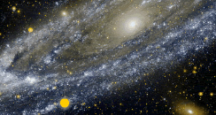
Gizmo Warm-up
In 1912, an astronomer named Henrietta Swan Leavitt studied a class of stars called Cepheid variables. These stars change from bright to dim to bright again. Her discoveries led to a method of measuring distances to other galaxies and eventually helped to support the Big Bang theory of the origin of the universe.

In the Big Bang Theory – Hubble’s Law Gizmo, select Region A. Look at the image of the Andromeda Galaxy, a galaxy relatively close to our own Milky Way galaxy.

- Locate the two Cepheid variables, the stars that change in brightness over time. Star A-091 is the yellow star, and A-171 is the white star.

- Which star reaches a greater apparent brightness?

- Which star takes longer to pulse?

- Because both stars are in the same galaxy, they are about the same distance from Earth. Based on what you see, how is the brightness of the star related to how quickly it pulses?

Activity A:  Period and brightness | Get the Gizmo ready:  - On the STARS tab, check that Region A: NGC 224 (Andromeda Galaxy) is selected. If not, click Return to map and select Region A. | 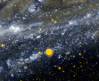

Introduction: Two factors determine how bright a star appears to an observer: its luminosity, or absolute brightness, and its distance from the observer. A star may appear bright because it is a large, luminous star, or because it is very close. It is only possible to use a star’s apparent brightness to determine its distance if you know the star’s luminosity. Henrietta Leavitt’s work on Cepheids provided the key to solving this problem.

Question: How do Cepheids allow astronomers to measure intergalactic distances?

- Collect data: Locate and select the yellow Cepheid variable star (A-091) in the lower left section of the Andromeda Galaxy. Click the Collect data button. You will see a graph of the apparent brightness of the star over time.

- How does the star’s apparent brightness change over time?

- Turn on Show time probes. Set the left probe at the first brightness peak, and the right probe at the second brightness peak. List the time represented by each probe:

Left probe time: Right probe time:

- What is the time difference between the two brightness peaks?

This is the period of the Cepheid.

- In the DATA tab, record the name of this star and its period. Do the same on your paper Data worksheet, located on the last page of this document.

- Collect data: The apparent brightness of the star is shown on the y-axis of the graph. The brightness is given as the ratio of the star’s brightness to the Sun’s brightness if viewed from a standard distance of one megaparsec (1 Mpc), which is about 3.26 million light years. For example, a brightness of “4,000” means that the star appears 4,000 times as bright as the Sun would appear if observed from a distance of 1 Mpc.

- What is your estimate of the mean apparent brightness of star A-091?

- Turn on Show mean brightness. What is the mean brightness of A-091?

Record this value in the Gizmo and on your Data worksheet.

(Activity A continued on next page)
Activity A (continued from previous page)

- Observe: Click Record spectrum. Stars emit light at a variety of wavelengths. Just as white light is separated into a rainbow when it passes through a prism, starlight can be separated into its constituent colors when it passes through an instrument called a spectrograph. The result is a pattern of colors and black bars called an absorption spectrum. The bars represent wavelengths of light that are absorbed in the star’s atmosphere. Each star’s unique spectrum depends on the temperature and composition of its atmosphere.

Look at the spectrum of A-091. Sketch the lines of its stellar spectrum in the diagram below.

- Record: Click Done. Select the other Cepheid variable star in the Andromeda Galaxy (A-171). Determine and record the period, mean brightness, and spectrum of this star. Then, click Return to map and select Region B.

There are a total of ten Cepheids hidden in the nine regions of the Gizmo. Record the period, mean brightness, and spectrum of all ten stars both in the Gizmo data table and on your own data table.

- Compare: By comparing Cepheid variables that were all about the same distance away, Henrietta Leavitt discovered that larger, more luminous Cepheids had longer periods. Look at the periods of the ten stars in your data table.

- Based on the periods of the stars, which three stars are the most luminous?

- Find two stars with similar periods, and therefore similar size. List these stars, their periods, and their mean brightness below.

Star: Period: Mean brightness:

Star: Period: Mean brightness:

- Compare the apparent brightness of these two stars. Which star do you think is farther away? Explain.

Activity B:  Luminosity and distance | Get the Gizmo ready:  - Select the DISTANCE tab.  - Check that Luminosity vs. Period is selected. | 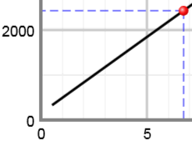

Introduction: Henrietta Leavitt observed Cepheids inside the Small Magellanic Cloud, a star cluster just outside the Milky Way. All of these stars are about the same distance away. Leavitt found that the most luminous Cepheids had the longest periods. By relating each Cepheid’s luminosity to its period, Leavitt discovered a way to find the luminosity of a Cepheid in any galaxy. By comparing the apparent brightness of a Cepheid variable to its known luminosity, the distance to any Cepheid (and its host galaxy) could then be determined.

Goal: Find the mean luminosity and distance of Cepheid stars.

- Collect data: On the DISTANCE tab, check that the Luminosity vs. Period graph is selected. Notice that as the period of a Cepheid variable increases, so does its luminosity. A luminosity of 2,000 Suns means that the star is 2,000 times brighter than the Sun.

- Based on the graph, what is the approximate mean luminosity of a Cepheid variable star with a period of 5 days? 10 days?
- Turn on Show draggable point. Move the point so that its x–coordinate is equal to the period of star A-091. What is the mean luminosity of this star?
Record this value in the data table of the Gizmo and on your own data table.

- Use the draggable point to find the mean luminosity of the other stars. If necessary, use the +/- zoom controls to zoom in or out on the graph. Record your results in the Gizmo and in your own data table.

- Calculate: The distance to a star can be found by comparing its luminosity to its apparent brightness. A star that is far away will be very dim compared to its luminosity, and the ratio of its luminosity to apparent brightness will be greater than for a nearby star.

- Stars B-618 and C-197 have about the same mean brightness. Calculate the “luminosity ratio” of each by dividing its mean luminosity by its mean brightness.

B-618 luminosity ratio: C-197 luminosity ratio:

- Based on these ratios, which star is farther away?

Explain.

(Activity B continued on next page)
Activity B (continued from previous page)

- Infer: Below the data table, click the right arrow once. You should now see a column labeled Luminosity/brightness. The ratio of each star’s luminosity to its brightness has been calculated for you.

Based on these ratios, which stars are closest, and which stars are farthest away?

Closest: Farthest:

Explain:

- Record: On the DISTANCE tab, select Distance vs. Luminosity Ratio. This graph allows you to estimate the distance of each star, measured in megaparsecs (Mpc), based on its luminosity ratio.

- Based on the graph, how does the ratio of a star’s luminosity to its apparent brightness relate to its distance?

- Use the draggable point to find each star’s distance. Record in the Gizmo data table and on your own data table.
Apparent brightness | Distance

- Compare: In the left column at right, list the stars in order of mean apparent brightness, from brightest to dimmest. In the right column, list the actual distances of these stars.

Suppose you estimated the distances of stars based only on their apparent brightness. Based on this group of stars, would this method work well? Explain.

Activity C:  Redshift | Get the Gizmo ready:  - Select the SPECTRA tab.  - On the DATA pane, click the right arrow so the Redshift (z) column is visible. | 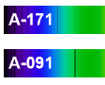

Introduction: Have you ever listened to the siren of an ambulance? As the ambulance passes by, the pitch of its siren gets lower. This occurs because of the Doppler shift. Sound waves are compressed as the ambulance approaches, causing the pitch to be higher. As the ambulance drives away, the sound waves are spread apart, causing the pitch to be lower.

A similar effect occurs if a star or galaxy is moving relative to Earth. When a star approaches Earth, the light waves it emits are compressed, causing its light to be shifted toward the blue end of the spectrum. This is called blueshift. When a star moves away from Earth, its light is shifted toward the red end of the spectrum, a phenomenon called redshift.

Goal: Measure and interpret the redshift of Cepheid variable stars.

- Check: In the bottom half of the Spectra tab, you should see 10 stellar spectra. If you are missing any, go back to the Stars tab, find the missing star, and record its spectrum.

- Observe: You can measure redshift by comparing the wavelength of a black absorption line on the star’s spectrum with an equivalent line on the reference spectrum. Drag the spectrum for star C-197 into the top part of the Spectra tab.

Do you notice any difference in the locations of the absorption lines in the reference spectrum and the spectrum for star C-197? Describe.

- Measure: Drag the probes to equivalent lines in each spectrum. Then, zoom in on the graph by clicking +. Adjust the probes so they are exactly on each absorption line.

- What is the wavelength of the line on the reference spectrum?

- What is the wavelength of the line on star C-197’s spectrum?

- Has the spectral line of star C-197 been shifted to the right (redshift) or to the left (blueshift)?
- Is the galaxy that contains star C-197 moving toward our galaxy (the Milky Way) or away from our galaxy? Explain.

(Activity C continued on next page)
Activity C (continued from previous page)

- Calculate: Redshift (z) is calculated by dividing the wavelength of the observed absorption line (λ_{obs}) by the wavelength of the equivalent reference line (λ_{ref}), and subtracting 1. (If the redshift is negative, the light is blueshifted.)

z =
What is the redshift of star C-197?

Check your answer by turning on the Redshift calculator.

- Record: Repeat the procedure to measure the redshift of each star. Record your answers in the Gizmo and on your data sheet.

Which star has the greatest redshift? Greatest blueshift?

- Infer: The Big Bang theory states that the universe began at a single point, and that the universe is still expanding today.

- Are most stars redshifted or blueshifted?

- What does this tell you about the galaxies that contain these stars?

- How does this relate to the theory that the universe is expanding?

- Analyze: Compare the redshifts you measured to the distances to the various stars.

- In general, what do you observe about the redshifts of stars that are relatively close to Earth?
- What do you notice about the redshifts of stars that are very far away?

Activity D:  Hubble’s law | Get the Gizmo ready:  - Select the HUBBLE’S LAW tab.  - Check that Redshift vs. Distance is selected. | 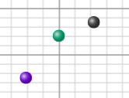

Introduction: Based at the Mount Wilson Observatory near Los Angeles, Edwin Hubble was the first to observe Cepheid variable stars in many “spiral nebulae.” Using the period-luminosity relationship discovered by Henrietta Swan Leavitt, Hubble estimated the distances to these “nebulae” and determined that these objects were located far outside the Milky Way. This confirmed that these “nebulae” were in fact other galaxies much like our own Milky Way.

In 1912 another American astronomer, Vesto Slipher, analyzed spectrographs of galaxies and measured their redshift. Hubble combined Slipher’s redshift data with his measurements of galactic distances to see how the distance to a galaxy was related to its redshift. This became a key piece of evidence that led to the Big Bang Theory.

Question: How is redshift related to distance?
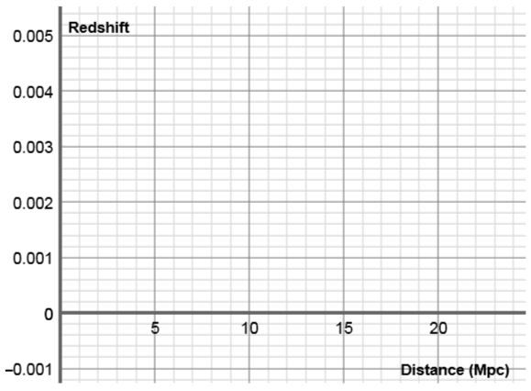
- Graph: At this point, you should have distance and redshift data for all 10 stars in the Gizmo. If not, go back and fill in any missing data.

Below the Redshift vs. Distance graph, you will see a table with the star names and draggable dots. Drag each dot to the graph to create a scatterplot of redshift vs. distance.

Sketch your resulting graph in the grid to the right.

- What pattern do you see?

- What does this pattern indicate about how quickly other galaxies are traveling away from our own galaxy? Explain your reasoning.

(Activity D continued on next page)
Activity D (continued from previous page)

- Interpret: The greater the redshift of a star, the faster it is moving away from our galaxy. Select Velocity vs. distance to see the same data graphed in terms of velocity.

- In general, how does the distance to a galaxy relate to how quickly it appears to be moving away?
This pattern is called Hubble’s law.

- Turn on Show trendline. What is the slope of this trendline?

This value, known as the Hubble constant, describes how recessional velocity is related to distance. The modern value of this constant is about 70 km/s/Mpc.

- How does Hubble’s law provide evidence that the universe is expanding? (Hint: Imagine our galaxy was a dot on a balloon that was covered by other dots. As the balloon expanded, which dots would move away from our dot most quickly?)

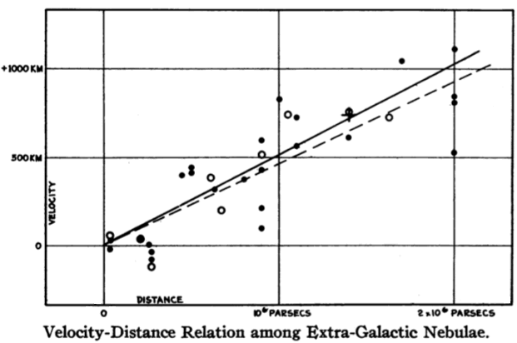

- Draw conclusions: In 1927, a little-known Belgian priest named Georges Lemaître was the first to propose an expanding universe, based on Einstein’s theory of general relativity. Two years later, Edwin Hubble published a scatterplot of recessional velocity vs. galactic distance, shown at right. This was the first observational evidence to support the hypothesis that grew into the Big Bang theory.

Describe how the evidence you have gathered in this Gizmo demonstrates that the universe is expanding and helps to confirm the Big Bang theory.

Name: Date:

Big Bang Theory – Hubble’s Law: Student Data Table

Instructions: As you record data in the Gizmo data table, record the same data here as well. Turn in this table with the rest of the Student Exploration sheet.

Star | Period (Days) | Mean brightness* | Mean luminosity** | Luminosity  Brightness | Distance (Mpc) | Redshift (z)

*Mean brightness is the mean apparent brightness of the Cepheid variable star. This is the ratio of the observed mean brightness of the star to the brightness of the Sun when viewed from a distance of one megaparsec (1 Mpc).

**Mean luminosity is the ratio of the luminosity of the Cepheid variable star to the luminosity of the Sun.

