Name: ______________________________________ Date: ________________________

Student Exploration: Bohr Model: Introduction

Vocabulary: absorption spectrum, Bohr model, electron volt, energy level, laser, orbil, photon

Prior Knowledge Questions (Do these BEFORE using the Gizmo.)
When light passes through a gas, certain wavelengths of the light are absorbed. The result is a unique absorption spectrum. Two examples are shown below.

- What colors of light are absorbed by hydrogen gas? _______________________________

_________________________________________________________________________

- What colors of light are absorbed by helium gas? __________________________________

_________________________________________________________________________

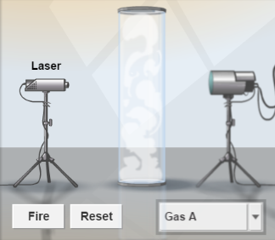
Gizmo Warm-up
In 1913, Niels Bohr proposed that the unique spectral lines created by different elements were related to the way electrons were arranged around the nucleus. The Bohr Model: Introduction Gizmo explores this connection.

The laser shown in the Gizmo can emit photons, or particles of light, at a variety of wavelengths. The energy of a photon, measured in electron volts (eV), is inversely proportional to its wavelength. Photons that pass through the gas are detected by the photon detector at right.

- With the Energy (eV) set to 1 eV, click Fire. Did the photon go straight through the gas in the tube, or was it absorbed by the gas? _________________________________________

- Set the Energy (eV) to 4 eV, and click Fire. What happened this time? ________________
_________________________________________________________________________
Activity A:  Absorption spectra | Get the Gizmo ready:  - On the SIMULATION pane, select Lamp.  - Check that Gas A is selected. | 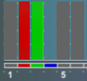

Introduction: The smaller the wavelength of a photon, the greater its energy. We can see photons with wavelengths between 700 nanometers (red) and 400 nanometers (violet), corresponding to energies between 1.8 and 3.1 eV.

Question: What does the absorption spectrum of an element indicate about its electron configuration?

- Record: Click Fire. The lamp emits photons of 1 eV, 2 eV, and so on up to 20 eV. The EL Photon Detector Display shows the photons that pass directly through the gas. Any missing photons were absorbed by the gas before being reemitted at various angles.

Which photon energies were absorbed by Gas A? _________________________________

- Observe: Select the Laser on the left and the ORBITS tab on the right. Set the Energy (eV) to 4 eV. The atom model at right, called the Bohr model, shows the nucleus of the atom as a purple dot. Colored rings surrounding the nucleus represent the orbits that the electron (blue dot) can follow. The variable “n” represents the orbit number.

Click Fire and watch closely. What happens? _____________________________________

_________________________________________________________________________

- Analyze: Click Fire again. This time, focus on the colors of the photons that enter and exit the atom.

    - What color is the incoming 4-eV photon? __________________________________

    - What happens to the electron when the photon is absorbed? ___________________

___________________________________________________________________

    - What color is the emitted photon? ________________________________________

    - What happens to the electron when the photon is emitted? ____________________

___________________________________________________________________

    - If necessary, turn on Show energy of emitted photon(s). What is the energy of the emitted photon? ______________________________________________________
(Activity A continued on next page)
Activity A (continued from previous page)

- Predict: What do you think will happen if you fire a 7-eV photon at the atom of Gas A? How about a 13-eV or a 19-eV photon? _____________________________________________
_________________________________________________________________________

_________________________________________________________________________

- Gather data: Test your predictions with the Gizmo and fill in the table below. (The first row has been filled in for you.)

Photon energy | Effect on electron | Energy of emitted photon(s)
4 eV | Electron moves up to n = 2 and then back down to n = 1. | 4 eV
7 eV
13 eV
19 eV

- Analyze: Find the total energy of each set of emitted photons. How does each sum relate to the energy of the absorbed photon? ____________________________________________
_________________________________________________________________________

- Explore: With the Energy (eV) set to 19 eV, click Fire six times. Record the energy of the emitted photons each time. Record the results of each trial below.

Trial | Energy of emitted photons | Trial | Energy of emitted photons
1 |  | 4
2 |  | 5
3 |  | 6

- Analyze: When an electron moves from a higher orbit to a lower one, does it always follow the same path? Explain. _____________________________________________________
_________________________________________________________________________

Activity B:  Energy levels | Get the Gizmo ready:  - Select the ENERGY LEVELS tab.  - Check that Gas A is selected. | 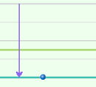

Introduction: When an electron absorbs a photon, it gains energy, causing it to move to a higher orbit. Because each possible orbit is associated with a specific amount of energy, the orbits are known as energy levels. Each element has a unique set of energy levels.

Question: How are energy levels related to absorption spectra?

- Record: By convention, an energy of 0 eV is assigned to the energy level that is infinitely far from the nucleus. As a result, each energy level is assigned a negative energy value. The energy levels for Gas A are shown on the graph. What is the energy of each level?

n = 1: ______ n = 2: ______ n = 3: ______ n = 4: ______ n = 5: ______

- Calculate: How much energy would an electron have to gain to move from n = 1 to n = 4?
_________________________________________________________________________

- Test: Set the Energy (eV) to this level and click Fire. What happened? ________________

_________________________________________________________________________

- Make connections: Recall that Gas A absorbs photons with the following energies: 4 eV,
7 eV, 13 eV, and 19 eV. How do these values relate to the energy level diagram? Test your ideas using the Gizmo.

_________________________________________________________________________

_________________________________________________________________________

_________________________________________________________________________

- Record: Each element has a unique configuration of energy levels. Select Gas B and record the energy of each energy level for this gas.

n = 1: ______ n = 2: ______ n = 3: ______ n = 4: ______ n = 5: ______

- Predict: Based on these energy levels, which photons do you expect Gas B to absorb?

_________________________________________________________________________

(Activity B continued on next page)
Activity B (continued from previous page)

- Test: Select the Lamp and click Fire. Which photons were absorbed by Gas B?

_________________________________________________________________________

- Record: Select Gas C and click Fire. Which photons were absorbed by Gas C?

_________________________________________________________________________

- Apply: Select the Laser. Based on the data you collected, draw an energy levels graph for Gas C. When you have finished, select the ENERGY LEVELS tab to check your answer. Fill in the actual graph on the right. (Hint: In Gas C, the first energy level is -18 eV.)

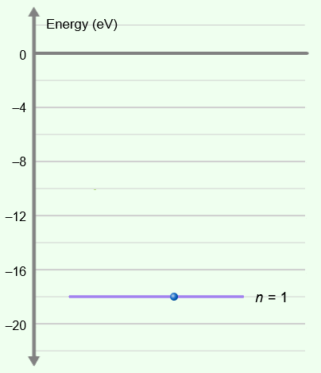

Predicted Actual

- Practice: For Mystery A and Mystery B, you are not given the actual energy level diagram. Use the EL Photon Detector Display to infer the energy level diagrams for each mystery element. (Hint: For each mystery gas, assume the first energy level is -20 eV.)

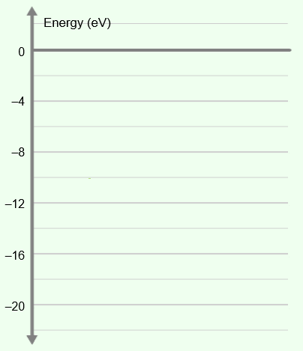

Mystery A Mystery B

