Name: ______________________________________ Date: ________________________

Student Exploration: Building DNA

Vocabulary: double helix, DNA, DNA helicase, DNA polymerase, enzyme, mutation, nitrogenous base, nucleotide, replication

Prior Knowledge Questions (Do these BEFORE using the Gizmo.)
DNA is an incredible molecule that forms the basis of life on Earth. DNA molecules contain instructions for building every living organism on Earth, from the tiniest bacterium to a massive blue whale. DNA also can make copies of itself. This allows living things to grow and reproduce.
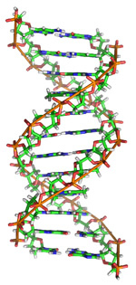
- Look at the DNA molecule shown at right. What does it look like?

This shape is called a double helix.

- Based on this picture, how do you think a DNA molecule makes a copy of itself? (Hint: Look at the bottom two “rungs” of the ladder.)

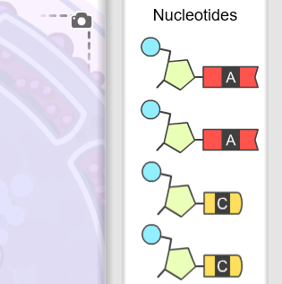
Gizmo Warm-up
The Building DNA Gizmo allows you to construct a DNA molecule and go through the process of DNA replication.

- Look on the right side of the Gizmo. What is the name for the components make up a DNA molecule?

A nucleotide consists of three parts: a phosphate group (blue circle), a sugar called deoxyribose (tan pentagon), and a nitrogenous base (shown in color).

- How many different nitrogenous bases do you see?

The names of these nitrogenous bases are adenine (A), cytosine (C), guanine (G), and thymine (T).

Activity A:  Build a DNA molecule | Get the Gizmo ready:  - If necessary, click Reset to start the building process. | 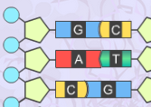

Question: What is the structure of DNA?

- Build: Follow the steps given in the Gizmo to construct a molecule of DNA. (Note: For simplicity, this DNA molecule is shown in two dimensions, without the twist.)

Stop when the hint reads: “The DNA molecule is complete.” In the spaces at right, list the sequence of nitrogenous bases on the left-hand side of the DNA molecule and the right-hand side.

- Take a picture: Click the camera () to take a snapshot of your DNA molecule. Right-click the image and select Copy Image. Paste the image into a blank document, and label this image “Original DNA molecule.”

Left side Right side

- Explain: Describe the structure of the DNA molecule you made.

    - What makes up the sides of the DNA molecule?

    - What makes up the “rungs” of the DNA molecule?

- Fill in: Write the name of the nitrogenous base that joins to each of the bases below:

Adenine (A) joins to Thymine (T) joins to

Cytosine (C) joins to Guanine (G) joins to
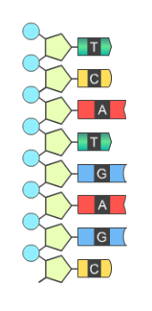

- Practice: The left side of a DNA molecule is shown. Draw a complementary right side of the molecule.

- Challenge: This DNA strand consists of eight pairs of nitrogenous bases. How many different sequences of eight bases can you make? Explain how you found your answer.

Activity B:  DNA replication | Get the Gizmo ready:  - Be sure the hint reads: “The DNA molecule is complete.” If not, click Reset and build a new DNA molecule. | 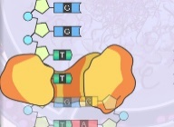

Question: How does DNA make a copy of itself?

- Observe: An enzyme is a protein that facilitates certain cell processes. Drag the blue DNA helicase enzyme onto the DNA strand. What does this enzyme do to the DNA molecule?

- Observe: Drag the yellow DNA polymerase molecule onto the DNA strand. DNA polymerase adds complementary nucleotides to create new double-stranded DNA molecules. Notice two groups of nucleotides on the right.

- Drag the correct nucleotide to the bottom of the left strand, where the DNA polymerase is located. What happens?
- Continue adding nucleotides to both strands. What happens to the DNA polymerase molecule each time you add a nucleotide?
- Complete the two DNA molecules. How do these molecules compare to each other?

- Compare: Click the camera to take a snapshot of the DNA molecules, then paste the image into your document. Label this image “Daughter DNA molecules.”

How do these molecules compare to the original?

Congratulations! You have completed the process of replication, where one “parent” DNA strand divides to form two identical “daughter” DNA strands.

- Think and discuss: Why is DNA replication such an important process?

- Extend your thinking: Sometimes errors called mutations occur during DNA replication. What are some of the possible consequences of mutations?

_________________________________________________________________________

_________________________________________________________________________

