Name: ______________________________________ Date: ________________________

Student Exploration: Building Topographic Maps

Vocabulary: contour interval, contour line, elevation, profile, relief, topographic map

Prior Knowledge Questions (Do these BEFORE using the Gizmo.)
The image below shows part of Lake Mead, the largest reservoir in the United States. Notice the band of white sediments above the water line. This band is known as the “bathtub ring.”

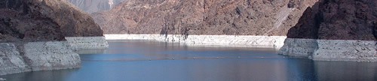

- How do you think the bathtub ring formed? _______________________________________

_________________________________________________________________________

- What do you notice about the boundary between the white sediment and dark rock above?

_________________________________________________________________________

Gizmo Warm-up
Due to gravity, the surface of a lake always forms a horizontal plane, with every point the same elevation above sea level. The shore of a lake thus forms a contour line, or a line of equal elevation. The Building Topographic Maps Gizmo allows you to create a topographic map by tracing the shore of a lake.

- Observe the 3D view of the landscape. On the blank map at right, mark where you think the highest point is located.

- Slowly increase the Water level (m). What do you see?

_____________________________________________

_____________________________________________

- About how high is the highest point on the map? ______

Activity:  Make a map | Get the Gizmo ready:  - Click New.  - Set the Water level to 0 m. | 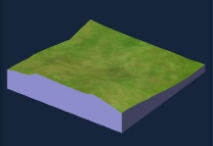

Goal: Use water to create a topographic map.

- Observe: Slowly raise the Water level from 0 m to 1000 m. Observe how the appearance of the landscape changes. What happens to mountains as the water level rises?

_________________________________________________________________________

- Calculate: The relief of a landscape is equal to the elevation difference between the highest and lowest points of the landscape. Use the Water level slider to measure the elevation of the lowest point and the highest point in the landscape.

    - What is the elevation of the lowest point in the landscape? ____________________

    - What is the elevation of the highest point in the landscape? ____________________

    - What is the relief of this landscape? ____________________

- Create: Set the Water level to 900 m. (Note: You can enter a number directly into the box to the right of the slider.) Click Draw Contour to insert a contour line at this water level. Decrease the water level and draw other contours at 800 m, 700 m, 600 m, and so on until no water remains on the landscape.

When your topographic map is complete, click the Tools menu and select Screen shot. Right click the image, select Copy Image, and then paste the image into a blank document that you will turn in with this sheet. Label the map “Topographic map 1.”

The contour interval of a map is the elevation difference between successive contour lines.

What is the contour interval of your map? ____________________

- Create: Click Reset. Using the same landscape, create a new map with a contour interval of 50 meters. Take a screenshot of this map and add it to your document. Label this map “Topographic map 2.”

    - How is this map different from the first map? _______________________________

    - What is an advantage of using a smaller contour interval? _____________________

___________________________________________________________________

    - What is a possible disadvantage of using a smaller contour interval? _____________

___________________________________________________________________

Extension:  Make a profile | Get the Gizmo ready:  - Click New.  - Set the Water level to 0 m. | 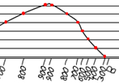

Introduction: A profile is a side view of a landscape, showing elevation changes along a given path. Profiles are used by mountaineers to plot ascents, by athletes planning long races, and by geologists creating cross-sections of rock structure. To make a profile, follow the steps below.

Goal: Create a profile of a topographic map.

- Step 1: Create a topographic map with a contour interval of 100 m. Take a screenshot of the map and paste it into the worksheet on the last page of this document. Then print out the worksheet. You will create your profile on this worksheet.

- Step 2: Draw two points on opposite sides of the map, and connect them with a line segment. Try to choose a line segment that crosses many contour lines. Label the endpoints of the line segment A and B.

- Step 3: Place a piece of scrap paper over your map and align it to segment AB as shown below. Mark the endpoints on the scrap paper. Then, make a tick mark on the scrap paper at every contour line, as shown. Write the elevation next to each tick mark.
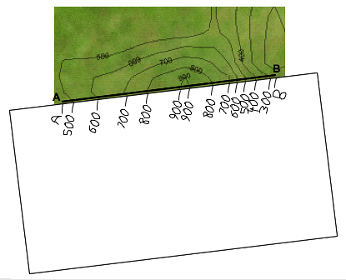

(Extension continued on next page)
Extension (continued from previous page)

- Step 4: Place the scrap paper on the 900-m line of the graph so the A endpoint is lined up with the y-axis, as shown below. Plot any 900-m points on the line.
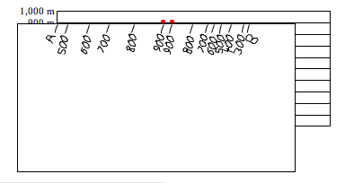

- Step 5: Repeat for the other elevations marked on the scrap paper. Make sure that for each elevation, endpoint A is always lined up with the y-axis.

- Step 6: The last step is to connect the dots on the graph with a smooth line as shown below. Now you have a profile of the landscape! To check your profile, choose the Horizontal view on the Gizmo and rotate the image to match your profile.
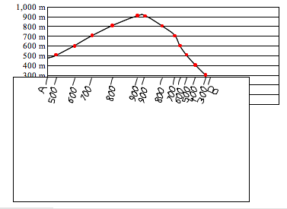
Name: ______________________________________ Date: ________________________

Extension Worksheet: Make a Profile

Paste your map image here, and then print this page out:

Create your profile on this graph:

After you have done your profile, label the steepest and most gentle slopes.

Apply: How would a profile help a hiker to plan his trek? _______________________________

____________________________________________________________________________

____________________________________________________________________________

____________________________________________________________________________

