Vocabulary: Carbon Cycle

Vocabulary

- Atmosphere – the gases that surround a planet.
  - Earth’s atmosphere consists of nitrogen (78%), oxygen (21%), argon (1%), and smaller amounts of other gases, including carbon dioxide and methane.
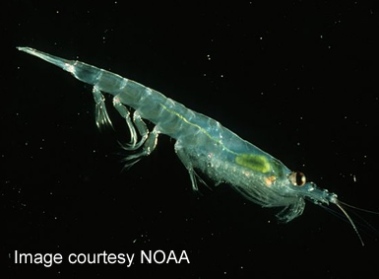
Antarctic krill
- Biomass – the total mass of a group of living things.
  - The animal species with the greatest biomass may be Antarctic krill, a small, shrimp-like organism.
    - The biomass of Antarctic krill is about 500 million metric tons. (One metric ton is equal to 1,000 kg, or 2,205 lbs.)

- Biosphere – living things on a planet.
  - Earth’s biosphere contains plants, animals, fungi, protists, and bacteria.

- Carbon reservoir – a part of Earth that stores carbon.
  - Examples of carbon reservoirs include the atmosphere, the ocean, soils, sediments, and the biosphere.

- Carbon sink – a carbon reservoir that absorbs carbon from the atmosphere and stores it for a long period of time.

- Fossil fuel – a fuel formed over thousands or millions of years from the remains of living organisms.
  - Fossil fuels include coal, natural gas, and petroleum (oil).

- Geosphere – the rocky, non-living parts of a planet.
  - Earth’s geosphere contains rocks, sediments, and soil.

- Greenhouse gas – a gas in Earth’s atmosphere that absorbs and then re-radiates heat.
  - Examples of greenhouse gases include carbon dioxide and methane.

- Hydrosphere – the water on a planet.
  - About 97% of Earth’s water is found in oceans. The rest is found in glaciers, groundwater, lakes, and rivers.

- Lithosphere – the rigid upper layer of the Earth.
  - The lithosphere consists of the crust and the upper part of the mantle.

- Photosynthesis – a process in which plants use energy from light to change carbon dioxide and water into glucose (sugar) and oxygen.

