Vocabulary: Cat and Mouse (Modeling with Linear Systems)

dictionary2

**Vocabulary**

* 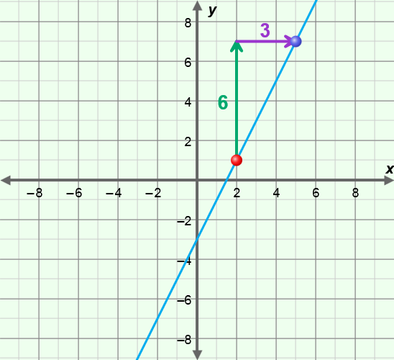Slope – a measure of the steepness of a line.
  + For two points on a line, (*x*1, *y*1) and (*x*2, *y*2), slope is defined as:

slope =  =  = .

* + For example, the slope of the line through the points (2, 1) and (5, 7) as shown to the right is:

 =  = 2.

* + Slope is a measure of the rate of change of a quantity. The greater the slope, the faster the *y*-value is changing, with respect to *x*.
* *y*-intercept – the *y*-coordinate of a point where a graph intersects the *y*-axis.
  + In general, the *y*-intercept is the value of *y* when *x* = 0.