Name: ______________________________________ Date: ________________________

Student Exploration: Cell Structure

Vocabulary: cell membrane, cell wall, capsule, centriole, chloroplast, cytoplasm, cytoskeleton, endoplasmic reticulum, flagellum, Golgi apparatus, lysosome, mitochondria, nucleoid, nuclear membrane, nucleolus, nucleus, organelle, pilus, plasmid, plastid, ribosome, vacuole, vesicle

Prior Knowledge Questions (Do these BEFORE using the Gizmo.)

- What do you think are some of the structures inside a cell that help it to live and perform its role in an organism?

- How do you think plant cells differ from animal cells? (Hint: What can plants do that animals cannot?)

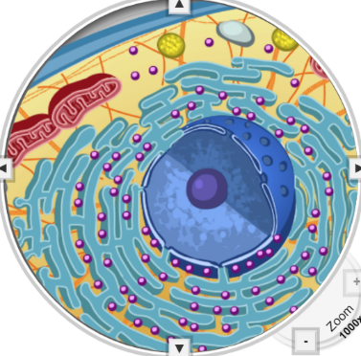

Gizmo Warm-up
The Cell Structure Gizmo allows you to look at typical animal, plant, and bacterial cells under a microscope. On the ANIMAL CELL tab, click Sample to take a sample of an animal cell. On the dropdown menu, select Centriole.

- Find the centrioles (Highlighted in green). Make a sketch of the centrioles in the space below.

- Read the description of the centrioles. What is their function?

Activity A:  Animal cells | Get the Gizmo ready:  - Check that an Animal cell is mounted on the microscope. | 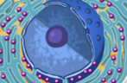

Question: Organelles are specialized structures that perform various functions in the cell. What are the functions of the organelles in an animal cell?

- Label: Locate each organelle in the animal cell. You can choose organelles from the dropdown menu or click on them directly. Label the organelles in the diagram below.

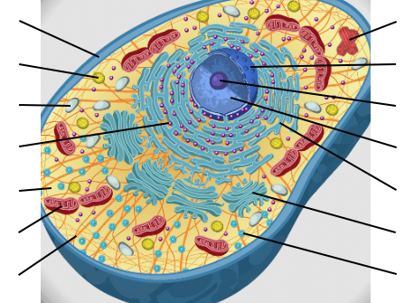

- Match: Read about each organelle. Then match each organelle to its function/description.

Cytoplasm
Lysosome
Mitochondria
Centriole
Endoplasmic reticulum
Vacuole
Cell membrane
Nucleus
Cytoskeleton
Ribosome
Nuclear membrane
Golgi apparatus
Vesicle
Nucleolus
- Structure that organizes motion of chromosomes.
- Stack of membranes that packages chemicals.
- Membrane that surrounds and protects the nucleus.
- Membrane that surrounds and protects the cell.
- Sac filled with digestive chemicals.
- Structures that convert nutrients to energy.
- Passageways where chemicals are made.
- Everything between the nuclear membrane and the cell membrane.
- Structure that manufactures ribosomes.
- Structure that contains DNA and regulates genes.
- Package created by the Golgi apparatus.
- Small structure that synthesizes proteins.
- Sac that stores water, nutrients, or waste products.
- Tubules and filaments that give the cell its shape.

(Activity A continued on next page)
Activity A (continued from previous page)

- Investigate: Select the Cell membrane. Turn on Show closeup. Read the description, watch the animation, and answer the following questions below.

  - What kind of molecules can diffuse (go through) the cell membrane directly?

  - How can some large molecules and charged ions get through the cell membrane?

- Investigate: Select the Nuclear membrane closeup. How is the nuclear membrane similar to the cell membrane?

- Investigate: Select the Mitochondrion closeup. What happens inside the mitochondrion?

- Investigate: Select the Ribosome closeup. How does the cell make proteins inside the ribosome?

- Investigate: Select the Vesicle closeup. How do vesicles move through the cell?

Activity B:  Plant cells | Get the Gizmo ready:  - Select the PLANT CELL tab, and click Sample.

Question: What functions do the organelles in a plant cell perform?

- Label: Locate each organelle in the plant cell. Label the organelles in the diagram below.

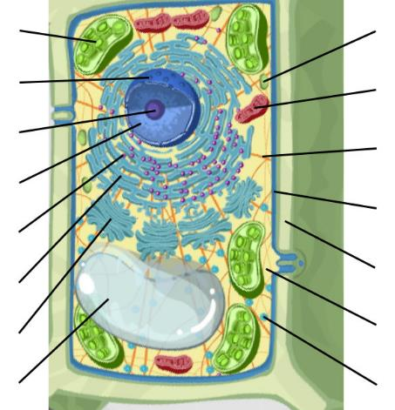

- Compare: What structures are present in an animal cell, but not in a plant cell?

What structures are present in a plant cell, but not in an animal cell?

- Fill in: Name the organelle or organelles that perform each of the following functions.

  - convert sunlight to chemical energy.

  - The , the , and the support the plant cell and help it to maintain its shape.
  - store food or pigments.

  - convert food into energy. They are found in plant and animal cells.
Activity C:  Bacterial cells | Get the Gizmo ready:  - Select the BACTERIAL CELL tab and click Sample. | 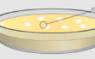

Question: How are bacterial cells different from plant and animal cells?

- Label: Locate each organelle in the bacterial cell. Label the organelles in the diagram below.

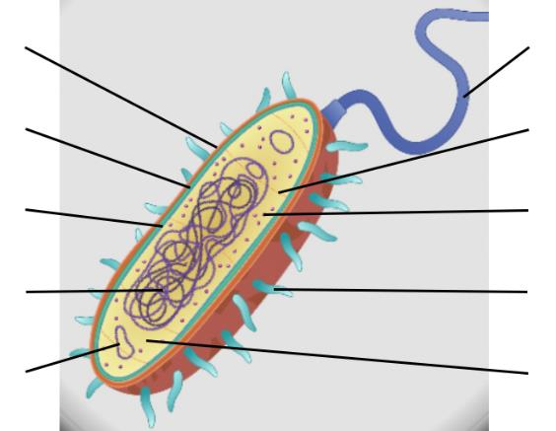

- Match: Read about each organelle. Then match each organelle to its function/description.

Capsule
Nucleoid
Plasmid
Flagellum
Pilus
- Hair-like structure that the cell uses for movement.
- Hair-like structure that attaches the cell to a surface and can transfer genetic material from one cell to another.
- Region inside cell that contains genetic material but is not surrounded by a nuclear membrane.
- Outermost layer of the cell that provides protection.
- Circular piece of genetic material.

- Compare: What structures are present in a bacterial cell, but not in a plant or animal cell?

What structures are present in plant and animal cells, but not in a bacterial cell?

What structures inside plant and animal cells look like bacteria?

Chloroplasts and mitochondria have their own DNA. Long ago, these structures may have originated as bacteria that were engulfed (eaten) by larger cells.

