Name: ______________________________________ Date: ________________________

Student Exploration: Center of Mass

Vocabulary: center of mass, mean, weighted mean

Prior Knowledge Questions (Do these BEFORE using the Gizmo.)
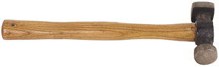
- The head of this hammer is made of steel. The handle is made of wood, which is much less dense than steel. Suppose you wanted to balance the hammer on your finger. Draw an arrow to indicate where you would balance the hammer on your finger.

- Explain why you chose to draw an arrow where you did: ____________________________

_________________________________________________________________________
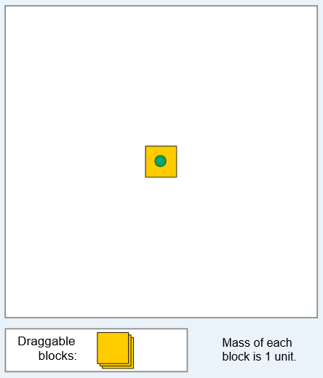
Gizmo Warm-up
Suppose you tried to balance a hammer by placing your finger halfway down the handle. The hammer would fall because the head is much heavier than the rest of the hammer. Instead, you would have to place your finger near the head to balance the hammer perfectly. The point where an object balances is called its center of mass.

You can use the Center of Mass Gizmo to explore how changing the distribution and masses of objects in a system affects the total system’s center of mass. On the SIMULATION pane, drag a single block into the white square. Turn on Show center of mass and Show mass of each region. The center of mass is marked by a green circle.

- Relative to the block, where is the center of mass? Is it where you expect it to be? ________
_________________________________________________________________________

_________________________________________________________________________

- Drag a second block a short distance away from the first. Where is the center of mass now?

_________________________________________________________________________

Activity A:  Observing center of mass | Get the Gizmo ready:  - Make sure two blocks are set in the large white square on the SIMULATION pane. | 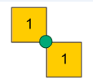

Goal: Observe how changing the distribution of mass in a set of objects affects the center of mass.

- Observe: Drag one of the blocks further away from the other block and then closer together. How does this affect the center of mass? ________________________________________
_________________________________________________________________________

- Explore: Drag a third block on top of one of the first two blocks.

    - How does this affect the position of the center of mass? ______________________

___________________________________________________________________

    - If the white area of the SIMULATION pane were a tray, where would you put your hand to pick it up? ____________________________________________________

- Observe: Set a third block on top of the stack of two blocks. Drag the single block close to and then away from the stack of three blocks. Observe how the center of mass changes.

- How did the position of the single block affect the location of the center of mass? ___________________________________________________________________
- In each case, which object was closer to the center of mass, the stack of three blocks or the single block? ______________________________________________

- Apply: Suppose a heavy person and a light person sat on opposite ends of a see-saw. If they wanted the see-saw to be balanced, which person would need to sit closer to the fulcrum (the see-saw’s pivot point)? Explain your answer.

_________________________________________________________________________

_________________________________________________________________________

_________________________________________________________________________

(Activity A continued on next page)
Activity A (continued from previous page)

- Predict: Select Square from the Predefined shapes dropdown menu. Turn on Show mass of each region. Click on the POINTER tray at the bottom of the Gizmo, and drag an arrow to where you think the center of mass on the square is located.

- Observe: Turn on Show center of mass. How close was your prediction to the actual location of the square’s center of mass? _________________________________________

- Predict: Select each of the objects listed below from the dropdown menu. Place an arrow where you think the center of mass will be. Then turn on Show center of mass to check your prediction.

In the spaces below, place a check mark if the tip your arrow is touching part of the green circle. Place an “X” if the tip of the arrow does not touch the green circle.

Right Triangle: __________ Hollow Rectangle: __________

“L” shape: __________ Weighted Bar: __________

Disjointed shapes: __________

- Compare: Look at your predictions for each shape.

- Which shapes were easiest to predict the center of mass? Why do you think they were easiest? ________________________________________________________
- Which shapes were hardest to predict the center of mass? Why do you think they were hardest? _______________________________________________________
___________________________________________________________________

- Observe: Select the Weighted Bar again from the dropdown menu. Turn on Show mass of each region.

- How is the weighted bar like a hammer? ___________________________________
- Why was it hard to guess the center of mass for this object? ___________________
___________________________________________________________________

Activity B:  Calculating center of mass | Get the Gizmo ready:  - Click Clear and drag all arrows back to the POINTER tray.  - Turn on Show grid. | 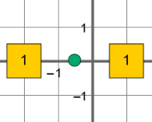

Question: How can you calculate the center of mass of a set of objects?

- Observe: Drag one block to the coordinates (-2, 0) and a second block to (4, 0). (Note: The coordinates of a block are displayed when you drag the block over the grid or hold your mouse over the block.)

- Based on the coordinates of each block, where would you expect the center of mass to be? ______________________________________________________________
- Turn on Show center of mass and Show (x, y) values of center of mass. Where is the actual center of mass? ____________________________________________

- Calculate: The mean of a set of numbers is found by dividing the sum by the number of pieces of data. Finding the sum of a negative and positive number is the same as subtracting the negative number from the positive number. For example, 4 + (-1) = 4 – 1 = 3.

- What is the mean of the x coordinates of each block? ________________
- How does this relate to the x coordinate of the center of mass? _________________

- Calculate: Turn off Show center of mass and Show (x, y) values of center of mass. Drag a third block to (4, 3).

- What is the mean of the x coordinates of each block? ________________________
- What is the mean of the y coordinates of each block? ________________________
- Turn on Show center of mass and Show (x, y) values of center of mass. Did the center of mass coordinates match the mean x and y values? ___________________

- Draw conclusions: Turn on Show mass of each region. Drag a second block to (4, 3).

- What are the new coordinates for the center of mass? ________________________
- What caused the location of the center of mass to change? ____________________
___________________________________________________________________
(Activity B continued on next page)
Activity B (continued from previous page)

- Calculate: If a set of objects have different masses, you cannot simply find the mean of the coordinates to locate the center of mass. Instead, you must find the weighted mean. To find the x coordinate of the center of mass (x_{CM}) for a set of n blocks, use the following equation:

In this equation, x_{i} is the x coordinate of each block and m_{i} is the mass of each block.

- Use this equation to determine the x coordinate for the center of mass for the following objects: three blocks at (-2, -2), one block at (1, 2), and two blocks at (3, 4).

x coordinate for center of mass: ___________________

- Use the same equation to determine the y coordinate for the center of mass.
y coordinate for center of mass: ___________________

Use the Gizmo to check your answers.

- Test: Turn off Show center of mass and Show (x, y) values of center of mass.
- Choose Weighted bar from the Predefined shapes menu. Calculate the x, y coordinates of its center of mass: __________ Use the Gizmo to check your answer.
- Choose Disjointed shapes from the Predefined shapes menu. Calculate the x, y coordinates of its center of mass: __________ Use the Gizmo to check your answer.

- Apply: Consider how you use the center of mass to balance objects. Can you think of a reason it would be important for engineers to know how to calculate the location of the center of mass for an object or set of objects?

_________________________________________________________________________

_________________________________________________________________________

_________________________________________________________________________

_________________________________________________________________________

