Vocabulary: Chords and Arcs

dictionary2

**Vocabulary**

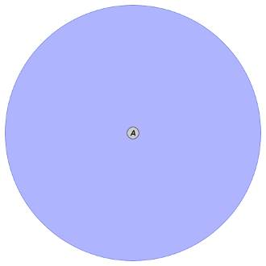

***D***

***E***

***C***

***B***

* Arc – a part of a circle between two points on the circle.
* For example, $\overset{⏜}{\text{BC}}$ is an arc of the circle shown to the right.
* Central angle – an angle with a vertex at the center of a circle.
* For example, ∠*BAC* is a central angle of the circle shown to the right.
* Chord – a segment whose endpoints lie on a circle.
* For example,  is a chord of the circle shown above.
* Circle – the set of all points that are the same distance from a given point.
* A circle is named by its center.
* For example, circle *A* is shown above.