Name: Date:

**Student Exploration: Circles**

**Vocabulary:** circle, conic section, distance formula, Pythagorean Theorem, radius,   
standard form of the equation of a circle

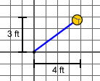

**Prior Knowledge Questions** (Do these BEFORE using the Gizmo.)

The school playground is being renovated. For safety, a yellow border is being painted around the tetherball area.

1. With its rope extended, the tetherball touches a point 4 feet east and 3 feet north of the pole, as shown in the image to the right.

What is the length of the rope? (Use the **Pythagorean Theorem**.)

1. The safety border is marked by extending the ball away from the pole in all directions.
2. What is the shape of this border?
3. What is true about the distance between every point on the border and the pole?

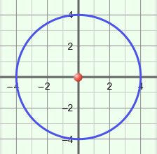**Gizmo Warm-up**

In the *Circles* Gizmo, you can explore **circles** in the coordinate plane. A circle is a **conic section** because it is formed when a plane intersects a cone. The **standard form of the equation of a circle** is (*x* – *h*)2 *+* (*y – k*)2= *r*2.

You can vary the values of ***h***, ***k***, and ***r*** by dragging the corresponding sliders. (To quickly set a slider to a specific value, type the value in the text box to the right of the slider, and hit **Enter**.)

1. Check that ***h*** and ***k*** are set to 0. Drag the ***r*** slider back and forth. How does changing *r* affect the circle?
2. Set ***r***to 4. Drag the ***h*** and ***k*** sliders back and forth.
3. How does changing *h* affect the circle?
4. How does changing *k* affect the circle?

|  |  |  |
| --- | --- | --- |
| **Activity A:**  **Circles centered at the origin** | Get the Gizmo ready:   * Be sure the **CONTROLS** tab is selected. * Set ***r***to 5, ***h***to 0, and ***k***to 0. | 127SE2 |

1. Select **Explore geometric definition**. Drag the purple point around.
2. What is true about every point on the blue circle?

1. Can the purple point be dragged off of the blue circle? Why or why not?

1. 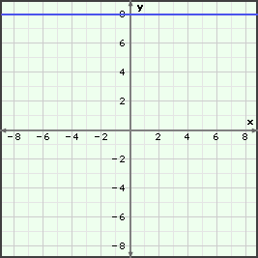Drag the purple point to the coordinates (3, 4).
2. Sketch the circle on the grid to the right. Label the point (3, 4) and the **radius**, *r* = 5.
3. Sketch a right triangle with vertices at (0, 0), (3, 4), and (3, 0).
4. Using the Pythagorean Theorem, write an equation relating the radius, *r* = 5, to the point (3, 4).

1. Write a general equation for any (*x, y*) point on this circle.
2. Compare your equation to the equation of the circle in the blue box in the Gizmo.

What do you notice?

1. Write an equation to generalize the relationship for any (*x*, *y*) point on a circle centered at (0, 0) with a radius of *r*.
2. Write an equation for the circle in the graph to the right.

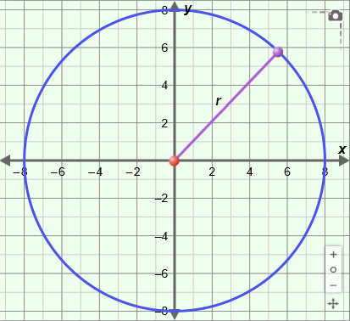

***r* = 8**

Graph your equation in the Gizmo to check.

|  |  |  |
| --- | --- | --- |
| **Activity B:**  **Translating a circle** | Get the Gizmo ready:   * Be sure the **CONTROLS** tab is selected. * Set ***r*** to 4, ***h*** to 2, and ***k*** to 3. | 127SE6 |

1. Place the cursor over the center of the circle so you can see its coordinates.
   1. What are the coordinates of the center of the circle? ( , )
   2. How do these coordinates relate to the values of *h* and *k*?

Try other values of *h* and *k* to confirm this is always true.

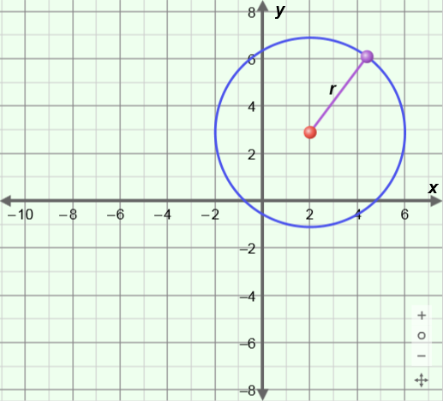

**(2, 3)**

**(*x*, *y*)**

1. With ***r*** set to 4, set ***h*** back to 2 and ***k*** to 3. Consider a general point (*x*, *y*) on the circle, as shown to the right.
   1. What is the horizontal distance between (*x*, *y*) and the center of the circle at (2, 3)?
   2. What is the vertical distance between (*x*, *y*) and the center of the circle at (2, 3)?
   3. On the graph above, draw a right triangle with the distance, *r*, from (*x*, *y*) to (2, 3) as the hypotenuse, and the horizontal and vertical distances as the legs. Then use the Pythagorean Theorem to write an equation relating the side lengths of this triangle.

* 1. How does your formula compare to the equation in the blue box in the Gizmo?

* 1. Based on what you have found, write a general equation for a circle with radius *r* and center located at (*h*, *k*). Check your answer at the top of the Gizmo.

* 1. The **distance formula** finds the distance between two points. The distance between the points (*x*1, *y*1) and (*x*2, *y*2) is given by the formula *d* = .

How does the distance formula compare to your equation above?

**(Activity B continued on next page)**

**Activity B (continued from previous page)**

1. Consider a circle with the equation (*x* – 1)2 + (*y* – 6)2 = 32. What are the center and radius of this circle? Center: ( , ) and *r* = Confirm in the Gizmo.
2. 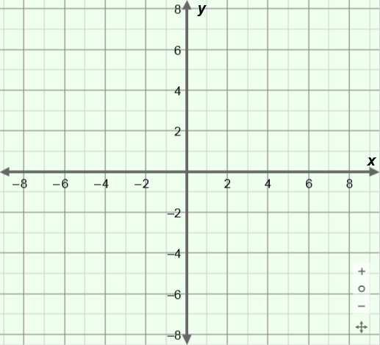Consider a circle with center (–4, –2) and a radius of 4 units.
3. Write the equation of the circle.

1. Sketch the circle on the coordinate plane. Plot at least four points on the circle. (Hint: You can use the points on the circle in the horizontal and vertical directions from the center.) Label the center, *C*.
2. Verify your equation and sketch in the Gizmo. Make necessary corrections.
3. Explain the significance of a sign change on *h* or *k* in the equation of a circle.

1. Determine the center and radius of the circle with the equation (*x* – 3)2 + (*y* + 6)2 = 49.

Center: ( , ) and *r* = Confirm in the Gizmo.

1. Set ***r*** to 7, ***h*** to –1, and ***k*** to 6. Using the **TABLE** tab, find *y* when *x* = 4.

Why are there two possibilities for *y*?

1. Consider the equation (*x* + 4)2 + (*y* – 8)2 = 25.

Find the *two* values of *y* when *x* = –7. Show your work in the space to the right.

*y* = or

Confirm *both* answers using the **TABLE** tab in the Gizmo.

|  |  |  |
| --- | --- | --- |
| **Activity C:**  **Real-world applications** | Get the Gizmo ready:   * Select the **CONTROLS** tab. | 127SE5 |

1. The only cell phone tower centered in a remote country town has a range of 6.5 miles. Tessa drives past the tower going east. After 5 miles, she turns north and drives for another 4 miles to her destination. Tessa needs to phone her mother to let her know she has arrived.
2. What is the distance from Tessa to the tower?

Show your work in the space to the right.

1. Can Tessa call her mom from this location?
2. Challenge: How much further north can Tessa travel before she is out of the range of the tower? (Hint: You can use the **TABLE** tab of the Gizmo to find the answer.)

1. A Navy helicopter departs from the aircraft carrier. The helicopter travels 7 nautical miles due south. It then receives instructions to travel 4.5 nautical miles west. When reaching its location, the helicopter hovers and lowers its sonar to search for submarines. This sonar has a range of 5 nautical miles.
2. Write an equation for the air boss on the aircraft carrier to determine the region of the ocean that is currently being scanned for submarines. (The carrier position is considered the origin.)

1. Based on the graph in the Gizmo, is the location of the carrier within the range of the sonar? Explain.

1. A submarine is 9 miles directly south of the carrier. Will the helicopter sonar detect this submarine? Why or why not?

Use the table and graph in the Gizmo to justify your answer.