Vocabulary: Circumference and Area of Circles

dictionary2

**Vocabulary**



**5**

**3**

* Area – the number of square units inside a plane figure.
* For example, the area of the figure to the right is 15 square units.
* Circle – the set of all points the same distance from a given point.
* 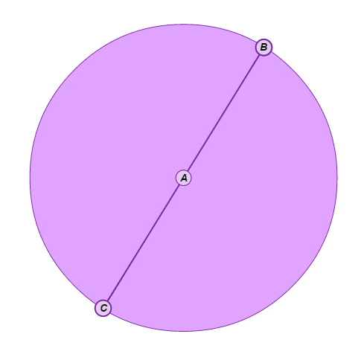A circle is named by its center.
* For example, circle *A* is shown to the right.
* Circumference – the distance around a circle.
* Diameter – a line segment that passes through the center of the circle and has endpoints on the circle.
* The diameter of the circle shown to the right is .
* Perimeter – the distance around a plane figure.
* For example, the perimeter of the rectangle shown above is 16 units.
* Pi (*π*) – the ratio of the circumference of a circle to its diameter.
* The value of *π* is 3.14159…, or approximately 3.14.
* Radius – a line segment with one endpoint at the center of a circle and the other endpoint on the circle.
* A radius of the circle shown above is .
* The length of a radius is half the length of a diameter of the same circle.