Vocabulary: City Tour (Coordinates)

Vocabulary

- Coordinates – a set of numbers that describe where something is located.

- Horizontal axis – a number line going from west to east (left to right).
  - The horizontal axis measures position east or west (right or left) of the origin.
  - The horizontal axis is also called the x-axis.

- Ordered pair – the coordinates of a point in the form (x, y).
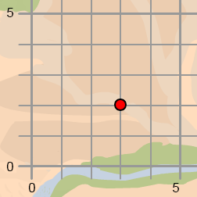
  - The first number in an ordered pair tells you how far the point is east or west (right or left) of the origin. This is also called the x-coordinate.
  - The second number in an ordered pair tells you how far the point is north or south of (above or below) the origin. This is also called the
y-coordinate.
  - In the example to the right, the coordinates of the red point are (3, 2). The point is 3 units to the right (east) of the origin, and 2 units above (north of) the origin.

- Origin – the point on a graph where the horizontal axis and the vertical axis intersect.
  - At the origin, the coordinates are (0, 0).

- Vertical axis – a number line going from north to south (up and down).
  - The vertical axis measures position north or south of the origin.
  - The vertical axis is also called the y-axis.

