Vocabulary: Classifying Triangles

Vocabulary
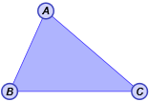
- Acute – having a measure greater than 0° and less than 90°.
- An acute triangle has three acute angles.
- For example, ΔABC, shown to the right, is acute.
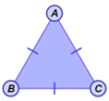
- Equilateral – having all sides congruent.
- An equilateral triangle has three congruent sides.
- For example, ΔABC, shown to the right, is equilateral.

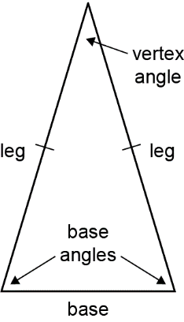
- Isosceles – having at least two sides congruent.
- The legs of an isosceles triangle are the congruent sides.
- The base of an isosceles triangle is the side that is not congruent to the other two sides.
- The base angles of an isosceles triangle are adjacent to the base.
- The vertex angle of an isosceles triangle is the angle opposite the base.

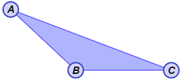
- Obtuse – having a measure greater than 90° and less than 180°.
- An obtuse triangle has one obtuse angle.
- For example, ΔABC, shown to the right, is obtuse.

- Right – having a measure equal to 90°.
leg
leg
hypotenuse
- A right triangle has one right angle.
- The legs of a right triangle are adjacent to the right angle.
- The hypotenuse of a right triangle is the side opposite the right angle.
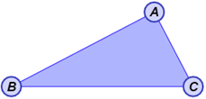
- Scalene – having three sides that are different lengths.
- For example, ΔABC, shown to the right, is scalene.

