Name: ______________________________________ Date: ________________________

Student Exploration: Coastal Winds and Clouds

Vocabulary: condensation, convection, convection current, land breeze, sea breeze

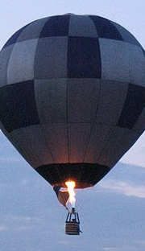
Prior Knowledge Questions (Do these BEFORE using the Gizmo.)
A hot-air balloon contains a propane burner that directs hot air into the interior of the balloon. You can see the flames in the photo at left.

- What happens when the air inside the balloon is heated? ___________

_________________________________________________________

- What might happen if the burner was turned off? __________________

_________________________________________________________

Gizmo Warm-up
Have you ever taken a walk along an ocean beach and noticed a refreshing breeze blowing in from the water? The cause of this breeze, called a sea breeze, is related to the reason that a hot-air balloon is able to fly high in the sky. The Coastal Winds and Clouds Gizmo allows you to explore how daily temperature variations are related to sea breezes and other weather phenomena.

Click Play (), and watch the Gizmo for 24 simulated hours, focusing on the sailboat.

- Click Pause () when the sailboat starts moving towards the shore. This represents the start of the sea breeze. What time is it? _________________________

- Click Play, and then click Pause when the sailboat starts moving out to sea again. This represents the start of the land breeze. What time is it now? _________________________

- Click Play, and now observe the clouds for a day. What do you notice? ________________

_________________________________________________________________________

_________________________________________________________________________

Activity A:  Temperature and wind | Get the Gizmo ready:  - Click Reset ().  - Turn on the Weather probe.

Question: How is wind speed and direction related to air temperature?

- Think about it: Imagine a pocket of air over the land (“land air”), and another pocket of air over the ocean (“ocean air”).

    - Which air pocket would you expect to heat up more during the day? _____________

Why? ______________________________________________________________

    - Which air pocket would you expect to cool down more at night? ________________

Why? ______________________________________________________________

- Gather data: Check that the time is 6:00 a.m. Drag the Weather probe so that it is on the ocean’s surface (Alt. 0 ft) on the left side of the Gizmo, and record the air temperature. Then, repeat with the probe on the land on the right side of the Gizmo.

Finally, move the probe to the land-sea boundary and record the type of breeze (sea or land breeze) and wind speed. Record data for each time listed in the table below. (Note: Stopping the simulation at the exact time is not necessary, just get close.)

Time | Ocean air temperature (°F) | Land air temperature (°F) | Sea breeze or land breeze? | Wind speed (mph)
6:00 a.m.
9:00 a.m.
12:00 p.m.
3:00 p.m.
6:00 p.m.
9:00 p.m.
12:00 a.m.
3:00 a.m.

- Calculate: For both the ocean air temperature column and land air temperature column, find the temperature range by subtracting the lowest temperature from the highest.

  - How much does the temperature over the ocean change in one day? ____________

  - How much does the temperature over the land change in one day? ____________

(Activity A continued on next page)
Activity A (continued from previous page)

- Analyze: Compare the air temperatures to the breezes.

  - At 6:00 a.m., where was the warmest air? __________________________________

  - At 6:00 a.m., in which direction did the breeze blow? _________________________

  - At 3:00 p.m., where was the warmest air? __________________________________

  - At 3:00 p.m., in which direction did the breeze blow? _________________________

- Summarize: What is always true when there is a land breeze? _______________________

_________________________________________________________________________

What is always true when there is a sea breeze? __________________________________

_________________________________________________________________________

- Draw conclusions: In general, the land changes temperature much more rapidly than the ocean. How does this fact explain the existence of land breezes and sea breezes?

_________________________________________________________________________

_________________________________________________________________________

- Extend your thinking: With the probe placed on the land-sea boundary, monitor the wind speed. Click Pause when the strength of the sea breeze is at a maximum.

  - At what time of day is the sea breeze strongest? ____________________________

  - Use the Weather probe to measure the land-air and ocean-air temperatures. What are these temperatures at this time? ______________________________________
  - Click Play, and then click Pause when the strength of the land breeze is at a maximum. What is the time? ____________________________________________
  - What are the land- and ocean-air temperatures now? ________________________
  - The wind changes direction at approximately 9:10 a.m. and 12:10 a.m. What is true about each of these times? _____________________________________________
___________________________________________________________________

Activity B:  Convection currents | Get the Gizmo ready:  - Click Reset.  - Turn on the Drifting balloon.

Question: Why do land breezes and sea breezes occur?

- Observe: Click Play, and observe the balloon for a period of 48 hours. Pause the simulation whenever the balloon changes direction. Describe what you see in the space below.

_________________________________________________________________________

_________________________________________________________________________

_________________________________________________________________________

- Analyze: During what time period does the balloon drift in a clockwise direction? _________

_________________________________________________________________________

During what time period does the balloon drift in a counterclockwise direction? __________

_________________________________________________________________________

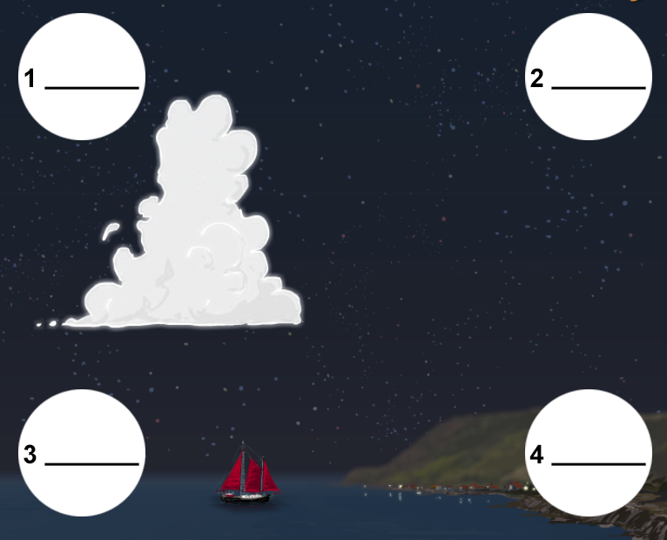
- Gather data: The diagram at right shows the scene at 6:00 a.m. Use the Weather probe to find and label the temperature at each of the numbered locations.

Next, find the wind direction between the points on the diagram. Draw arrows to represent the movement of air.

Which points represent the lowest and highest temperatures on the diagram?

Lowest: _________ Highest: _________

- Analyze: In which direction is the hottest air in the diagram moving? ___________________

In which direction is the coldest air in the diagram moving? ___________________

This pattern—in which low-density, hot air rises while high-density, cold air sinks—is an example of convection. The resulting circular flow of air is called a convection current.

(Activity B continued on next page)
Activity B (continued from previous page)
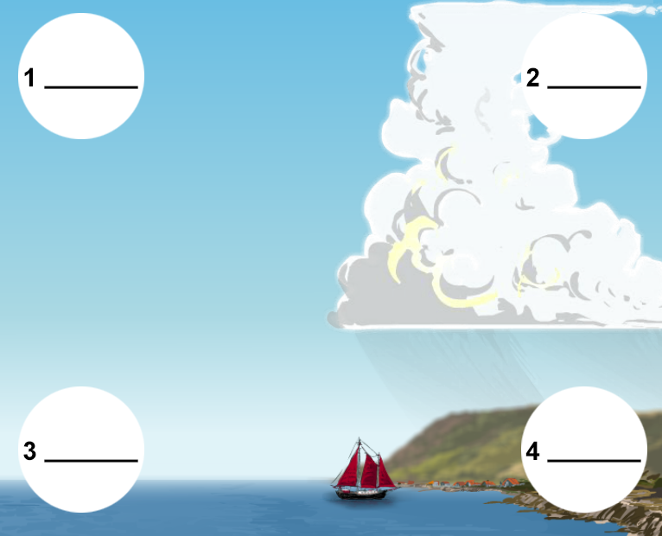
- Gather data: Click Play, and then click Pause at 3:00 p.m. Use the Weather probe to find and label the temperature at each of the numbered locations.

Find the wind direction between the points as you did before. Draw arrows to represent the movement of air.

Which points represent the lowest and highest temperatures on the diagram?

Lowest: _________ Highest: _________

- Analyze: In which direction is the hottest air in the diagram moving? ___________________

In which direction is the coldest air in the diagram moving? ___________________

- Explain: What causes the counterclockwise flow of air in the afternoon? ________________

_________________________________________________________________________

_________________________________________________________________________

- Observe: Place the Weather probe at the land-sea boundary, and click Pause when the sea breeze is strongest.

- What do you notice in the sky at this time? _________________________________

- Click Play, and then pause the simulation when the land breeze is strongest. What do you notice in the sky now? ___________________________________________

- Explain: Clouds often form when a large mass of warm, moist air rises quickly and cools, resulting in condensation of the water vapor.

Based on this statement, why do clouds tend to form around 3:00 p.m. and 6:00 a.m.?

_________________________________________________________________________

_________________________________________________________________________

_________________________________________________________________________

_________________________________________________________________________

