Name: ______________________________________ Date: ________________________

Student Exploration: Collision Theory

Vocabulary: activated complex, catalyst, chemical reaction, concentration, enzyme, half-life, molecule, product, reactant, surface area

Prior Knowledge Questions (Do these BEFORE using the Gizmo.)

- Suppose you added a spoonful of sugar to hot water and another to ice-cold water. Which type of water will cause the sugar to dissolve more quickly? _________________________

- Suppose you held a lighted match to a solid hunk of wood and another match to a pile of wood shavings. Which form of wood will catch fire more easily? ______________________

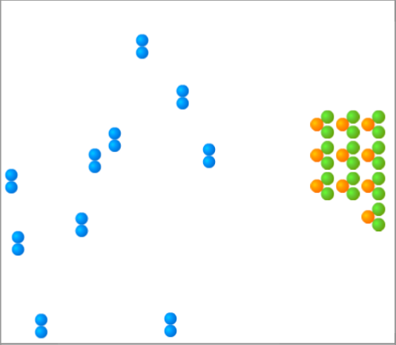
Gizmo Warm-up
A chemical reaction causes the chemical compositions of substances to change. Reactants are substances that enter into a reaction, and products are substances produced by the reaction. The Collision Theory Gizmo allows you to experiment with several factors that affect the rate at which reactants are transformed into products in a chemical reaction.

You will need blue, green, and orange markers or colored pencils for the first part of this activity.

- Look at the key at the bottom of the SIMULATION pane. In the space below, draw the two reactants and two products of this chemical reaction.

Reactants: Products:

- Click Play (). What do you see? ____________________________________________

_________________________________________________________________________

_________________________________________________________________________

_________________________________________________________________________

Activity A:  Temperature | Get the Gizmo ready:  - Click Reset ().  - Check that the Reactant concentration is set to 1.0 mol/L, the Catalyst concentration is set to 0.00 mol/L, and the Surface area is Minimum. | 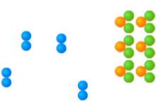

Question: How does temperature affect the rate of a chemical reaction?

- Observe: Select the ANIMATION tab. View the animation with No catalyst selected.

What do you see? __________________________________________________________

_________________________________________________________________________

_________________________________________________________________________

When two reactant molecules meet, they form a temporary structure called an activated complex. The activated complex breaks up into the product molecules.

- Observe: Return to the CONTROLS pane. Set the Temperature to 0 °C and the Simulation speed to its maximum setting. Click Play.

    - Describe the motions of the molecules. ____________________________________

___________________________________________________________________

    - Now set the Temperature to 200 °C. How does increasing the temperature affect the motions of the molecules? ___________________________________________
    - What do you notice about the chemical reaction at the higher temperature? _______

___________________________________________________________________

- Interpret: Select the GRAPH tab. Click the zoom out button (–) until you can see the whole graph. What does this graph show? ____________________________________________
_________________________________________________________________________

- Predict: How do you think temperature will affect the rate of a chemical reaction? ________

_________________________________________________________________________

_________________________________________________________________________

(Activity A continued on next page)
Activity A (continued from previous page)

- Gather data: Click Reset. A useful way to compare reaction rates is to record the time required for half of the reactants to react, called the half-life of the reaction. With the Temperature set to 200 °C, click Play. Click Pause () when the number of reactant molecules is 10. Record the half-life time in the first space of the table below.

Trial | 200 °C | 150 °C | 100 °C | 50 °C
1
2

Mean half-life

Repeat the experiment at different temperatures to complete the table. (Note: To get exact times, you can refer to the TABLE tab.)

- Calculate: Calculate the mean half-life for each temperature. Fill in these values above.

(Hint: To get an exact mean, first convert each time to seconds by multiplying the minutes value by 60 and adding this to the seconds. To find the mean in seconds, add up the two times and divide by two. Convert the answer back to minutes and seconds.)

- Analyze: What do your results indicate? _________________________________________

_________________________________________________________________________

_________________________________________________________________________

- Draw conclusions: For two molecules to react, they must collide at just the right angle and with enough energy to break the original bonds and form new ones. Based on these facts, why does the reaction tend to go more quickly at higher temperatures?

_________________________________________________________________________

_________________________________________________________________________

- Apply: Paper must be heated to 234 °C to begin reacting with oxygen. This can be done by putting the paper over a flame. Why do you think the paper must be heated to start burning?

_________________________________________________________________________

_________________________________________________________________________

_________________________________________________________________________

Activity B:  Surface area and concentration | Get the Gizmo ready:  - Click Reset.  - Check that the Catalyst concentration is set to 0.00 mol/L and the Surface area is Minimum.  - Set the Temperature to 200 °C. | 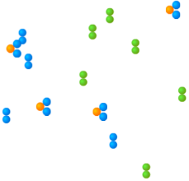

Introduction: Reaction rates are also influenced by surface area and concentration. The surface area of a solid is a measure of how much of the solid is exposed to other substances. The concentration of a substance is a measure of how many molecules of that substance are present in a given volume.

Question: How do surface area and concentration affect reaction rates?

- Observe: Change the Surface area from Minimum to Maximum. You can imagine that a solid reactant has been dissolved in a liquid.

How does this change how many Reactant B molecules are exposed to Reactant A?

_________________________________________________________________________

- Predict: How do you think increasing the surface area will affect the rate of the reaction?

_________________________________________________________________________

- Gather data: Set the Reactant concentration to 2.0 mol/L. Use the Gizmo to measure the half-life of the reaction for each surface area setting. (There will now be 20 reactant molecules left at the half-life.) Then, calculate the mean half-life for each setting.

Trial | Minimum surface area | Maximum surface area
1
2

Mean half-life

- Analyze: What do your results indicate? _________________________________________

_________________________________________________________________________

- Explain: Why does the reaction proceed more quickly when the surface area is increased?

_________________________________________________________________________

_________________________________________________________________________

(Activity B continued on next page)
Activity B (continued from previous page)

- Observe: Click Reset. Move the Reactant concentration slider back and forth. What do you notice?

_________________________________________________________________________

- Predict: How will increasing the reactant concentration affect the rate of the reaction? Why?

_________________________________________________________________________

_________________________________________________________________________

- Gather data: Make sure the Temperature is 200 °C and the Surface area is Maximum. Use the Gizmo to measure the half-life for each given reactant concentration. (Note that the number of reactant molecules changes with each concentration.) Calculate the means.

Trial | 0.4 mol/L | 0.8 mol/L | 1.2 mol/L | 1.6 mol/L | 2.0 mol/L
1
2

Mean half-life

- Compare: If possible, find the mean times for each concentration for your entire class. What is the mean class time for a concentration of 0.4 mol/L? How about for 2.0 mol/L?

Mean for 0.4 mol/L: ______________ Mean for 2.0 mol/L: ______________

- Analyze: What do these results indicate? ________________________________________

_________________________________________________________________________

_________________________________________________________________________

- Apply: Hydrochloric acid reacts with the mineral calcite to produce carbon dioxide gas, water, and calcium chloride. Based on what you have learned in activity A and activity B, what are three things you could do to make the reaction occur more quickly?

_________________________________________________________________________

_________________________________________________________________________

_________________________________________________________________________

Activity C:  Catalysts | Get the Gizmo ready:  - Click Reset (). | 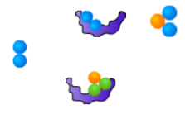

Introduction: A catalyst is a substance that helps a chemical reaction to proceed. The catalyst molecules are not changed by the reaction and can be reused over and over again.

Question: How do catalysts affect the rate of a chemical reaction?

- Observe: Select the ANIMATION tab. Select With catalyst, and observe.

    - What do you see? ____________________________________________________

___________________________________________________________________

    - Why do you think the shape of a catalyst is important? _______________________

___________________________________________________________________

___________________________________________________________________

Many catalysts have a special shape that allows them to bind to specific reactant molecules.

- Predict: How do you think catalysts will affect the rate of a chemical reaction? ___________

_________________________________________________________________________

- Gather data: On the CONTROLS pane, set the Reactant concentration to 2.0 mol/L, the Surface area to Maximum, and the Temperature to 50 °C. Measure the half-life for each given catalyst concentration. Calculate the means.

Trial | Catalyst concentration
 | 0.00 mol/L | 0.05 mol/L | 0.10 mol/L | 0.15 mol/L
1
2

Mean half-life

- Analyze: What do your results indicate? _________________________________________

_________________________________________________________________________

_________________________________________________________________________

(Activity C continued on next page)
Activity C (continued from previous page)

- Explore: Set the Catalyst concentration to 0.00 mol/L and the Temperature to 0 °C. Click Play, wait for 10 minutes of simulated time, and click Pause.

    - What happens? ______________________________________________________

    - Click Reset, set the Catalyst concentration to 0.25 mol/L, and click Play. After 10 simulated minutes, click Pause. What happens now? ________________________
___________________________________________________________________
    - Why do you think the catalysts allowed the chemical reaction to take place at 0 °C?

___________________________________________________________________

___________________________________________________________________

___________________________________________________________________

- Draw conclusions: What is the usefulness of catalysts? _____________________________

_________________________________________________________________________

_________________________________________________________________________

- Apply: Most of the chemical reactions inside your body rely on protein catalysts called enzymes to take place. For example, the enzyme pepsin helps to break down protein molecules in your stomach. What might happen if your stomach stopped producing pepsin?

_________________________________________________________________________

_________________________________________________________________________

_________________________________________________________________________

