Vocabulary: Comparing and Ordering Decimals

Vocabulary

- Compound inequality – two or more inequalities combined into one.
  - For example, 9.2 < 9.3 < 9.4 is a combination of the two inequalities 9.2 < 9.3 and 9.3 < 9.4.

- Decimal – a number written in the base-10 system.
  - Usually “decimal” refers to a number that contains a decimal point.

- Decimal point – a point that separates the ones place from tenths, hundredths, etc.
  - For example, the decimal 7.4 is seven and four tenths. The decimal 7.41 is seven and forty-one hundredths.

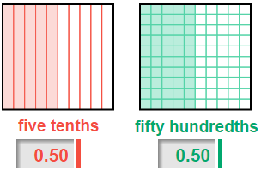
- Equivalent – equal in value.
  - Equivalent decimals have different numbers of digits but represent the same amount.
  - For example, 0.5 (five tenths) and 0.50 (fifty hundredths) are equivalent decimals.

- Hundredth – one of 100 equal parts of a whole.
  - The hundredths place is the position of the second digit after the decimal point.
  - For example, in the number 89.71 the 1 is in the hundredths place.

- Inequality – a statement showing that one number is greater than (>) or less than (<) another number.
  - For example, 5.3 < 6.8 is an inequality stating that 5.3 is less than 6.8.

- Tenth – one of 10 equal parts of a whole.
  - The tenths place is the position of the first digit after the decimal point.
  - For example, in the number 89.71 the 7 is in the tenths place.

