Name: ______________________________________ Date: ________________________

Student Exploration: Comparing Earth and Venus

Vocabulary: angular velocity, orbit, period, revolve, rotation, sidereal day, solar day, year

Prior Knowledge Questions (Do these BEFORE using the Gizmo.)

- Which planet is closest to Earth? ______________________________

- Which planet is most similar in size to Earth? ______________________________

- Which planet is most similar in temperature to Earth? ______________________________

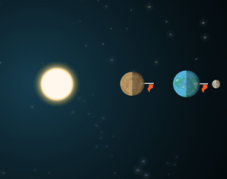
Gizmo Warm-up
Venus is often called Earth’s “sister planet” because it is the closest planet to Earth and almost the same size. Also, both Venus and Earth are enveloped in thick atmospheres that are filled with swirling clouds.

But that is where the similarities end. The atmosphere of Venus is about 97% carbon dioxide, the clouds are composed mainly of sulfuric acid, and the surface temperature of Venus is over 450 °C—hot enough to melt lead!

The Comparing Earth and Venus Gizmo allows you to compare the orbits of Earth and Venus. The sizes of Venus, Earth, the Moon, and the Sun shown in the Gizmo are not to scale. (If they were, Earth, Venus, and the Moon would be too tiny to see.)

- Click Play (). You are looking down on the North Pole of Earth. From this perspective, do Earth and Venus revolve around the Sun in a clockwise or counterclockwise direction?

_________________________________________________________________________

- The flags in the picture were included to demonstrate the rotation, or spinning motion, of Earth and Venus. What do you notice about the rotation of Earth and Venus?

_________________________________________________________________________

_________________________________________________________________________

Activity A:  Revolution | Get the Gizmo ready:  - Click Reset ().  - Set the Speed to Fast. | 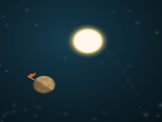

Question: How does a year on Venus compare to a year on Earth?

- Observe: Click Play. Which planet revolves around the Sun more quickly? ______________

Which planet has a shorter distance to travel in its orbit? ______________

- Measure: Click Reset. The period of a planet is the time it takes to complete one orbit around the Sun. From the POINTER tray at the bottom of the Gizmo, drag an arrow to mark Earth’s initial position. Drag a second arrow to mark the initial position of Venus.

Click Play, and then click Pause () when the faster planet reaches its original position. Record this time below. Then use the Gizmo to measure the period of the slower planet.

Period of Earth (Earth days): __________ Period of Venus (Earth days): __________

- Analyze: What unit of time is equal to Earth’s period? ______________________________

How long is a year on Venus? ______________________________

- Explain: What are two reasons the period of Venus is shorter than the period of Earth?

_________________________________________________________________________

_________________________________________________________________________

_________________________________________________________________________

- Explore: Click Reset, and reduce the Speed to a slower setting. Observe the orbit of the Moon around Earth.

- Is the Moon’s orbit clockwise or counterclockwise? _________________________

- About how long does it take for the Moon to circle Earth? _____________________

- Make a rule: Based on your observations of the orbits of the Moon, Earth, and Venus, how does the radius of an orbit relate to the average speed of the orbiting body?

_________________________________________________________________________

_________________________________________________________________________

Activity B:  Rotation | Get the Gizmo ready:  - Click Reset.  - Set the Speed to a relatively slow setting.  - Return all the pointers to their tray. | 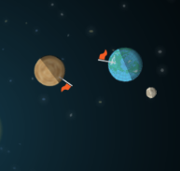

Introduction: There are two ways to measure the length of a day. The first is the time from one midnight to another. This is called a solar day. The second method is to measure how long it takes a planet to spin 360 degrees. This is a sidereal day.

Question: How does a day on Venus compare to a day on Earth?

- Observe: Click Play. Observe each of the four celestial bodies in the Gizmo, then state whether its rotation is clockwise or counterclockwise.

Earth: _________________________ Moon: _________________________

Venus: _________________________ Sun: _________________________

- Explain: What is unusual about the rotation of Venus? ______________________________

_________________________________________________________________________

- Measure: Click Reset, and set the Speed to Slow. From the POINTER tray at the bottom of the Gizmo, drag an arrow to show the Earth flag’s initial position. Click Play and then Pause when the flag returns to the same position.

About how long is a sidereal day on Earth? ______________________________________

- Measure: Click Reset, and set the speed to Fast. Measure the length of a sidereal day on Venus. (Hint: At the end of a sidereal day, the flag on Venus is pointing to the right.)

- About how many Earth days equal one sidereal day on Venus? ________________

- Which is longer on Venus, a sidereal day or a year? Explain. ___________________

___________________________________________________________________

- Observe: Click Reset. Notice that the man on Venus is pointing away from the Sun.

- What is the time of day on Venus? _______________________________________

- Click Play, and then click Pause when the flag is pointing toward the Sun. What is the time of day on Venus now? __________________________________________
(Activity B continued on next page)
Activity B (continued from previous page)

- Measure: Use the Gizmo to measure the length of a solar day on Venus. (Hint: At the end of a solar day, the flag will be pointing away from the Sun, in the “midnight” position.)

- About how many Earth days equal one solar day on Venus? ___________________

- Which is longer on Venus, a solar day or a year? Explain. _____________________

___________________________________________________________________

- Describe: On Earth, we are very familiar with the rising and setting of the Sun every day. What would a sunrise be like on Venus? How long would night last? Use your imagination to describe a day on Venus. If necessary, continue your description on another page.

_________________________________________________________________________

_________________________________________________________________________

_________________________________________________________________________

_________________________________________________________________________

- Challenge: On Earth, the length of a sidereal day is only 4 minutes less than the length of a solar day. On Venus, a sidereal day is 126 Earth days longer than a solar day.

- Why is the length of a sidereal day and a solar day on Earth so similar? __________

___________________________________________________________________

___________________________________________________________________

- Why is a sidereal day shorter than a solar day on Earth? ______________________

___________________________________________________________________

___________________________________________________________________

- Why is the length of a sidereal day and a solar day on Venus so different? ________

___________________________________________________________________

___________________________________________________________________

- Why is a sidereal day longer than a solar day on Venus? _____________________

___________________________________________________________________

___________________________________________________________________

Extension:  Orbit calculations | Get the Gizmo ready:  - Click Reset.  - You will need a calculator to complete this activity. | 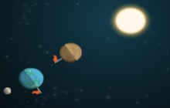

Introduction: Because Venus moves faster than Earth and has a shorter distance to travel around the Sun than Earth, it passes—or “laps”—Earth at a regular time interval. Calculating how long it takes Venus to lap Earth is an interesting application of algebra to astronomy.
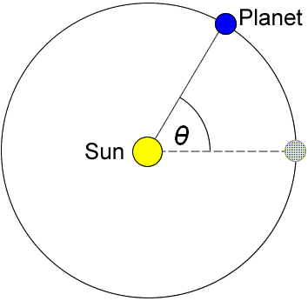
Question: How long does it take for Venus to lap Earth?

- Write expressions: Imagine a line drawn from a planet to the Sun. As the planet orbits the Sun, the line moves through an angle (θ) of 360 degrees. The angular velocity (ω) of a planet is equal to 360° divided by the period (T) of the planet:

ω = 360°
T

Suppose it takes V days for Venus to orbit the Sun and E days for Earth to orbit the Sun. Substitute these variables for T in the equation above to write expressions for the angular velocities of Venus and Earth:

Venus: ω = Earth: ω =

- Write expressions: The angle (θ) a planet has passed through in a given time is equal to the angular velocity of the planet multiplied by the time (t). Write expressions for the angular distances traveled by Venus and Earth:

Venus: θ = Earth: θ =

- Set up an equation: At the time that Venus “laps” Earth, Venus will have traveled through the same angle as Earth plus an additional 360 degrees. So at time t, the angular position of Venus will equal the angular position of Earth plus 360 degrees. Write a single equation that describes this equality.

- Simplify: Notice that each term of the equation is multiplied by 360°. To simplify the equation, divide both sides of the equation by 360° and write the simplified equation below.

(Extension continued on next page)
Extension (continued from previous page)

- Solve: If you have done everything correctly so far, you should have the following equation (or its equivalent):
(t / E) + 1 = t / V

Use algebra to solve this equation for the variable t. Show your work.

- Measure: Use the Gizmo to measure the period of Venus and Earth (in Earth days), or look the values up from your work in activity A of this worksheet. Write these values below:

Venus: V = _____________ Earth: E = _____________

- Calculate: Plug the values of E and V into your equation and solve for the time required for Venus to lap Earth. Starting when the two planets are aligned, how much time will pass until the next alignment?
t = __________________

- Test: Set the Speed to Fast and click Play. Click Pause after the predicted time to the next alignment has passed. Are the planets aligned again? Describe what you see.

_________________________________________________________________________

_________________________________________________________________________

- Apply: Mars has a period of 687 Earth days. How long does it take for Earth to lap Mars?

t = __________________

Describe how you solved this problem: __________________________________________

_________________________________________________________________________

_________________________________________________________________________

_________________________________________________________________________

