Vocabulary: Concurrent Lines, Medians, and Altitudes

dictionary2

**Vocabulary**

* Altitude – a line that passes through a vertex of a figure and is perpendicular to the opposite side.
* Bisector – a line, segment, or ray that divides a figure into two congruent parts.

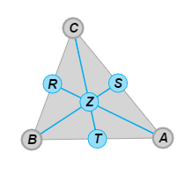

* Centroid – the point where the medians *o*f a triangle intersect.
* The mediansof Δ*ABC* shown to the right are , , and .
* The medians intersect at point *Z*, the centroid of Δ*ABC*.
* 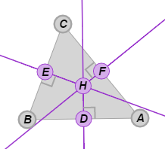Circumcenter – the point where the perpendicular bisectors of a triangle intersect.
* The perpendicular bisectors of Δ*ABC* shown to the right are , , and *.*
* The perpendicular bisectors intersect at point *H*, the circumcenter of Δ*ABC*.
* Circumscribed circle – a circle on which all vertices of a figure lie.
* Concurrent – meeting at a point.
* The point where concurrent lines intersect is called the *point of concurrency*.

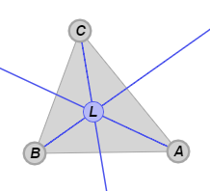

* Incenter – the point where the angle bisectors of triangle intersect.
* The angle bisectors of Δ*ABC* shown to the right intersect at point *L*, the incenter of Δ*ABC*.
* Inscribed circle – a circle that fits inside of a figure and touches each side of the figure at exactly one point.
* Median (of a triangle) – a line that passes through a vertex of a triangle and the midpoint of the opposite side.

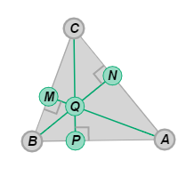

* Orthocenter – the point where the altitudes of a triangle intersect.
* The altitudesof Δ*ABC* shown to the right are , , and .
* The altitudes intersect at point *Q*, the orthocenter of Δ*ABC*.