Vocabulary: Congruence in Right Triangles

dictionary2

**Vocabulary**

* Congruent – having the same size and shape.
  + The symbol ≅ means “is congruent to.”
  + Two triangles are congruent when all of the corresponding angles and corresponding sides are congruent.

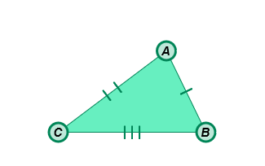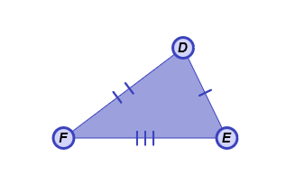

* For example, in the figures to the right,   
  Δ*ABC* ≅ Δ*DEF*.
* Corresponding angles (of a polygon) – the matching angles of polygons.
  + For example, the corresponding angles in Δ*ABC* and Δ*DEF* are ∠*A* and ∠*D*, ∠*B* and ∠*E*, and ∠*C* and ∠*F*.
* Corresponding sides – the matching sides of polygons.
  + For example, the corresponding sides in Δ*ABC* and Δ*DEF* are  and , and , and  and .
* Hypotenuse – the side of a right triangle opposite the right angle.
* The hypotenuse is the longest side of a right triangle.

**leg**

**leg**

**hypotenuse**

* Legs (of a right triangle) – the two sides of a right triangle that form the right angle.
* Right triangle – a triangle that contains one right angle.

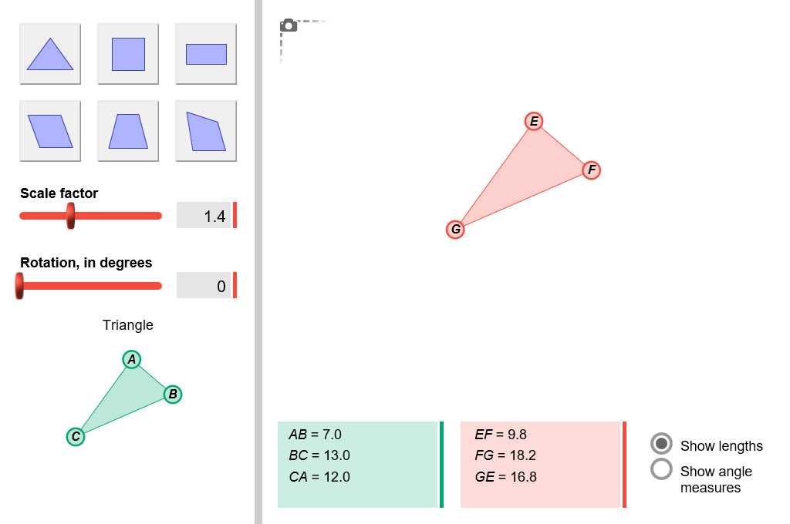

* Similar – having the same shape, but not necessarily the same size.
  + The symbol ∼ means “is similar to.”
  + Two polygons are similar when all corresponding angles are congruent.
* For example, in the figure to the right,   
  Δ*ABC* ∼ Δ*EFG*.