Vocabulary: Convection Cells

Vocabulary

- Convection – the transfer of heat through motion of a fluid (liquid or gas).
  - Convection occurs when hotter, less dense fluid rises while cooler, denser fluid sinks.
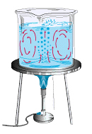

Convection cells

- Convection cell – a zone in a fluid where hot fluid rises while cool fluid sinks, resulting in a circulation of fluid.
  - As a hot fluid rises to the top of a container, it tends to cool off and become denser. The cooler fluid is pushed to the side by the rising fluid below it. Eventually the cooler, denser fluid sinks to the bottom where it is heated again.
  - Convection cells are also called convection currents.

- Density – the amount of mass in a given volume.
- Density is calculated by dividing mass by volume, D = m / v.
- Density can be a measure of how tightly packed the particles in a fluid are. As the particles become more tightly packed, the density increases.

- Global conveyor belt – a very slow circulation of water throughout the world’s oceans.
  - The global conveyor belt includes both surface currents and deep currents near the seafloor.
  - The global conveyor belt is driven by thermohaline currents. Water density changes occur due to changes in both temperature and salinity, or salt content. These changes cause water currents to rise or sink.

- Mantle – the layer of Earth between the crust and the core.
  - The mantle extends from 2,900 km below Earth’s surface to the base of the crust.
  - The mantle contains both solid and partially molten rock. Mantle rock circulates very slowly, a few cm per year.
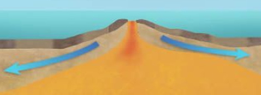

Mid-ocean ridge
- Mid-ocean ridge – a seafloor mountain range that forms where tectonic plates are diverging, or moving apart.
  - At the center of a mid-ocean ridge, mantle magma emerges and cools to form new ocean crust.
  - Examples of mid-ocean ridges include the Mid-Atlantic Ridge and the East Pacific Rise.

- Subduction zone – a region where one tectonic plate slides beneath another.
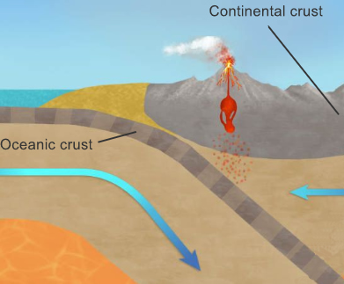

Subduction zone
  - When two tectonic plates collide, the denser plate (often an oceanic plate) is pushed below the less dense plate (often a continental plate). If two oceanic plates meet, the plate with older crust is usually denser and will sink.
  - Subduction zones are usually associated with earthquakes, mountain ranges, and volcanic activity.

- Vector – a quantity that has both direction and magnitude, such as velocity.
  - Vectors are often represented by arrows. The length of the arrow represents the magnitude (such as speed) while the orientation of the arrow gives the direction.

- Viscosity – a measure that describes the resistance of a fluid to flow.
  - A “thick” liquid such as ketchup has a higher viscosity than a “thin” liquid like water.
  - In the Convection Cells Gizmo, the viscosity given is kinematic viscosity, or viscosity divided by density. The units of kinematic viscosity are m²/s.

