Name: Date:

Student Exploration: Coral Reefs 1 – Abiotic Factors

Vocabulary: consumer, coral, coral bleaching, coral reef, filter feeder, food chain, food web, grazer, nutrients, ocean acidification, pH, plankton, predator, producer, sediment, zooxanthellae
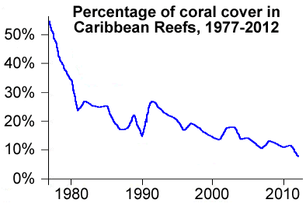

Prior Knowledge Questions (Do these BEFORE using the Gizmo.)

- Look at the graph to the right. What does it show?

- Why do you think corals have declined since 1977?

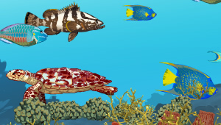
Gizmo Warm-up
Coral reefs are some of the most diverse habitats on Earth, home to over a quarter of all marine species. The Coral Reefs Gizmo provides a simplified model of interactions among 10 key species in Caribbean reefs. In the Coral Reefs 1 exploration, you will focus on the effects of environmental factors on Caribbean reefs.

- Click Advance year 10 times. Look carefully at the composition of the reef over time. Do you see any major changes?

- Select the DATA tab. Check that Staghorn coral, Star coral, Sponges, and Algae are selected. Populations are given as a percentage of normal populations.

What do you notice about these populations?

- On the right side of the Gizmo, select the SUMMARY tab. In a healthy reef, what are the values for Nutrient load, Water clarity, Coral cover, and the total number of fish species?

Nutrient load: Water clarity: Coral cover: Total fish species:

Activity A:  The Caribbean reef ecosystem | Get the Gizmo ready:  - On the CONDITIONS tab, click Return to original settings. Click Restart.  - Select the CORAL REEF tab. | 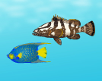

Introduction: A healthy Caribbean reef is home to over 50 species of coral and over 400 fish species. In this simplified model, we only consider the interactions of ten important species.

Question: How do different species interact in a healthy coral reef?

- Describe: On the CORAL REEF tab, click on each organism shown in the table below. For each organism, give its name and what it eats (or how it obtains energy).

Picture | Name | What it eats (or how it obtains energy)
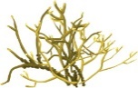
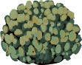
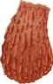
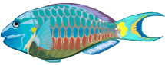
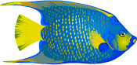
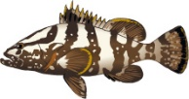
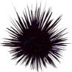
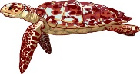

- Corals obtain energy from tiny photosynthetic algae, called zooxanthellae, which live inside the coral’s tissue. How do you think corals would be affected by cloudy, muddy water?

(Activity A continued on next page)
Activity A (continued from previous page)

- Classify: A producer is an organism that makes its own energy, usually from sunlight. A consumer is an organism that gets energy by feeding on other organisms.

- Which of the reef organisms in this Gizmo are producers?

- Which of the reef organisms are consumers?

- Consumers in the reef can be further classified as filter feeders, or organisms that eat plankton by filtering water; grazers, or organisms that feed on organisms that don’t move; and predators, or organisms that eat other animals. List at least one example of each.

Filter feeders:

Grazers:

Predators:

- Create: A food chain is a series that shows which organisms obtain energy from other organisms. For example, the food chain “grass → mouse → hawk” means that the mouse eats grass and the hawk eats the mouse.

Create two possible food chains for the Caribbean coral reef based on what you have learned about the ten organisms in this Gizmo.

Food chain 1:

Food chain 2:

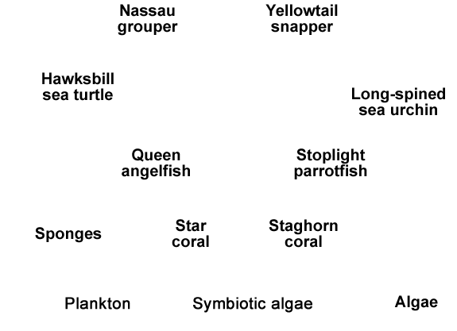
- Challenge: A food web is a more complicated diagram that shows the feeding relationships of all the organisms in the ecosystem. As with a food chain, an arrow pointing from species A to species B indicates species B gets its energy from species A.

In the diagram at right, create a food web by drawing arrows to show which organisms obtain energy from others.

Activity B:  Ocean conditions | Get the Gizmo ready:  - On the CONDITIONS tab, Click Return to original settings and Restart. Check that Ocean conditions is selected on the dropdown menu. | 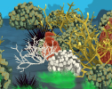

Introduction: In recent decades, global climate change has altered ocean conditions in the Caribbean. Average surface temperatures have risen about 0.25 °C – 0.5 °C. Many scientists think climate change will lead to stronger storms and may cause the ocean to be more acidic.

Question: How are coral reefs affected by storms, high temperatures, and acidic water?

- Predict: Coral reefs in the Caribbean are sometimes damaged by hurricanes. Of the two types of coral shown, which do you think is more resistant to storm damage? Explain.

- Observe: Set the Storm severity to 50%. Click Advance year 10 times. What changes do you notice?

- Analyze: On the DATA tab, select Staghorn coral, Star coral, Sponges, and Algae. Which organism was most hurt by increased storms, and why do you think this is so?

- Predict: In the Caribbean, water temperatures typically range from 24 °C to 30 °C. What do you think might happen if temperatures rise much higher than 30 °C?

- Observe: Select the CORAL REEF tab. Click Return to original settings and Restart. Set the Ocean temperature to 33 °C. Click Advance year 10 times.

- What changes do you notice?

The white corals you see have undergone coral bleaching. At high temperatures, corals may lose their zooxanthellae, causing corals to lose their color and their main source of food. Once bleaching occurs, the coral colony usually dies.

- Select the DATA tab. Which coral is most affected by bleaching?

(Activity B continued on next page)
Activity B (continued from previous page)

- Analyze: On the DATA tab, select every organism. In general, how does the decline in corals affect the other organisms on the reef?

- Predict: The pH of a solution is a measure of how acidic or basic it is. The greater the pH, the more basic the solution is. Corals and other marine invertebrates require less energy to make their exoskeletons and shells when ocean water is slightly basic. As carbon dioxide concentrations in Earth’s atmosphere rise, ocean water absorbs carbon dioxide and becomes more acidic. This process is called ocean acidification.

How do you think ocean acidification will affect coral reefs?

- Observe: Click Return to original conditions and Restart. Set the Ocean pH to 7.6. Click Advance year 20 times. What changes do you see on the CORAL REEF and DATA tabs?

- Observe: Select the SUMMARY tab. How has the loss of coral affected the number of fish species present on the reef?

- Summarize: Many scientists predict stronger storms, warmer oceans, and lower ocean pH in the future. If this occurs, how do you think these changes will affect Caribbean coral reefs?

Test your ideas using the Gizmo.

- Apply: In the 1970s, staghorn corals dominated Caribbean reefs. Since that time, staghorn corals have declined by over 90% and are now classified as critically endangered. What do you think are the causes of this decline, and why do you think staghorns are so vulnerable?

Activity C:  Land use | Get the Gizmo ready:  - On the CONDITIONS tab, click Return to original settings and Restart. Select Land use. | 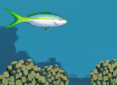

Introduction: Corals depend on ample sunlight, warm (but not too warm) temperatures, clear water, and low levels of nutrients such as nitrogen and phosphorus. Algae and sponges, on the other hand, thrive in water that is higher in nutrients. Logging, agriculture, and other human activities can add excess nutrients and sediments (small dirt particles) to the sea.

Question: How do changes in land use affect reefs?

- Observe: Select the SUMMARY tab. Under normal conditions, what is the sediment load, nutrient load, and water clarity?
The sediment load and nutrient load are measured in parts per thousand (ppt).

- Predict: Logging removes vegetation that anchors soil and prevents erosion. How do you think logging will affect a coral reef? Explain.

- Observe: On the CONDITIONS tab, set Logging to 50%. Select the SUMMARY tab. What is the sediment load, nutrient load, and water clarity?

- Observe: Click Advance year 10 times. What changes do you notice?

- Analyze: On the DATA tab, select Staghorn coral, Star coral, Sponges, Algae, Stoplight parrotfish, Queen angelfish, and Long-spined sea urchin.

- Which species were hurt the most by logging?

- Which species were helped most by logging?

- Why do you think the populations of parrotfish and long-spined sea urchins changed the way they did?

(Activity C continued on next page)
Activity C (continued from previous page)

- Observe: Click Restart. On the CONDITIONS tab, set Logging to 0% and Sewage to 50%. Select the SUMMARY tab. What is the sediment load, nutrient load, and water clarity now?

- Predict: The primary effect of dumping raw sewage into ocean water is a sharp increase in the nutrient load. How do you think this will affect the reef?

- Observe: Select the CORAL REEF tab. Click Advance year 10 times. What changes do you notice?

- Analyze: On the DATA tab, select every organism except Red lionfish and Crown-of-thorns starfish. (These are invasive species you will experiment with in another activity.)

- How does the increase in nutrients affect the algae population?

- How does this change the populations of the two species that eat algae, parrotfish and sea urchins?

- Experiment: Click Restart. In 1983, a mysterious disease killed off most of the long-spined sea urchins in the Caribbean. To model this, select Disease from the CONDITIONS tab and set the Sea urchin infection rate to 100%. Check that Sewage is still 50%.

- Click Advance year 10 times. What happens?

- Based on these results, what is the importance of long-spined sea urchins to Caribbean reefs?

- On your own: Click Return to original settings and Restart. Investigate the effects of agriculture on Caribbean reefs. Summarize your findings on a separate sheet of paper to turn in with this activity.

