Vocabulary: Correlation

dictionary2

**Vocabulary**

* Correlation – a measure of the relationship between two variables.
* If the variables vary together (as one goes up, the other tends to go up), they are *positively correlated*.
* If the variables vary in opposite directions (as one goes up, the other tends to go down), they are *negatively correlated*.
* If the variables are unrelated, they have *no correlation*.
* Correlation coefficient – a number between –1 and 1, represented by the letter *r*, that indicates how strongly two variables are correlated and the type of correlation.
  + A positive value of *r* indicates a positive correlation, while a negative value of *r* indicates a negative correlation.
  + The closer *r* is to 1, the stronger the positive correlation between the variables.
  + The closer *r* is to –1, the stronger the negative correlation.
  + A value of *r* near 0 indicates little to no correlation between the variables.
* Least-squares fit line – the line that best represents the linear relationship between two variables.

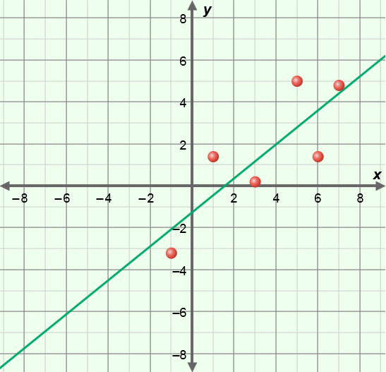

* + The least-squares fit line is also called the *least-squares regression line*.
  + The least-squares fit line is the line that minimizes the total sum of the squares of the *residuals*, where the residuals are the vertical distances from the data points to the least-squares fit line, as shown to the right.
* Scatter plot – a graph of (*x*, *y*) points that shows the general relationship between two variables, *x* and *y*.
  + Generally, the variable on the horizontal (*x*) axis is the *independent variable*, and the variable on the vertical (*y*) axis is the *dependent variable*.