Name: ______________________________________ Date: ________________________

Student Exploration: Density via Comparison

Vocabulary: density, mass, volume

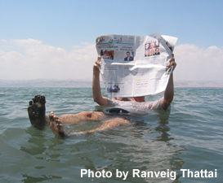
Prior Knowledge Questions (Do these BEFORE using the Gizmo.)
The image at right shows a man floating in the Dead Sea, an extremely salty lake that lies between Israel and Jordan.

- Why do you think the man is floating so high in the water? ____________________________________
__________________________________________

- What might happen if this man tried to read the newspaper while floating in a normal pool?

_________________________________________________________________________

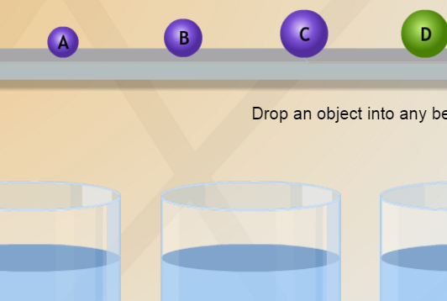
Gizmo Warm-up
Whether an object floats or sinks in a fluid depends on the density—or mass per unit of volume—of the object as well as the density of the fluid. The Density via Comparison Gizmo allows you to compare objects by placing them in fluids of differing densities.

- Place object A into Beaker 2, which contains a liquid with a density of 1 g/mL, equal to the density of water.

- What happens? ______________________________________________________

- Is object A more or less dense than water? Explain how you know. ______________

___________________________________________________________________

- Now drop object B into Beaker 2. Describe what happens and explain what that tells you about the density of object B. _________________________________________________
_________________________________________________________________________

Activity:  Estimating density | Get the Gizmo ready:  - Double-click on the shelf to return all objects to the shelf. | 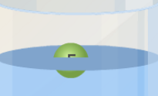

Question: How do you estimate the density of an object without measuring its mass or volume?

- Observe: Drag object A into Beaker 1. If it sinks, move it into beakers 2, 3, and so on until it floats.

    - What is the highest-density fluid in which object A sinks? ______________________

    - What is the lowest-density fluid in which object A floats? ______________________
    - Based on the previous two answers, what can you say about the density of object A? (Note: The density of a solid is measured in g/cm³, which are equivalent to g/mL.)

___________________________________________________________________

- Gather data: Drag each object into all of the beakers. Write “floats” or “sinks” in each space in the table below. In the last column, estimate the density of each object.

Object | Beaker 1 (0.5 g/mL) | Beaker 2 (1 g/mL) | Beaker 3 (1.5 g/mL) | Beaker 4 (2.5 g/mL) | Estimated density
B
C
D
E
F

- Analyze: Drag objects B and E into Beaker 2. Which object is denser? _________________

Explain how you know: ______________________________________________________

- Challenge yourself: Describe how you know which object is denser in each situation.

    - Objects A and B are placed in Beaker 1: __________________________________

___________________________________________________________________

    - Objects A and B are placed in Beaker 4: __________________________________

___________________________________________________________________

