Vocabulary: Graphs of Derivative Functions

dictionary2

**Vocabulary**

* Derivative – the slope of the tangent line at a given point on a graph.
* The derivative of *f*(*x*) is defined as *f*’(*x*) = .
  + - This means that *f*’(*x*) is the slope of the line between two points on a curve, as the distance between those points (Δ*x*) goes to zero.
    - *f*’(*x*) is usually called “*f* prime” or “*f* prime of *x*.”
* The derivative is the rate of change of the function at a given point.

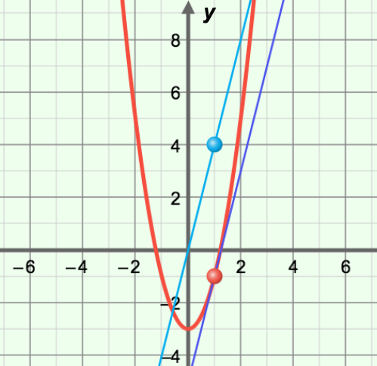

***f*(*x*) = 2*x*2 – 3**

***f*’(*x*) = 4*x***

**Slope = *f*’(1) = 4**

* In other words, the derivative describes how quickly *f*(*x*) (or *y*) is changing, relative to *x*.
* For example, the derivative of the quadratic function graphed to the right is *f*’(*x*) = 4*x*, so the slope of the tangent line at *x* = 1 is *f*’(1) = 4(1), or 4.
  + - Function: *f*(*x*) = 2*x*2 – 3
    - Derivative: *f*’(*x*) = 4*x*
    - Derivative at *x* = 1: *f*’(1) = 4(1) = 4
* The process of finding the derivative is called *differentiation*.