Name: Date:

Student Exploration: Describing Data Using Statistics

Vocabulary: line plot, mean, median, mode, outlier, range

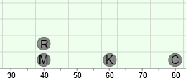
Prior Knowledge Questions (Do these BEFORE using the Gizmo.)
Chuck, Molly, Katya, and Russell all work as lifeguards during the summer. They each make $5 per hour. The line plot to the right shows how much each makes in a week.

- Who makes the most money? Who makes the least?

- What is the difference between the greatest amount of money and the least?

Gizmo Warm-up
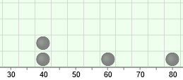
Data sets can often be large and messy, with too many items to list individually. Statisticians often summarize data sets by describing where the numbers are centered, and how spread out they are. You can learn about three measures of center and one measure of spread in the Describing Data Using Statistics Gizmo.

To begin, model the situation described above by dragging two dots to 40, one dot to 60, and one dot to 80. You will first investigate the range, a measure of the spread of the data.

- The range of a data set is the difference between the highest and lowest values in the data set. To find the range, subtract the lowest value from the highest.

What is the range of this data set? To check, select Range on the Gizmo.

- Move the dot on 60 around between 40 and 80. Does this affect the range?

- Move the other dots. Try to increase and decrease the range.

- How can you increase the range?

- How can you decrease the range?

- In general, when does a change in the data affect the range?

Activity A:  Mode | Get the Gizmo ready:  - If necessary, move the dots to model the data set 40, 40, 60, 80.  - Turn off all checkboxes. | 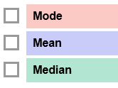

- The mode is the value that occurs most often in the data set.

- What is the mode of this data set? Turn on Mode to check.

- Drag a second point to 60. What happens?

- Drag a second point to 80. What happens, and why do you think this is?

- Drag a point to 50. What happens, and why do you think this is?

- Click Clear. Drag points to 30, 40, and 50. Does this data set have a mode?

Explain.

- Turn off Mode. Click New to generate a new data set. Sketch a line plot of your data set in the chart below, and circle the mode (or modes). Check your answer with the Gizmo.
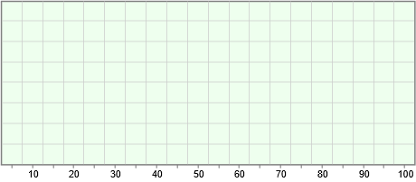

- Remove a point that is not a mode from the data. Does this affect the mode?

- Remove a point from one of the modes. Does this affect the mode? Explain.

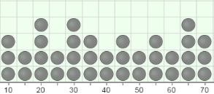
- What is/are the mode(s) of the data set shown to the right?

Activity B:  Mean | Get the Gizmo ready:  - Turn off all checkboxes. Click Clear.  - Drag points to model the data set 40 and 80.

- The mean is a measure of the center of a data set. Consider a data set with just two values, 40 and 80. When there are just two values, the mean is the halfway between them.

- What value is halfway between 40 and 80? Turn on Mean to check.

- Drag a second point to 40. What happens to the mean?

- With Mean selected, click New. Notice that the mean is near the middle of the data set. Try moving points from one place to another on the line graph, observing the mean as you do.

- What happens to the mean when you move points to the right?

- What happens to the mean when you move points to the left?

- Is it possible to move a point without changing the mean?

- Turn off Mean, and click Clear. Suppose in one week Russell earned $40, Chuck earned $40, and Katya earned $70. Model this in the Gizmo.

- Suppose Russell, Chuck, and Katya combined their earnings and then divided the money evenly. How much would each person have?
- How did you calculate this?

- Turn on Mean. What is the mean?

- Click Clear. The mean () is found by adding up all the values in the data set (x₁, x₂, etc.) and dividing by the number of values (n), as shown in this equation: =

What is the mean of 10, 25, 30, 30, 35? Use the Gizmo to check your answer.

- Noah got the following scores on quizzes: 90, 10, 100, 95, and 100.

- Noah was sick during one quiz. What score do you think he got on this quiz?

- This value, which is very different from the others, is an outlier. How did this outlier affect Noah’s mean quiz score?

Activity C:  Median | Get the Gizmo ready:  - Turn off all checkboxes. Click Clear.  - Drag points to model the data set 30, 70, and 80. | 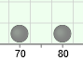

- The median is the middle value of a data set. Consider the data set 30, 70, 80.

- Which value is the middle value? Turn on Median to check.

- Turn on Mean. Is the median the same as the mean for this data set?

- Drag the point at 30 back and forth. As long as this point is below 70, does its value affect the median? Does its value affect the mean?
- Return the point to 30. Drag the point at 80 back and forth. As long as it is above 70, does its value affect the median? Does it affect the mean?
- Return the uppermost point to 80. Drag the point at 70 back and forth. As long as it is between 30 and 80, how does its value affect the median and the mean?

- Turn off Mean. Drag a point to 50 so the data set is now 30, 50, 70, 80.

What is the median now? When there is an even number of items in the data set, the median is the mean of the two middle values.

- Turn off Median. Click New until you get a data set with fewer than 20 items and an even number of items. Sketch a line plot of your data set in the chart below.

What is the median of this data set?

(Note: If the two middle values have the same value, the median is equal to this value.)

