Name: ______________________________________ Date: ________________________

Student Exploration: Digestive System

Vocabulary: absorption, amino acid, carbohydrate, chemical digestion, chyme, complex carbohydrate, digestion, digestive system, elimination, enzyme, fat, fatty acid, fiber, food calorie, mechanical digestion, monoglyceride, nutrient, peristalsis, protein, starch, sugar, villus

Prior Knowledge Questions (Do these BEFORE using the Gizmo.)

- Why do we need to eat food? _________________________________________________

_________________________________________________________________________

- How do you think our bodies break food down into useful nutrients? __________________

_________________________________________________________________________

_________________________________________________________________________

_________________________________________________________________________

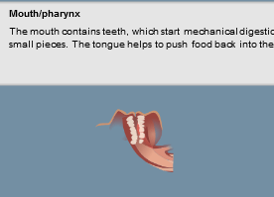
Gizmo Warm-up
The digestive system is a group of organs that does three things:
- First, the digestive system breaks food down into useful nutrients, a process called digestion.
- Next, the nutrients move into the bloodstream, a process called absorption.
- Finally, the leftover waste is removed from the body, a process called elimination.

With the Digestive System Gizmo, you can arrange the organs of the digestive system any way you like. To begin, look at the organs on the LARGE ORGANS tab. Place your cursor over each organ to learn more about it.

- Which organs allow nutrients to be absorbed? ____________________________________

- Which organ stores and compacts waste before it is eliminated? ______________________

- Which two organs help to break food down mechanically? _____________ _____________

Activity A:  Build a digestive system | Get the Gizmo ready:  - If necessary, click Clear screen. | 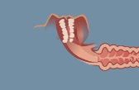

Goal: Design your own digestive system.

- Explore: Read the descriptions of the large organs, as well as those of the small organs on the next tab. Fill in the names of the organs that serve the functions listed below:

__________________ This organ absorbs water and vitamin K from digested food.

__________________ This organ produces enzymes that break down nutrients.

__________________ These tiny blood vessels transport absorbed nutrients.

__________________ These cells produce hydrochloric acid (HCl).

__________________ These cells produce pepsin, which breaks down proteins.

- Build: Now it is time to design and build your own digestive system! Start with the LARGE ORGANS tab to build a basic system, starting with the Mouth/pharynx. Next, attach organs from the SMALL ORGANS tab to the large organs to complete your system. Draw a picture of your system below. (If you like, open the Tools menu and click Screen shot. Right-click the image, choose Copy Image, and paste the image into a blank document.)

- Predict: How well do you think your system will digest food? Explain your reasoning.

_________________________________________________________________________

_________________________________________________________________________

_________________________________________________________________________

(Activity A continued on next page)
Activity A (continued from previous page)

- Prepare: Select the FOOD tab. The energy we get from food is measured in food calories (Calories). Each Calorie is equal to 4,184 joules of energy. Calories are found in the three main nutrients in food: carbohydrates (sugars and starches), proteins, and fats.

Drag the Cheeseburger above the mouth in your digestive system. How many Calories in the cheeseburger come from carbohydrates, proteins, and fats?

Carbohydrate Calories: ________ Protein Calories: ________ Fat Calories: ________

- Run the Gizmo: Click Play (), and observe the food moving through the digestive system. The muscular contractions that push food through the system are called peristalsis. When food has finished passing through the system, you will see a message.

- What percentage of Calories were absorbed by your system? ________

- What percentage of water was absorbed? ________

- Based on these results, how well do you think this digestive system worked? Explain.

___________________________________________________________________

___________________________________________________________________

___________________________________________________________________

- Revise: Click Reset (). Rearrange the organs of your system to try to improve your results. Describe how you changed your system below.

_________________________________________________________________________

_________________________________________________________________________

_________________________________________________________________________

- Test: Click Play or Fastplay (). List the results below. Did the system improve? ________

Percentage of Calories absorbed: ________ Percentage of water absorbed: ________

- Explain: If your system improved, why do you think this was so? ______________________

_________________________________________________________________________

_________________________________________________________________________

Activity B:  Mechanical and chemical digestion | Get the Gizmo ready:  - Click Reset and Clear screen.  - Build a system with a Mouth, Salivary gland, Esophagus, Pancreas, and Rectum. | 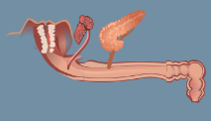

Introduction: Before nutrients are absorbed, they must be broken down to their simplest components. Teeth and muscular contractions in the stomach break food down into smaller particles, a process called mechanical digestion. In the meantime, powerful chemicals break down food in a process called chemical digestion.

Question: How are nutrients broken down in your digestive system?

- Set up the Gizmo: Check that the current digestive system has a mouth, salivary gland, esophagus, pancreas, and rectum, as shown above. From the FOOD tab, drag the Baked potato to the mouth. A potato mostly consists of complex carbohydrates, such as starch.

- View the ANALYSIS tab. What is the initial value of complex carbohydrates? ______

- Click Play or Fastplay. What is the final value of complex carbohydrates? ________

- How many Calories of complex carbohydrates were converted to sugars? ________

Explain how you know: ________________________________________________

The pancreas produces three digestive enzymes: Amylase breaks down complex carbohydrates into simple carbohydrates (sugars), trypsin breaks down proteins into amino acids, and lipase breaks down fats into fatty acids and monoglycerides.

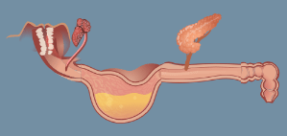
- Experiment: Click Reset. Move the Rectum, Esophagus, and Pancreas to the right and insert the Stomach so that the system looks like the image at right. Click Play/Fastplay.

- After digestion is complete, what is the value of complex carbohydrates? ________
- How many Calories of complex carbohydrates were converted to sugars? ________

- Why do you think the results were different? ________________________________

___________________________________________________________________

___________________________________________________________________

The muscular walls of the stomach churn food, transforming food chunks into a thick liquid called chyme. The nutrients in chyme break down more easily because they are exposed to digestive enzymes rather than hidden in food chunks.

(Activity B continued on next page)
Activity B (continued from previous page)

- Observe: Click Reset. Drag the Steamed tofu above the mouth. The Calories in tofu mostly come from proteins and fat. We will look at fat digestion first.

- What is the initial number of fat Calories? ________

- Click Play. How many fat Calories were converted to fatty acids? ________

- Experiment: Click Reset. Move the Pancreas one space to the right (still attached to the esophagus). Place the Gallbladder on the esophagus to the left of the pancreas. Click Play.

- How many fat Calories were converted to fatty acids in this situation? ________

- How did adding the gallbladder affect fat digestion? __________________________

Fat molecules can be difficult to break down because large fat droplets do not mix well with water-based enzymes such as lipase. For lipase to work, it helps if the fat is emulsified into tiny droplets. This is done with the help of bile, which is stored in the gallbladder.

- Observe: Now look at the results for proteins. (Do not press Reset yet.) Proteins are complex molecules formed from long chains of amino acids.

How many of the original 72 protein Calories were converted to amino acids? ________

- Experiment: Click Reset. The process of protein digestion is helped by the enzyme pepsin.

- Look at the remaining small organs. Which ones produce pepsin? ______________

Add these cells to the stomach.

- Click Play. How much protein is converted to amino acids now? ________

- Click Reset. Pepsin works best in an acidic environment. Which of the remaining small organs produces an acid? ____________________ Add these to the stomach.
- Click Play. How much protein is converted to amino acids now? ________

- Explain: How do mechanical and chemical digestion work together to break down food?

_________________________________________________________________________

_________________________________________________________________________

_________________________________________________________________________

Activity C:  Absorption | Get the Gizmo ready:  - Click Reset and Clear screen. | 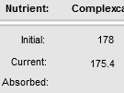

Introduction: Digesting nutrients into simple carbohydrates, amino acids, and fatty acids is important, but it doesn’t matter unless the nutrients get into the bloodstream to feed body cells. This process is called absorption.

Question: How are nutrients absorbed?

- Observe: Look through the descriptions of the large and small organs.

- Which of the large organs allow nutrients and water to pass through their walls?

___________________________________________________________________

- Which of the small organs transport absorbed nutrients to the bloodstream?

___________________________________________________________________

- Set up the Gizmo: Create the digestive system shown. The small intestine has three parts: the duodenum (attached to the stomach), the jejunum (the middle portion), and the ilium (attached to the large intestine). Drag the Pecan pie to the mouth.

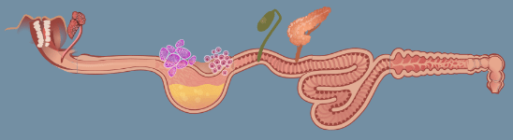

Test each of the scenarios below. For each setup, record the nutrients that are absorbed by the system. (Be sure to look at the “Absorbed” row of the Analysis table.)

Scenario | Sugars | Amino acids | Fatty acids | Water
Capillaries attached to the small intestine segments only
Capillaries attached to the large intestine only
Lymphatic vessels attached to the small intestine segments only (no capillaries)
Lymphatic vessels attached to the large intestine only (no capillaries)

(Activity C continued on next page)
Activity C (continued from previous page)

- Analyze: Examine the results of your four experiments.

- Which nutrients were absorbed by capillaries in the small intestine? _____________

___________________________________________________________________

- Which nutrients were absorbed by capillaries in the large intestine? _____________

___________________________________________________________________

Bacteria in the large intestine break down some types of fiber—a difficult to digest complex carbohydrate—into sugars that are absorbed in the large intestine.

- Which nutrient was absorbed by small intestine lymphatic vessels? ______________

- Did lymphatic vessels absorb anything from the large intestine? ________________

- Draw conclusions: Based on your experiments, where should the capillaries and lymphatic vessels be placed to maximize the absorption of nutrients from food?

Capillaries: ________________________________________________________________

Lymphatic vessels: _________________________________________________________

- Investigate: Click Reset. From the FOOD tab, drag the Apple to the work area to view its Nutritional Facts. What nutrient makes up most of an apple’s Calories? _______________

- Challenge: Using a total of only five organs, design a digestive system that can absorb the maximum number of Calories from the apple. Describe your system below.

_________________________________________________________________________

_________________________________________________________________________

- Test: Click Play. What percentage of Calories did your system absorb? _______

- Explore: Use the Gizmo to determine how absorption of water affects the texture of the stool (poop) that is produced by the digestive system. What do you conclude?

_________________________________________________________________________

_________________________________________________________________________

Activity D:  Human digestion | Get the Gizmo ready:  - Click Reset and Clear screen. | 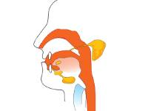

Introduction: Now that you have explored a model of human digestion, it is time to apply what you have learned to the real human digestive system.

Goal: Describe the human digestive system.

- Label: Based on what you have learned, identify the organs of the human digestive system.

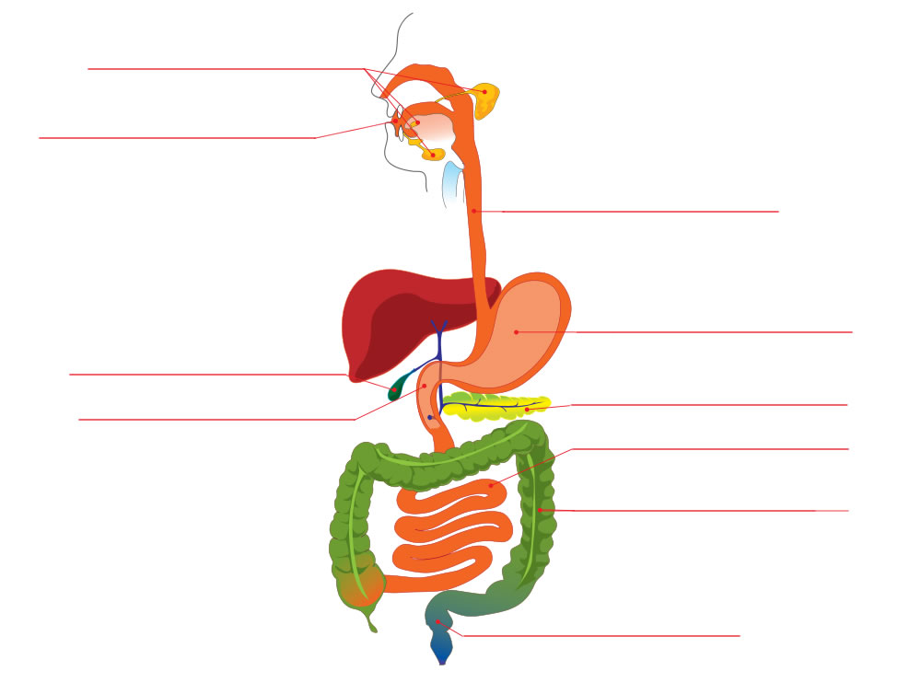

- Think and discuss: Why is it important that the mouth and stomach are near the start of the digestive system? __________________________________________________________
_________________________________________________________________________

(Activity D continued on next page)
Activity D (continued from previous page)

- Match: Match each structure, chemical, or process to its function.

_____ Amylase A. Upper section of the small intestine

_____ Peristalsis B. Muscular tube connecting the throat and stomach

_____ Duodenum C. Organ that produces a variety of digestive enzymes

_____ Lymphatic vessel D. Chemical that breaks up large fat droplets

_____ Anus E. Muscular contractions that push food through the digestive system

_____ Large intestine F. Enzyme that starts to digest proteins in the stomach

_____ Esophagus G. Opening through which wastes are eliminated

_____ Pepsin H. Produces hydrochloric acid in the stomach

_____ Pancreas I. Transports absorbed fatty acids to the bloodstream

_____ Parietal cell J. Organ that absorbs water and vitamin K

_____ Bile K. Enzyme that breaks down starches into simple carbohydrates

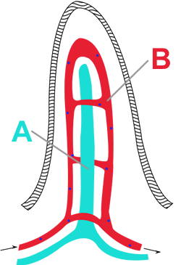
- Infer: The diagram at right shows part of a villus. A villus is a tiny, fingerlike projection in the wall of the small intestine. The small intestine contains millions of villi.

- What are the names of the vessels labeled A and B in the diagram? __________________________________________
- What do you think is the function of a villus? ______________

__________________________________________________

- Evaluate: In humans, the small intestine can be over 8 meters (26 feet) long. Why do you think this organ is so long? ___________________________________________________
_________________________________________________________________________

_________________________________________________________________________

